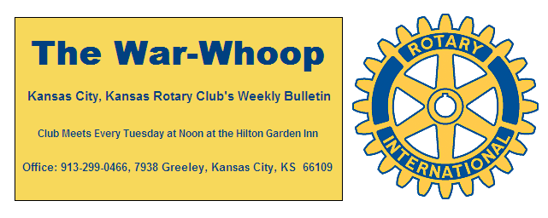
Websites: Club: www.rotarydowntownkck.org, District: www.rotary5710.org, International: www.rotary.org

Volume 78 September 30, 2016 No. 14

LAST WEEK AT ROTARY- “VOTE on November 8th on the local school board bond issue” was the message of our speaker, Rick Behrens, last Tuesday, Rick, a school board member of School District 500 made a presentation on the need of a school bond issue that will be on the November Ballot. He told members that the issue will be on the bottom of the ballot, so make sure that members, living in Wyandotte County, go through the entire ballot. He told members that this issue will be ZERO TAX INCREASE on tax payers of Wyandotte County tax payers.
Plan highlights include:
***Safety and security enhancements, including new secured entrances.
***Two new elementary schools and two new middle schools.
***High School College and career Academy spaces.
***Middle school career exploration spaces.
***Kitchen construction and upgrades at six elementary and one middle school.
***New elementary playgrounds at 9 elementary schools.
*** Building remodels and renovations.
Rick told members that a facilities assessment was made last December and found that the schools are 97% full at the present time. In the next 5-8 years there will be an increase in the student population at the higher grades.

Vice-President Fred opened the meeting and Dan Duncan gave the invocation. Scott Kaufmann led the singing and Dave Skidgel introduced the visitors. Jacob Spalding was a guest of new member Andrea Spalding.

NEXT WEEK AT ROTARY- The program for next week has not been confirmed as of this morning.

NEW MEMBER- Membership chairmen Phil Gibbs introduced the newest member in Rotary in the person of Andrea Spalding. Andrea is an architect with the firm of HMN architects located at 7400 W. 110 St in Overland Park. Her classification in Rotary will be Architect/Add’l Active. Andrea has had a very interesting background and would make a great Classification talk for our club.

PAUL HARRIS DRAWING- Ken Davis won the right to draw for the joker last Tuesday. Ken did not draw the joker and the amount goes to $233.00 for next week’s drawing.

DAFADOILS ARE HERE- Ken Davis reported that he has 1,000 flower bulbs at his home to be distributed to local high and middle schools. Ken is going to need help in the next few weeks.

MEDICAL UPDATE- Scott Martens has fallen and broke his leg. He is waiting for the swelling to go down so that he will be able to have a second surgery on the leg.

ANNUAL PROGRAM PLEDGE LETTER- The Rotary Annual Pledge letter and Pledge sheet has been emailed out to all members. Please give this letter your attention. Members wanting to be billed in installments starting on October 1st should try and get their pledge sheets in by September 30th (TODAY) so that we can begin billing members on the October quarterly billing. Pledge sheets are also available at the back table at our luncheons each week. A quarterly pledge sheet is included in this week’s mailing.

FLAG- Our American flag was missing again last week.
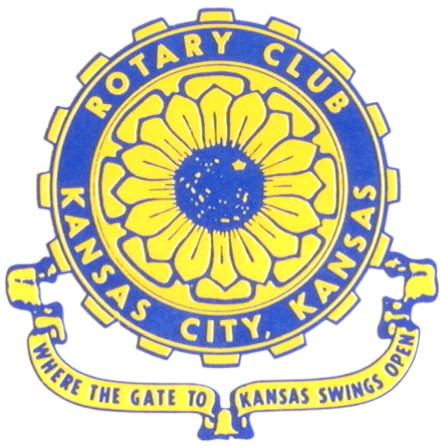
Where the Gate to Kansas Swings Open

The Kansas City, Kansas Rotary Club was organized on November 2, 1915 and received its charter as Club No. 195 in January 1916. Its members take pride in more than 100 years of Rotary service to the community and to international fellowship. From this Club have come five District Governors and two Directors of Rotary International. The Club’s history is as rich as that of the community it represents.

Following the Lewis and Clark expedition which camped at the confluence of the Kansas and Missouri rivers on June 26, 1804, in present day Kansas City, Kansas, this area became an important center for fur trappers. In the following years, many Indian tribes were relocated here from the East. In 1842 the Wyandot Indians acquired land here and founded a town. During this period, and for the next five decades, this area became the main gateway to the inviting majesty of the sprawling Kansas Prairie and the American West. This was where the frontier began. Pioneers found river transportation, outfitters and the beginning of the Santa Fe and Oregon Trails. After the covered wagons came major trunk railroads and barge lines.

In 1886, Kansas City, Kansas received its charter as an incorporated city, combining the towns of Wyandot, Argentine and Armourdale. (Rosedale was added in 1922.) Kansas City, Kansas is the site of the first industrial park in the United States, home of the prestigious University of Kansas Medical Center, and the location of the National Agricultural Hall of Fame and the nationally recognized Kansas Speedway.

Near the geographical and population centers of the contiguous United States, it is in the temperate latitudes at an elevation of 726 feet above sea level. The average rainfall is 35 inches. The average mean temperature ranges from 30°F in January to 80°F in July. The lowest recorded temperature was -23°F on December 23, 1989, and the highest was 113°F on August 14, 1936. Our city’s population of 145,000 and 155 square miles rank it 158th among cities in the United States.

Welcome to Kansas City, Kansas Rotary, and the vibrant community it represents.

Service Above Self

Rotary Websites:
KCK Club: www.rotarydowntownkck.org, District: www.rotary5710.org, International: www.rotary.org

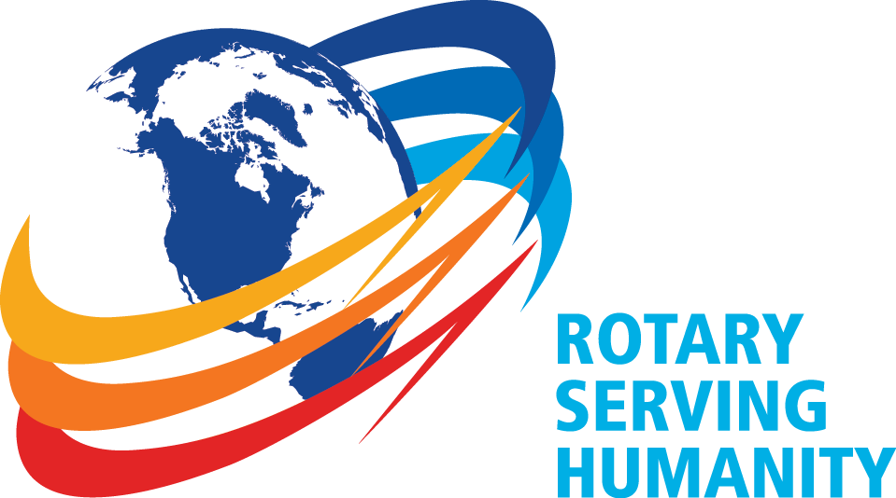

WHERE NEARBY TO MAKE UP ATTENDANCE
MONDAY
Bonner Springs (11:45am) --------------------------------- Twister Bar & Grill, 13100 Kansas Ave.
Overland Park (11:30am) ----------------------------------- Doubletree Hotel, 10100 College Blvd.
TUESDAY
Gladstone (7:00am) -------------------------------------- Fairview Christian Church, 1800 N.E. 65th
Johnson County-Sunset (5:15pm) ------------------------- Hilton Garden Inn Olathe, 119th & I-35
WEDNESDAY
Overland Park South (7:15am) ------------------------ Deer Creek Country Club, 7000 W. 133rd
Leavenworth (Noon) --------------------------- Riverfront Community Center, 123 S. Esplanade
KCI, Missouri (Noon) -------------------------------- KCI Expo Center, 11730 N. Ambassador Dr.
Shawnee Mission (Noon) ----------------------------- Sylvester Powell Center, Martway & Lamar
Olathe (Noon) ------------------------------ Mahaffie/Heritage Center, 1200 E. Kansas City Road
Kansas City South, Missouri (Noon) ----------------------------- EBT, 1310 Carondolet, 2nd Floor
THURSDAY
South Platte, Missouri (7:00am) ----------------------- Trezo Mare, 4105 Mulberry Drive, KCMO
Johnson County (7:15am) --------------------------- Crowne Plaza Hotel, 12601 W. 95th, Lenexa
Leawood (7:15am) ---------------------------------- Hallbrook Country Club, 11200 Overbrook Rd
Village West (7:15am) -------------------------- Dave & Buster’s, 1843 Village West Pkwy., KCK
Gardner (7:30am) ---------------------------------------------------- Senior Citizen Bldg., 128 E. Park
Olathe Santa Fe Trail (7:30am) --- Mid-Am Nazarene U, 2030 E. College Way, Campus Ctr.
Kansas City, Missouri (Noon) -------------------------------- The Gallery, 61 E. 14th Street, KCMO
FRIDAY
Desoto (7:00am) ------------------------ Desoto United Methodist Church, 8760 Kill Creek Road
Shawnee (7:15am) --------------------------------------------------- Town Hall, 11600 Johnson Drive
Plaza, Missouri (7:15am) -------------------------------- Intercontinental Hotel, 401 Ward Parkway
North Kansas City, Missouri (Noon) ------------------------------ NKC Library, 2251 Howell Street
Parkville, Missouri (Noon) ------------------------ Park University Underground, Woodard Center
Lenexa (Noon) ------------------------------- Lakeview Village, Northpointe Bldg., 91st & Park St.

Meeting make ups can be made 14 days before or after the missed meeting.
Please see the Secretary for the world directory of all Rotary Club’s meeting times, days and places.

2016-2017 Board of Directors
Officers Directors
Ashley Adorante Rick Behrens
President Karole Bradford
Fred Zimmerman John Freshnock
Vice President Phil Gibbs
Greg Shondell Wendell Maddox
Treasurer Melissa Mundt
Jim Knight Bruce Schlosser
Secretary Donna Severance
Rosemary Podrebarac Fred Zimmerman
Sergeant at Arms
Hank Chamberlain
Past President

