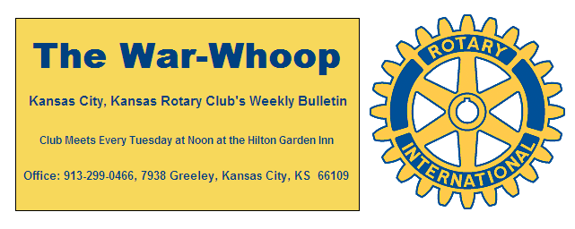
Websites: Club: www.rotarydowntownkck.org, District: www.rotary5710.org, International: www.rotary.org

Volume 78 November 18, 2016 No. 21

LAST WEEK AT ROTARY- Pauy Hart, Interim Director for the Lead to Read program, talked about the program. The program is a one on one reading to students between grades one through third. The proram is based in Kansas City, Missouri at the time being. The program is being held at the Whittier Elementary school in Kansas City, Kansas. She told members that students this age are learning to read and fourth grade on are expected to read. The literacy percentage for these grades are 49% which is very low. It has been upgraded to this amount from 37% in just the last year.
The program has increased from 300 to 900 adult readers in just a short time. Their goal is 5000 which she admitted was a lofty goal.
Adult readers volunteer to read ½ hour per week to one student. Adults are pared together, called the buddy system, to make sure that one adult is present each week to read. She showed a power point presentation about the program. She answered questions after her presentation.

President Ashley opened the meeting and Bob Kimball gave the invocation. Scott Kaufmann led the singing and Melissa Mundt introduced the visitors.

PROGRAM NOTE- The Sumner choir will perform their annual concert in front of Rotarians on December 6th. If members plan on guests, please let the secretary know, so that reservations can be made with the caterer.

NEXT WEEK AT ROTARY- A member of the organization, Girls on the Run will talk about Program. Girls on the Run is a non-profit organization dedicated to creating a world where every girl knows and activates her limitless potential and is free to boldly pursue her dreams. The program teaches life’s skills through dynamic, interactive lessons and running programs.

Kelsy Allison will be the program chair for the day and for the month.

BELL RINGING- Rotarians will again ring bells for the Salvation Army on Saturday, December 6th at the Nebraska Furniture Mart. A signup sheet was passed around again last Tuesday. All slots were filled at our meeting on Tuesday.

NOMINATING COMMITTEE- The Nominating Committee has nominated the following members to a three year term beginning July 1,2017.

Rick Behrens Tony Martinez Terry Robinson
The election for the new board members and officers will be held on Tuesday, December 13th at our regular Rotary luncheon.

MEDICAL UPDATE- It was great to see Scott Martens back last Tuesday. Scott fell off his bike and broke his leg two months ago. He is still in a wheel chair, but coasting along.
Karen Hostetler reported that Dan Duncan fractured his wrist last week.

PAUL HARRIS DRAWING- A visitor, Shawn DeCoursey, won the right to draw for thr joker last week Shawn did not draw the joker and the pot goes to $15.00 for next week. President Ashley presented Bill Porter with his check for $173.00 for drawing the joker last week. Shawn was a guest of Scott Martens.

UNITED WAY ANNUAL MEETING- Rotarians are invited to the United Way Annual meeting on December 8th at 11:30am at Children’s Mercy Park, One Sporting Way. Reservations are needed by December 1st. Reservations can be made by calling 913.371.1507

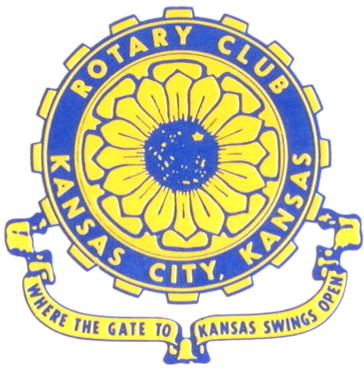
Where the Gate to Kansas Swings Open

The Kansas City, Kansas Rotary Club was organized on November 2, 1915 and received its charter as Club No. 195 in January 1916. Its members take pride in more than 100 years of Rotary service to the community and to international fellowship. From this Club have come five District Governors and two Directors of Rotary International. The Club’s history is as rich as that of the community it represents.

Following the Lewis and Clark expedition which camped at the confluence of the Kansas and Missouri rivers on June 26, 1804, in present day Kansas City, Kansas, this area became an important center for fur trappers. In the following years, many Indian tribes were relocated here from the East. In 1842 the Wyandot Indians acquired land here and founded a town. During this period, and for the next five decades, this area became the main gateway to the inviting majesty of the sprawling Kansas Prairie and the American West. This was where the frontier began. Pioneers found river transportation, outfitters and the beginning of the Santa Fe and Oregon Trails. After the covered wagons came major trunk railroads and barge lines.

In 1886, Kansas City, Kansas received its charter as an incorporated city, combining the towns of Wyandot, Argentine and Armourdale. (Rosedale was added in 1922.) Kansas City, Kansas is the site of the first industrial park in the United States, home of the prestigious University of Kansas Medical Center, and the location of the National Agricultural Hall of Fame and the nationally recognized Kansas Speedway.

Near the geographical and population centers of the contiguous United States, it is in the temperate latitudes at an elevation of 726 feet above sea level. The average rainfall is 35 inches. The average mean temperature ranges from 30°F in January to 80°F in July. The lowest recorded temperature was -23°F on December 23, 1989, and the highest was 113°F on August 14, 1936. Our city’s population of 145,000 and 155 square miles rank it 158th among cities in the United States.

Welcome to Kansas City, Kansas Rotary, and the vibrant community it represents.

Service Above Self

Rotary Websites:
KCK Club: www.rotarydowntownkck.org, District: www.rotary5710.org, International: www.rotary.org



WHERE NEARBY TO MAKE UP ATTENDANCE
MONDAY
Bonner Springs (11:45am) --------------------------------- Twister Bar & Grill, 13100 Kansas Ave.
Overland Park (11:30am) ----------------------------------- Doubletree Hotel, 10100 College Blvd.
TUESDAY
Gladstone (7:00am) -------------------------------------- Fairview Christian Church, 1800 N.E. 65th
Johnson County-Sunset (5:15pm) ------------------------- Hilton Garden Inn Olathe, 119th & I-35
WEDNESDAY
Overland Park South (7:15am) ------------------------ Deer Creek Country Club, 7000 W. 133rd
Leavenworth (Noon) --------------------------- Riverfront Community Center, 123 S. Esplanade
KCI, Missouri (Noon) -------------------------------- KCI Expo Center, 11730 N. Ambassador Dr.
Shawnee Mission (Noon) ----------------------------- Sylvester Powell Center, Martway & Lamar
Olathe (Noon) ------------------------------ Mahaffie/Heritage Center, 1200 E. Kansas City Road
Kansas City South, Missouri (Noon) ----------------------------- EBT, 1310 Carondolet, 2nd Floor
THURSDAY
South Platte, Missouri (7:00am) ----------------------- Trezo Mare, 4105 Mulberry Drive, KCMO
Johnson County (7:15am) --------------------------- Crowne Plaza Hotel, 12601 W. 95th, Lenexa
Leawood (7:15am) ---------------------------------- Hallbrook Country Club, 11200 Overbrook Rd
Village West (7:15am) -------------------------- Dave & Buster’s, 1843 Village West Pkwy., KCK
Gardner (7:30am) ---------------------------------------------------- Senior Citizen Bldg., 128 E. Park
Olathe Santa Fe Trail (7:30am) --- Mid-Am Nazarene U, 2030 E. College Way, Campus Ctr.
Kansas City, Missouri (Noon) -------------------------------- The Gallery, 61 E. 14th Street, KCMO
FRIDAY
Desoto (7:00am) ------------------------ Desoto United Methodist Church, 8760 Kill Creek Road
Shawnee (7:15am) --------------------------------------------------- Town Hall, 11600 Johnson Drive
Plaza, Missouri (7:15am) -------------------------------- Intercontinental Hotel, 401 Ward Parkway
North Kansas City, Missouri (Noon) ------------------------------ NKC Library, 2251 Howell Street
Parkville, Missouri (Noon) ------------------------ Park University Underground, Woodard Center
Lenexa (Noon) ------------------------------- Lakeview Village, Northpointe Bldg., 91st & Park St.

Meeting make ups can be made 14 days before or after the missed meeting.
Please see the Secretary for the world directory of all Rotary Club’s meeting times, days and places.

2016-2017 Board of Directors
Officers Directors
Ashley Adorante Rick Behrens
President Karole Bradford
Fred Zimmerman John Freshnock
Vice President Phil Gibbs
Greg Shondell Wendell Maddox
Treasurer Melissa Mundt
Jim Knight Bruce Schlosser
Secretary Donna Severance
Rosemary Podrebarac Fred Zimmerman
Sergeant at Arms
Hank Chamberlain
Past President

