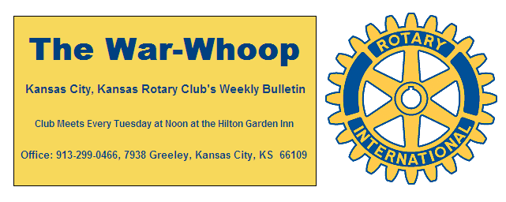
Websites: Club: www.rotarydowntownkck.org, District: www.rotary5710.org, International: www.rotary.org

Volume 78 December 9, 2016 No. 23

LAST WEEK AT ROTARY- Rotarians were entertained by the Sumner Academy choir. The group sang songs and then led Rotarians in a sing-a-long before leaving and going back to school. The group had a soloist that sang a carol and sounded very profess-ional. According to the choir leader he has been picked for a national choir. They were great as usual.

President Ashley opened the meeting and Dan Duncan gave the invocation. Karole Bradford introduced the visitors. We had ten visitors this week to come and hear the Sumner choir.

PAUL HARRIS DRAWING- Merle Parks won the right to draw for the joker. Merle did not draw the joker and the amount goes to $43.00 for next week’s drawing.

NOMINATING COMMITTEE- The Nominating Committee has nominated the following members for a three year term beginning July 1,2017.

Rick Behrens Tony Martinez Terry Robinson
The election for the new board members and officers will be held next Tuesday, December 13th at our regular Rotary luncheon. Nominations may be made from the floor. Any nominations from the floor must be made with the consent of the person nominated.

NEXT WEEK AT ROTARY- Next week Rotarians will hear about the rise in the stock market among other thoughts about the market. Jason Young, Vice President of American Funds, will be talking about the market at this time. This should be am interesting program to hear with the way the market has grown since the election.

Scott Kaufmann will be the program chairman for the day and for the month of December.

**** Another reminder that Rotary will not meet on the last Tuesday in December(December 27th).

MEAL COSTS- At our recent social gathering the subject of meal costs came up in a conversation. Meal costs have gone up from a $15.00 charge to $19.67. Both charges includes service charges and taxes. The board has looked into a new location for our luncheons, but as of this time has not been able to come up with a location. We have contacted the hotel for the use of the Eisenhower Room and they are about a dollar cheaper, but cannot guarantee the use of the room on a regular basis. If any member has any ideas regarding this situation, please contact one of the board members. The board would like to keep our meeting downtown.

DISTRICT NEWSLETTER- All members should have re-ceived the District Newsletter by email this week. Take some time and read about the events that are happening in the district. Any member that has not received a monthly news-letter should contact secretary Jim and he would be happy to forward a copy to you.

WEBSITE- Please take a look at our website as Greg Shondell has updated it with pictures from the bell ringing last Saturday and the Sumner choir on Tuesday

.
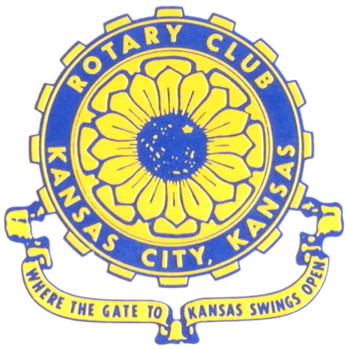
Where the Gate to Kansas Swings Open

The Kansas City, Kansas Rotary Club was organized on November 2, 1915 and received its charter as Club No. 195 in January 1916. Its members take pride in more than 100 years of Rotary service to the community and to international fellowship. From this Club have come five District Governors and two Directors of Rotary International. The Club’s history is as rich as that of the community it represents.

Following the Lewis and Clark expedition which camped at the confluence of the Kansas and Missouri rivers on June 26, 1804, in present day Kansas City, Kansas, this area became an important center for fur trappers. In the following years, many Indian tribes were relocated here from the East. In 1842 the Wyandot Indians acquired land here and founded a town. During this period, and for the next five decades, this area became the main gateway to the inviting majesty of the sprawling Kansas Prairie and the American West. This was where the frontier began. Pioneers found river transportation, outfitters and the beginning of the Santa Fe and Oregon Trails. After the covered wagons came major trunk railroads and barge lines.

In 1886, Kansas City, Kansas received its charter as an incorporated city, combining the towns of Wyandot, Argentine and Armourdale. (Rosedale was added in 1922.) Kansas City, Kansas is the site of the first industrial park in the United States, home of the prestigious University of Kansas Medical Center, and the location of the National Agricultural Hall of Fame and the nationally recognized Kansas Speedway.

Near the geographical and population centers of the contiguous United States, it is in the temperate latitudes at an elevation of 726 feet above sea level. The average rainfall is 35 inches. The average mean temperature ranges from 30°F in January to 80°F in July. The lowest recorded temperature was -23°F on December 23, 1989, and the highest was 113°F on August 14, 1936. Our city’s population of 145,000 and 155 square miles rank it 158th among cities in the United States.

Welcome to Kansas City, Kansas Rotary, and the vibrant community it represents.

Service Above Self

Rotary Websites:
KCK Club: www.rotarydowntownkck.org, District: www.rotary5710.org, International: www.rotary.org



WHERE NEARBY TO MAKE UP ATTENDANCE
MONDAY
Bonner Springs (11:45am) --------------------------------- Twister Bar & Grill, 13100 Kansas Ave.
Overland Park (11:30am) ----------------------------------- Doubletree Hotel, 10100 College Blvd.
TUESDAY
Gladstone (7:00am) -------------------------------------- Fairview Christian Church, 1800 N.E. 65th
Johnson County-Sunset (5:15pm) ------------------------- Hilton Garden Inn Olathe, 119th & I-35
WEDNESDAY
Overland Park South (7:15am) ------------------------ Deer Creek Country Club, 7000 W. 133rd
Leavenworth (Noon) --------------------------- Riverfront Community Center, 123 S. Esplanade
KCI, Missouri (Noon) -------------------------------- KCI Expo Center, 11730 N. Ambassador Dr.
Shawnee Mission (Noon) ----------------------------- Sylvester Powell Center, Martway & Lamar
Olathe (Noon) ------------------------------ Mahaffie/Heritage Center, 1200 E. Kansas City Road
Kansas City South, Missouri (Noon) ----------------------------- EBT, 1310 Carondolet, 2nd Floor
THURSDAY
South Platte, Missouri (7:00am) ----------------------- Trezo Mare, 4105 Mulberry Drive, KCMO
Johnson County (7:15am) --------------------------- Crowne Plaza Hotel, 12601 W. 95th, Lenexa
Leawood (7:15am) ---------------------------------- Hallbrook Country Club, 11200 Overbrook Rd
Village West (7:15am) -------------------------- Dave & Buster’s, 1843 Village West Pkwy., KCK
Gardner (7:30am) ---------------------------------------------------- Senior Citizen Bldg., 128 E. Park
Olathe Santa Fe Trail (7:30am) --- Mid-Am Nazarene U, 2030 E. College Way, Campus Ctr.
Kansas City, Missouri (Noon) -------------------------------- The Gallery, 61 E. 14th Street, KCMO
FRIDAY
Desoto (7:00am) ------------------------ Desoto United Methodist Church, 8760 Kill Creek Road
Shawnee (7:15am) --------------------------------------------------- Town Hall, 11600 Johnson Drive
Plaza, Missouri (7:15am) -------------------------------- Intercontinental Hotel, 401 Ward Parkway
North Kansas City, Missouri (Noon) ------------------------------ NKC Library, 2251 Howell Street
Parkville, Missouri (Noon) ------------------------ Park University Underground, Woodard Center
Lenexa (Noon) ------------------------------- Lakeview Village, Northpointe Bldg., 91st & Park St.

Meeting make ups can be made 14 days before or after the missed meeting.
Please see the Secretary for the world directory of all Rotary Club’s meeting times, days and places.

2016-2017 Board of Directors
Officers Directors
Ashley Adorante Rick Behrens
President Karole Bradford
Fred Zimmerman John Freshnock
Vice President Phil Gibbs
Greg Shondell Wendell Maddox
Treasurer Melissa Mundt
Jim Knight Bruce Schlosser
Secretary Donna Severance
Rosemary Podrebarac Fred Zimmerman
Sergeant at Arms
Hank Chamberlain
Past President

