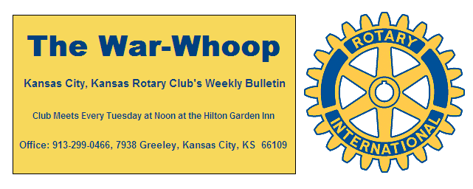
Websites: Club: www.rotarydowntownkck.org, District: www.rotary5710.org, International: www.rotary.org

Volume 78 December 30, 2016 No. 26


OUR ROAMING ROTARIANS
eClub----------------------------------------------------Terry Robinson
eClub---------------------------------------------------- Dave Tyler
Shawnee Mission---------------------------------- Dave Tyler

NEXT WEEK AT ROTARY- The program for next week has not been confirmed as the War Whoop is being mailed.

YOU ARE INVITED- ALL club members are invited to Dan Duncan's retirement party on Friday, January 6, 2017 at 5:30 pm at the George Meyn Community Center in Wyco Park (120th and State Ave). Please RSVP by phone or text to Lee Ann (816-223-3486) or Dan (816-223-3863) by January 2nd so that enough food and drink can be ordered.

2016 TAX LETTERS- Tax Letters were handed out to members in attendance last week. Members, not in attendance, received their tax letters in the mail. Please check with Secretary Jim if you do not receive a tax letter by the end of the month. Tax letters are sent to members annually in December, reporting calendar year Foundation contributions.
- Tax Deductible Guidelines:
GENERAL TAX DEDUCTIBILITY GUIDELINES- With the end of the year fast approaching, Treasurer Greg Shondell wanted to review with members several income tax issues of club membership. Each member pays annual club dues of $188.00 ($47.00 billed quarterly) and $13.00 per week for lunches ($169.00 billed quarterly). Each member can also make voluntary contributions to our Club’s local foundation to support charitable efforts of the club.
Club dues may be deductible as a business expense by the member based on the individual’s facts and circumstances.
50% of the lunch cost (subject to the 50% meals and entertainment reduction) may be deductible as a business expense by the member, based on the individual’s facts and circumstances.
Contributions directly to our Club’s local foundation should be deductible as a charitable contribution, subject to the individual’s overall tax limitations. Please note that to obtain this charitable deduction, members must write their contribution checks (even if billed quarterly) directly to the Kansas City, Kansas Rotary President’s Foundation. Under IRS regulations, writing a single check to pay club dues and make deductible charitable contributions is not allowed.
These are general guidelines; please consult your tax/legal advisers for your specific situation.

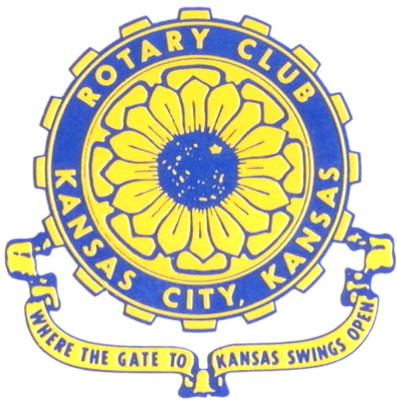
Where the Gate to Kansas Swings Open

The Kansas City, Kansas Rotary Club was organized on November 2, 1915 and received its charter as Club No. 195 in January 1916. Its members take pride in more than 100 years of Rotary service to the community and to international fellowship. From this Club have come five District Governors and two Directors of Rotary International. The Club’s history is as rich as that of the community it represents.

Following the Lewis and Clark expedition which camped at the confluence of the Kansas and Missouri rivers on June 26, 1804, in present day Kansas City, Kansas, this area became an important center for fur trappers. In the following years, many Indian tribes were relocated here from the East. In 1842 the Wyandot Indians acquired land here and founded a town. During this period, and for the next five decades, this area became the main gateway to the inviting majesty of the sprawling Kansas Prairie and the American West. This was where the frontier began. Pioneers found river transportation, outfitters and the beginning of the Santa Fe and Oregon Trails. After the covered wagons came major trunk railroads and barge lines.

In 1886, Kansas City, Kansas received its charter as an incorporated city, combining the towns of Wyandot, Argentine and Armourdale. (Rosedale was added in 1922.) Kansas City, Kansas is the site of the first industrial park in the United States, home of the prestigious University of Kansas Medical Center, and the location of the National Agricultural Hall of Fame and the nationally recognized Kansas Speedway.

Near the geographical and population centers of the contiguous United States, it is in the temperate latitudes at an elevation of 726 feet above sea level. The average rainfall is 35 inches. The average mean temperature ranges from 30°F in January to 80°F in July. The lowest recorded temperature was -23°F on December 23, 1989, and the highest was 113°F on August 14, 1936. Our city’s population of 145,000 and 155 square miles rank it 158th among cities in the United States.

Welcome to Kansas City, Kansas Rotary, and the vibrant community it represents.

Service Above Self

Rotary Websites:
KCK Club: www.rotarydowntownkck.org, District: www.rotary5710.org, International: www.rotary.org



WHERE NEARBY TO MAKE UP ATTENDANCE
MONDAY
Bonner Springs (11:45am) --------------------------------- Twister Bar & Grill, 13100 Kansas Ave.
Overland Park (11:30am) ----------------------------------- Doubletree Hotel, 10100 College Blvd.
TUESDAY
Gladstone (7:00am) -------------------------------------- Fairview Christian Church, 1800 N.E. 65th
Johnson County-Sunset (5:15pm) ------------------------- Hilton Garden Inn Olathe, 119th & I-35
WEDNESDAY
Overland Park South (7:15am) ------------------------ Deer Creek Country Club, 7000 W. 133rd
Leavenworth (Noon) --------------------------- Riverfront Community Center, 123 S. Esplanade
KCI, Missouri (Noon) -------------------------------- KCI Expo Center, 11730 N. Ambassador Dr.
Shawnee Mission (Noon) ----------------------------- Sylvester Powell Center, Martway & Lamar
Olathe (Noon) ------------------------------ Mahaffie/Heritage Center, 1200 E. Kansas City Road
Kansas City South, Missouri (Noon) ----------------------------- EBT, 1310 Carondolet, 2nd Floor
THURSDAY
South Platte, Missouri (7:00am) ----------------------- Trezo Mare, 4105 Mulberry Drive, KCMO
Johnson County (7:15am) --------------------------- Crowne Plaza Hotel, 12601 W. 95th, Lenexa
Leawood (7:15am) ---------------------------------- Hallbrook Country Club, 11200 Overbrook Rd
Village West (7:15am) -------------------------- Dave & Buster’s, 1843 Village West Pkwy., KCK
Gardner (7:30am) ---------------------------------------------------- Senior Citizen Bldg., 128 E. Park
Olathe Santa Fe Trail (7:30am) --- Mid-Am Nazarene U, 2030 E. College Way, Campus Ctr.
Kansas City, Missouri (Noon) -------------------------------- The Gallery, 61 E. 14th Street, KCMO
FRIDAY
Desoto (7:00am) ------------------------ Desoto United Methodist Church, 8760 Kill Creek Road
Shawnee (7:15am) --------------------------------------------------- Town Hall, 11600 Johnson Drive
Plaza, Missouri (7:15am) -------------------------------- Intercontinental Hotel, 401 Ward Parkway
North Kansas City, Missouri (Noon) ------------------------------ NKC Library, 2251 Howell Street
Parkville, Missouri (Noon) ------------------------ Park University Underground, Woodard Center
Lenexa (Noon) ------------------------------- Lakeview Village, Northpointe Bldg., 91st & Park St.

Meeting make ups can be made 14 days before or after the missed meeting.
Please see the Secretary for the world directory of all Rotary Club’s meeting times, days and places.

2016-2017 Board of Directors
Officers Directors
Ashley Adorante Rick Behrens
President Karole Bradford
Fred Zimmerman John Freshnock
Vice President Phil Gibbs
Greg Shondell Wendell Maddox
Treasurer Melissa Mundt
Jim Knight Bruce Schlosser
Secretary Donna Severance
Rosemary Podrebarac Fred Zimmerman
Sergeant at Arms
Hank Chamberlain
Past President

