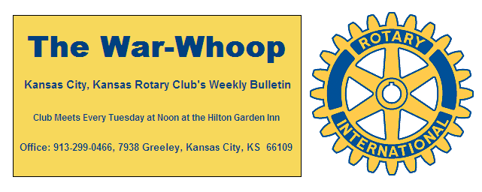
Websites: Club: www.rotarydowntownkck.org, District: www.rotary5710.org, International: www.rotary.org

Volume 78 January 6, 2017 No. 27

LAST WEEK AT ROTARY- Ken Davis came to the rescue last Tuesday when he gave an entertaining and interesting classification talk. While Ken is now retired from Kansas Uni-versity Medical Center this past year. Ken’s parents were Methodist Missionaries in Brazil.
Ken’s first introduction to Rotary was working for Rotary International during college years. His second was even more interesting when he broke up with his girlfriend in Chicago and decided to head for Atlanta, Georgia by bicycle. When he decided to come back to Illionis, he stop in Metropolis, Ill for just a layover. He was dirty from his bicycle ride and saw a group of men walking into a restaurant and asked one of the gentlemen what was going on at lunch. The man told him that it was a Rotary Club and invited him to attend. Even though he was not dressed for the occasion he accepted the free lunch. While there they asked him to be the speaker and talk about his bicycle travels from Chicago to Atlanta. Ken’s classification in Rotary was Public Health and was a teacher at KU Medical Center. He spent a few minutes also talking about public health. Thanks Ken for telling us a little about your life.

President Ashley opened the meeting and Karen Hostetler gave the invocation. Scott Kaufmann led the singing and Sarah Antrobus introduced the guests.

NEXT WEEK AT ROTARY- Marcus Dupree, newly elected District attorney will be the speaker next week.

Tony Martinez will be the program chairman for the day and Fred Zimmerman is the program chairman for the month...

PAUL HARRIS DRAWING- Scott Kuafmann won the right to draw for the joker last Tuesday. Scott did not draw the joker and the amount goes to $79.00 for next week’s drawing.

LEAVING- Sarah Antrobus will be leaving at the end of the month for another position with the UMB Bank. She will be traveling in the states of Texas, Oklahoma and western Kansas.

HAPPY BIRTHDAY- Scott led members in singing “Happy Birthday” to Frank Simonich and Bill Strumillo. Other members with birthdays in January, not in attendance, are Kyle Fulbright and Melissa Mundt.

ATTENDANCE-The average for Rotary’s attendance for the past six month was 70%. Top attendance for members was as follows:
100%
Bill Mullarky Dave Skidgel Fred Zimmerman
Terry Robinson Dave Tyler
92% (two misses)
Ken Davis Donna Severance
Scott Kaufmann Greg Shondell
88% (three Misses)
Ashley Adorante Pat Crillty Bill Strumillo
John Bukaty Frank Simonich
84%(Four Misses)-
Bruce Schlosser
Please check with the secretary if YOU have a question regarding your attendance for the past six months.

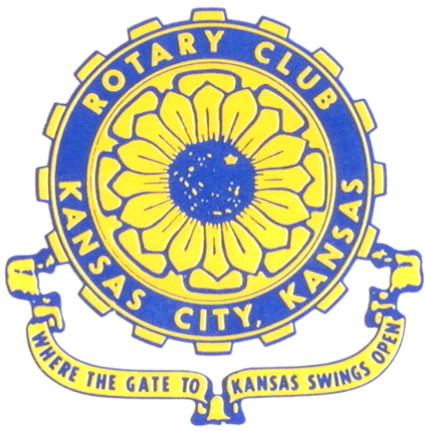
Where the Gate to Kansas Swings Open

The Kansas City, Kansas Rotary Club was organized on November 2, 1915 and received its charter as Club No. 195 in January 1916. Its members take pride in more than 100 years of Rotary service to the community and to international fellowship. From this Club have come five District Governors and two Directors of Rotary International. The Club’s history is as rich as that of the community it represents.

Following the Lewis and Clark expedition which camped at the confluence of the Kansas and Missouri rivers on June 26, 1804, in present day Kansas City, Kansas, this area became an important center for fur trappers. In the following years, many Indian tribes were relocated here from the East. In 1842 the Wyandot Indians acquired land here and founded a town. During this period, and for the next five decades, this area became the main gateway to the inviting majesty of the sprawling Kansas Prairie and the American West. This was where the frontier began. Pioneers found river transportation, outfitters and the beginning of the Santa Fe and Oregon Trails. After the covered wagons came major trunk railroads and barge lines.

In 1886, Kansas City, Kansas received its charter as an incorporated city, combining the towns of Wyandot, Argentine and Armourdale. (Rosedale was added in 1922.) Kansas City, Kansas is the site of the first industrial park in the United States, home of the prestigious University of Kansas Medical Center, and the location of the National Agricultural Hall of Fame and the nationally recognized Kansas Speedway.

Near the geographical and population centers of the contiguous United States, it is in the temperate latitudes at an elevation of 726 feet above sea level. The average rainfall is 35 inches. The average mean temperature ranges from 30°F in January to 80°F in July. The lowest recorded temperature was -23°F on December 23, 1989, and the highest was 113°F on August 14, 1936. Our city’s population of 145,000 and 155 square miles rank it 158th among cities in the United States.

Welcome to Kansas City, Kansas Rotary, and the vibrant community it represents.

Service Above Self

Rotary Websites:
KCK Club: www.rotarydowntownkck.org, District: www.rotary5710.org, International: www.rotary.org

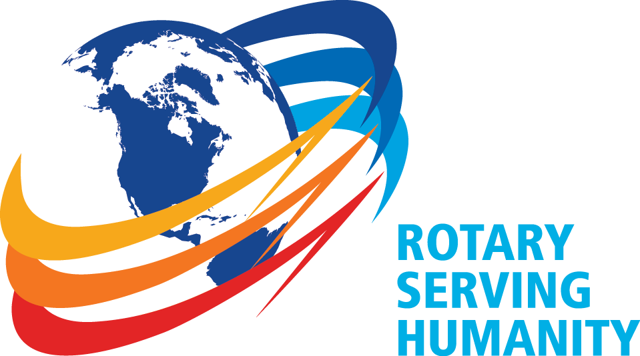

WHERE NEARBY TO MAKE UP ATTENDANCE
MONDAY
Bonner Springs (11:45am) --------------------------------- Twister Bar & Grill, 13100 Kansas Ave.
Overland Park (11:30am) ----------------------------------- Doubletree Hotel, 10100 College Blvd.
TUESDAY
Gladstone (7:00am) -------------------------------------- Fairview Christian Church, 1800 N.E. 65th
Johnson County-Sunset (5:15pm) ------------------------- Hilton Garden Inn Olathe, 119th & I-35
WEDNESDAY
Overland Park South (7:15am) ------------------------ Deer Creek Country Club, 7000 W. 133rd
Leavenworth (Noon) --------------------------- Riverfront Community Center, 123 S. Esplanade
KCI, Missouri (Noon) -------------------------------- KCI Expo Center, 11730 N. Ambassador Dr.
Shawnee Mission (Noon) ----------------------------- Sylvester Powell Center, Martway & Lamar
Olathe (Noon) ------------------------------ Mahaffie/Heritage Center, 1200 E. Kansas City Road
Kansas City South, Missouri (Noon) ----------------------------- EBT, 1310 Carondolet, 2nd Floor
THURSDAY
South Platte, Missouri (7:00am) ----------------------- Trezo Mare, 4105 Mulberry Drive, KCMO
Johnson County (7:15am) --------------------------- Crowne Plaza Hotel, 12601 W. 95th, Lenexa
Leawood (7:15am) ---------------------------------- Hallbrook Country Club, 11200 Overbrook Rd
Village West (7:15am) -------------------------- Dave & Buster’s, 1843 Village West Pkwy., KCK
Gardner (7:30am) ---------------------------------------------------- Senior Citizen Bldg., 128 E. Park
Olathe Santa Fe Trail (7:30am) --- Mid-Am Nazarene U, 2030 E. College Way, Campus Ctr.
Kansas City, Missouri (Noon) -------------------------------- The Gallery, 61 E. 14th Street, KCMO
FRIDAY
Desoto (7:00am) ------------------------ Desoto United Methodist Church, 8760 Kill Creek Road
Shawnee (7:15am) --------------------------------------------------- Town Hall, 11600 Johnson Drive
Plaza, Missouri (7:15am) -------------------------------- Intercontinental Hotel, 401 Ward Parkway
North Kansas City, Missouri (Noon) ------------------------------ NKC Library, 2251 Howell Street
Parkville, Missouri (Noon) ------------------------ Park University Underground, Woodard Center
Lenexa (Noon) ------------------------------- Lakeview Village, Northpointe Bldg., 91st & Park St.

Meeting make ups can be made 14 days before or after the missed meeting.
Please see the Secretary for the world directory of all Rotary Club’s meeting times, days and places.

2016-2017 Board of Directors
Officers Directors
Ashley Adorante Rick Behrens
President Karole Bradford
Fred Zimmerman John Freshnock
Vice President Phil Gibbs
Greg Shondell Wendell Maddox
Treasurer Melissa Mundt
Jim Knight Bruce Schlosser
Secretary Donna Severance
Rosemary Podrebarac Fred Zimmerman
Sergeant at Arms
Hank Chamberlain
Past President

