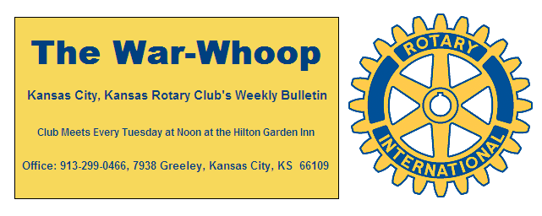
Websites: Club: www.rotarydowntownkck.org, District: www.rotary5710.org, International: www.rotary.org

Volume 78 May 12, 2017 No. 44

PROGRAM LAST WEEK- Laura Loveless, Director of the local library talked about the value of the library to the community in Wyandotte County. When we say the word library, we think books, books and more books, but it means much more to our community. Sometimes it may provide shelter from the heat and the cold. They provide computer classes from begin-ners to advance classes. These classes are free to the public.They also provide data and basises for many programs. They are now providing books library materials at local bus stops. Activities are provided for both youth and adults. They now have a Kansas Libray on the second floor of the main facility. Local high school year books are included on the same floor. There are first run movies provided at all the facilities during the week.
The library system is supported by the local and county governments and is responsible to them.

President Ashley opened the meeting and Karole Bradford gave the invocation. Frank Simonich led the singing and Scott Martens introduced the visitors.

OUR ROAMING ROTARIANS
Overland Park, Ks------------------------------Andrea Spalding
District Conference---------------------------- Greg Shondell
Hank Chamblain

PROGRAM NEXT WEEK- Rob Richardson Director of Planning for the United Government will be the speaker next week.

Pat Crilly is the program chairman for the day and for the month of May.

PAUL HARRIS DRAWING- Bruce Schlosser won the right to draw the joker and he drew the joker on the second draw. Bruce won half of the $285.00 pot. The other half will go to the Rotary Foundation.

BOOK PROJECT- The date of the book project has been changed to Thursday, May 18th. The change was made at the request of the school district so that kids will have an opportunity to pick up the books before school is over. President Ashley will attend a training session at 9:00am next Tuesday and then will hold a short training session with our members after our luncheon next Tuesday, May16th. Again, the book project will be held at the KCKCC Tech Center at 65th and State avenue. A luncheon will be provided at 12:00 and the book exchange will start at 1:00pm.

ROSTER PAGES- Each year we update our roster pages. If YOU have any changes on your personal page please let the secretary know, in writing. Greg Shondell will be able to take pictures on Tuesdays, May 16th and 30th. Pictures will be taken before the luncheon on these days. Once corrections are made they are taken to the printer.

VACATION-Our song leader, Scott Kaufmann, and his wife are on two trips this week. They went to Florida to watch the graduation of Lily and then driving her car back to Kansas City and then flying to New York to watch Lily perform there. Busy week, but a fun week, with their daughter.

DUES ARE NOW DUE- The fourth quarter dues are now past due. If YOU have any questions about your dues statement, check with the secretary.

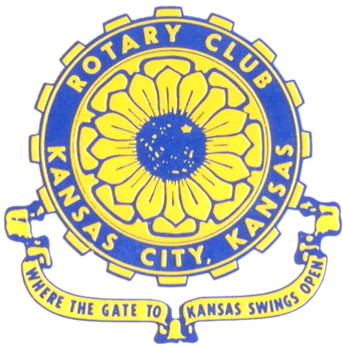
Where the Gate to Kansas Swings Open

The Kansas City, Kansas Rotary Club was organized on November 2, 1915 and received its charter as Club No. 195 in January 1916. Its members take pride in more than 100 years of Rotary service to the community and to international fellowship. From this Club have come five District Governors and two Directors of Rotary International. The Club’s history is as rich as that of the community it represents.

Following the Lewis and Clark expedition which camped at the confluence of the Kansas and Missouri rivers on June 26, 1804, in present day Kansas City, Kansas, this area became an important center for fur trappers. In the following years, many Indian tribes were relocated here from the East. In 1842 the Wyandot Indians acquired land here and founded a town. During this period, and for the next five decades, this area became the main gateway to the inviting majesty of the sprawling Kansas Prairie and the American West. This was where the frontier began. Pioneers found river transportation, outfitters and the beginning of the Santa Fe and Oregon Trails. After the covered wagons came major trunk railroads and barge lines.

In 1886, Kansas City, Kansas received its charter as an incorporated city, combining the towns of Wyandot, Argentine and Armourdale. (Rosedale was added in 1922.) Kansas City, Kansas is the site of the first industrial park in the United States, home of the prestigious University of Kansas Medical Center, and the location of the National Agricultural Hall of Fame and the nationally recognized Kansas Speedway.

Near the geographical and population centers of the contiguous United States, it is in the temperate latitudes at an elevation of 726 feet above sea level. The average rainfall is 35 inches. The average mean temperature ranges from 30°F in January to 80°F in July. The lowest recorded temperature was -23°F on December 23, 1989, and the highest was 113°F on August 14, 1936. Our city’s population of 145,000 and 155 square miles rank it 158th among cities in the United States.

Welcome to Kansas City, Kansas Rotary, and the vibrant community it represents.

Service Above Self

Rotary Websites:
KCK Club: www.rotarydowntownkck.org, District: www.rotary5710.org, International: www.rotary.org



WHERE NEARBY TO MAKE UP ATTENDANCE
MONDAY
Bonner Springs (11:45am) --------------------------------- Twister Bar & Grill, 13100 Kansas Ave.
Overland Park (11:30am) ----------------------------------- Doubletree Hotel, 10100 College Blvd.
TUESDAY
Gladstone (7:00am) -------------------------------------- Fairview Christian Church, 1800 N.E. 65th
Johnson County-Sunset (5:15pm) ------------------------- Hilton Garden Inn Olathe, 119th & I-35
WEDNESDAY
Overland Park South (7:15am) ------------------------ Deer Creek Country Club, 7000 W. 133rd
Leavenworth (Noon) --------------------------- Riverfront Community Center, 123 S. Esplanade
KCI, Missouri (Noon) -------------------------------- KCI Expo Center, 11730 N. Ambassador Dr.
Shawnee Mission (Noon) ----------------------------- Sylvester Powell Center, Martway & Lamar
Olathe (Noon) ------------------------------ Mahaffie/Heritage Center, 1200 E. Kansas City Road
Kansas City South, Missouri (Noon) ----------------------------- EBT, 1310 Carondolet, 2nd Floor
THURSDAY
South Platte, Missouri (7:00am) ----------------------- Trezo Mare, 4105 Mulberry Drive, KCMO
Johnson County (7:15am) --------------------------- Crowne Plaza Hotel, 12601 W. 95th, Lenexa
Leawood (7:15am) ---------------------------------- Hallbrook Country Club, 11200 Overbrook Rd
Village West (7:15am) -------------------------- Dave & Buster’s, 1843 Village West Pkwy., KCK
Gardner (7:30am) ---------------------------------------------------- Senior Citizen Bldg., 128 E. Park
Olathe Santa Fe Trail (7:30am) --- Mid-Am Nazarene U, 2030 E. College Way, Campus Ctr.
Kansas City, Missouri (Noon) -------------------------------- The Gallery, 61 E. 14th Street, KCMO
FRIDAY
Desoto (7:00am) ------------------------ Desoto United Methodist Church, 8760 Kill Creek Road
Shawnee (7:15am) --------------------------------------------------- Town Hall, 11600 Johnson Drive
Plaza, Missouri (7:15am) -------------------------------- Intercontinental Hotel, 401 Ward Parkway
North Kansas City, Missouri (Noon) ------------------------------ NKC Library, 2251 Howell Street
Parkville, Missouri (Noon) ------------------------ Park University Underground, Woodard Center
Lenexa (Noon) ------------------------------- Lakeview Village, Northpointe Bldg., 91st & Park St.

Meeting make ups can be made 14 days before or after the missed meeting.
Please see the Secretary for the world directory of all Rotary Club’s meeting times, days and places.

2016-2017 Board of Directors
Officers Directors
Ashley Adorante Rick Behrens
President Karole Bradford
Fred Zimmerman John Freshnock
Vice President Phil Gibbs
Greg Shondell Wendell Maddox
Treasurer Melissa Mundt
Jim Knight Bruce Schlosser
Secretary Donna Severance
Rosemary Podrebarac Fred Zimmerman
Sergeant at Arms
Hank Chamberlain
Past President

