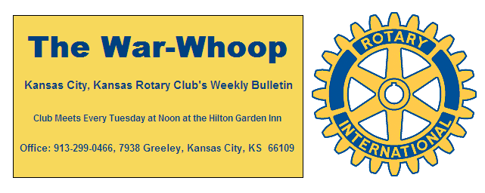
Websites: Club: www.rotarydowntownkck.org, District: www.rotary5710.org, International: www.rotary.org

Volume 78 May 19, 2017 No. 45

PROGRAM LAST WEEK- Rob Richardson Director of Planning for the United Government talked about all the planning projects that are in the process of building or are going to be built in our city. He touched on many projects in different areas of the city. He Talked about the new Amazon building that should open this month. He also talked about a new industrial building by General Motors that is almost completed. He went on to say that the new soccer fields will bring in 120-150 coaches into the area each week. A new hotel in being built west of Walmart. A medial building is being built in the Legends area. Individual housing starts have increased. He also added that a major announcement should be made soon about a new healthy campus in the downtown area. He was asked many questions after his presentation. Questions asked were about:
**Competition for catering at the Convention Center?
** What is happening at the Indian Springs property?
**Question about the lack of knowledge with Building modification.
** The high cost of real estate taxes in the county. Mr. Richardson told members that taxes were lowered, but property values were raised.

President Ashley opened the meeting and Karen Hostetler
gave the invocation. Scott Kaufmann led the singing and Margaret Steele introduced the visitors. President Ashley had three new interns that will be working with her for several months. Mary Viveros has a visitor from District 500.

PROGRAM NEXT WEEK- Kate Fields, Executive Director of the Humane Society, will be our speaker next week. Kate is the daughter of a former longtime Rotarian, Pete Fields.

Pat Crilly is the program chairman for the day and for the month of May.

FIFTH TUESDAY- There is a fifth Tuesday this month and Dan Duncan is busy planning for this month’s “Social”.

PAUL HARRIS DRAWING- Merle Parks won the right to draw for the joker last week. Merle did not draw the joker and the amount will go to $12.00 for next week. President Ashley presented Bruce Schlosser with a check for $142.50 for winning last week.

ROSTER PAGES-The secretary reminded all the new members to have their pictures taken last Tuesday. He did forget to remind the photographer, so we have changed the date the first Tuesday in June 7th to have the pictures taken. If any member has a photo, they can email or bring the picture to the secretary. Please check your page for any corrections and give them (in writing) to the secretary.

OUR ROAMING ROTARIAN
Fiji, Suva------------------------------------------------Dan Duncan
Dan and his wife, Lee Ann, were on vacation in Fiji visiting their son who is on duty there.

CONGRATULATIONS- To Melissa Mundt on her recent marriage to Darren Sieben. A great picture of Melissa and Darren is on her Facebook page.

2017-18 PROGRAMS-Program chairman for the year, John Freshnock, announced that the month of September is the only month without a chair. Help out and volunteer, maybe two members could get together and share the month.

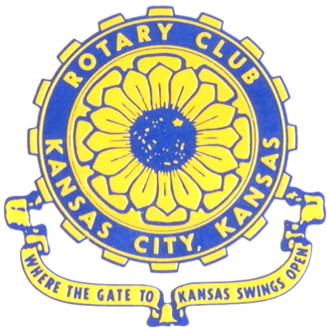
Where the Gate to Kansas Swings Open

The Kansas City, Kansas Rotary Club was organized on November 2, 1915 and received its charter as Club No. 195 in January 1916. Its members take pride in more than 100 years of Rotary service to the community and to international fellowship. From this Club have come five District Governors and two Directors of Rotary International. The Club’s history is as rich as that of the community it represents.

Following the Lewis and Clark expedition which camped at the confluence of the Kansas and Missouri rivers on June 26, 1804, in present day Kansas City, Kansas, this area became an important center for fur trappers. In the following years, many Indian tribes were relocated here from the East. In 1842 the Wyandot Indians acquired land here and founded a town. During this period, and for the next five decades, this area became the main gateway to the inviting majesty of the sprawling Kansas Prairie and the American West. This was where the frontier began. Pioneers found river transportation, outfitters and the beginning of the Santa Fe and Oregon Trails. After the covered wagons came major trunk railroads and barge lines.

In 1886, Kansas City, Kansas received its charter as an incorporated city, combining the towns of Wyandot, Argentine and Armourdale. (Rosedale was added in 1922.) Kansas City, Kansas is the site of the first industrial park in the United States, home of the prestigious University of Kansas Medical Center, and the location of the National Agricultural Hall of Fame and the nationally recognized Kansas Speedway.

Near the geographical and population centers of the contiguous United States, it is in the temperate latitudes at an elevation of 726 feet above sea level. The average rainfall is 35 inches. The average mean temperature ranges from 30°F in January to 80°F in July. The lowest recorded temperature was -23°F on December 23, 1989, and the highest was 113°F on August 14, 1936. Our city’s population of 145,000 and 155 square miles rank it 158th among cities in the United States.

Welcome to Kansas City, Kansas Rotary, and the vibrant community it represents.

Service Above Self

Rotary Websites:
KCK Club: www.rotarydowntownkck.org, District: www.rotary5710.org, International: www.rotary.org



WHERE NEARBY TO MAKE UP ATTENDANCE
MONDAY
Bonner Springs (11:45am) --------------------------------- Twister Bar & Grill, 13100 Kansas Ave.
Overland Park (11:30am) ----------------------------------- Doubletree Hotel, 10100 College Blvd.
TUESDAY
Gladstone (7:00am) -------------------------------------- Fairview Christian Church, 1800 N.E. 65th
Johnson County-Sunset (5:15pm) ------------------------- Hilton Garden Inn Olathe, 119th & I-35
WEDNESDAY
Overland Park South (7:15am) ------------------------ Deer Creek Country Club, 7000 W. 133rd
Leavenworth (Noon) --------------------------- Riverfront Community Center, 123 S. Esplanade
KCI, Missouri (Noon) -------------------------------- KCI Expo Center, 11730 N. Ambassador Dr.
Shawnee Mission (Noon) ----------------------------- Sylvester Powell Center, Martway & Lamar
Olathe (Noon) ------------------------------ Mahaffie/Heritage Center, 1200 E. Kansas City Road
Kansas City South, Missouri (Noon) ----------------------------- EBT, 1310 Carondolet, 2nd Floor
THURSDAY
South Platte, Missouri (7:00am) ----------------------- Trezo Mare, 4105 Mulberry Drive, KCMO
Johnson County (7:15am) --------------------------- Crowne Plaza Hotel, 12601 W. 95th, Lenexa
Leawood (7:15am) ---------------------------------- Hallbrook Country Club, 11200 Overbrook Rd
Village West (7:15am) -------------------------- Dave & Buster’s, 1843 Village West Pkwy., KCK
Gardner (7:30am) ---------------------------------------------------- Senior Citizen Bldg., 128 E. Park
Olathe Santa Fe Trail (7:30am) --- Mid-Am Nazarene U, 2030 E. College Way, Campus Ctr.
Kansas City, Missouri (Noon) -------------------------------- The Gallery, 61 E. 14th Street, KCMO
FRIDAY
Desoto (7:00am) ------------------------ Desoto United Methodist Church, 8760 Kill Creek Road
Shawnee (7:15am) --------------------------------------------------- Town Hall, 11600 Johnson Drive
Plaza, Missouri (7:15am) -------------------------------- Intercontinental Hotel, 401 Ward Parkway
North Kansas City, Missouri (Noon) ------------------------------ NKC Library, 2251 Howell Street
Parkville, Missouri (Noon) ------------------------ Park University Underground, Woodard Center
Lenexa (Noon) ------------------------------- Lakeview Village, Northpointe Bldg., 91st & Park St.

Meeting make ups can be made 14 days before or after the missed meeting.
Please see the Secretary for the world directory of all Rotary Club’s meeting times, days and places.

2016-2017 Board of Directors
Officers Directors
Ashley Adorante Rick Behrens
President Karole Bradford
Fred Zimmerman John Freshnock
Vice President Phil Gibbs
Greg Shondell Wendell Maddox
Treasurer Melissa Mundt
Jim Knight Bruce Schlosser
Secretary Donna Severance
Rosemary Podrebarac Fred Zimmerman
Sergeant at Arms
Hank Chamberlain
Past President

