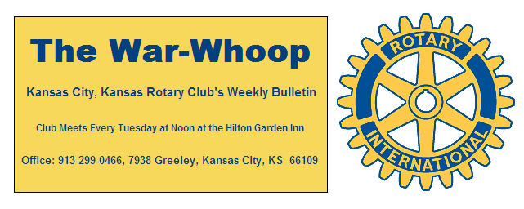

**Websites: Club:** [**www.rotarydowntownkck.org**](http://www.rotarydowntownkck.org)**, District:** [**www.rotary5710.org**](http://www.rotary5710.org)**, International:** [**www.rotary.org**](http://www.rotary.org)

**Volume 78 June 2, 2017 No. 47**

**PROGRAM LAST –** Twenty one members and six spouses enjoyed a fun evening at the Taquero Mexico Restaruant. A lot of Mexican food was eaten during the evening as members ordered their favorite dishes. They also celebrated the 84th birthday of Secretary **Jim**. He had his picture taken with a hugh sombero. This was the first time in many years that **Jim** was in town for his birthday, since this is the week that he and his fishing buddies usually spent the week at Bennett Springs.

**COMING EVENTS-** There are two fun events bing planned for the last part of June. Incoming President **Fred Zimmerman** has scheduled the **Inaugration Dinner for June 27th**. Chair **Dan** **Duncan** has scheduled our annual basebll night at the **T Bones** **game on June 20th**. Please mark your calendars for these events.

**The cost for the T Bones game will be $11.00 per ticket**. This will include a tailgate picnic prior to the game. This would be a great night to bring a guest.

**OUR ROAMING ROTARIANS**

Johnson County Sunset --------------------------**Dave Skidgel**

Dunedin Waterside, Florida---------------------**Greg Shondell**

**Dave Skidgel** made up early as he in on his way to Belgium and France.

**BOARD MEETING** is scheduled for Wednesday, June 7th.

**NEXT WEEK AT ROTARY- Melissa Mundt,** has planned the program for next week. She will try to bring the Parks and Recreational Director for the Unified Government this week.

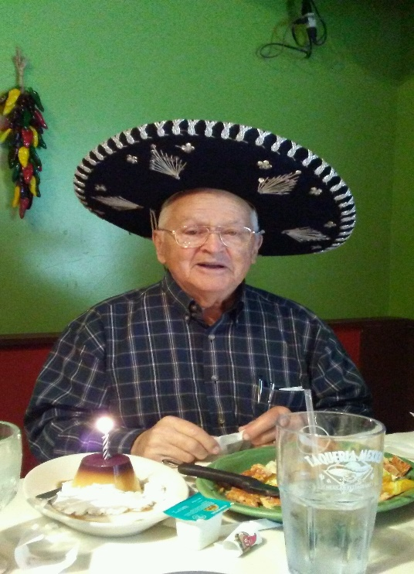

**Secretary Jim’s 84th birthday**

**ROSTER PAGES-** Another reminder that members check their pages in the roster book to make sure that all the information is correct. New members and members wanting to update their pictures will be able to have their pictures taken on **Tuesday, June 6th prior to the regular luncheon meeting. Changes include retirement from business, telephone numbers, email, and addresses.** Secretary will leave page as is if he does not hear from a member. Members might want to include their cell numbers at this time.

If new members have a picture of themselves, please send the picture to the secretary or bring it to Rotary. It will be returned as soon as the printer is finished.

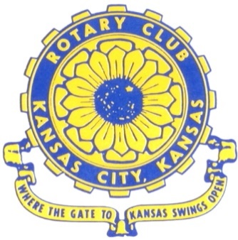

**Where the Gate to Kansas Swings Open**

The Kansas City, Kansas Rotary Club was organized on November 2, 1915 and received its charter as Club No. 195 in January 1916. Its members take pride in more than 100 years of Rotary service to the community and to international fellowship. From this Club have come five District Governors and two Directors of Rotary International. The Club’s history is as rich as that of the community it represents.

Following the Lewis and Clark expedition which camped at the confluence of the Kansas and Missouri rivers on June 26, 1804, in present day Kansas City, Kansas, this area became an important center for fur trappers. In the following years, many Indian tribes were relocated here from the East. In 1842 the Wyandot Indians acquired land here and founded a town. During this period, and for the next five decades, this area became the main gateway to the inviting majesty of the sprawling Kansas Prairie and the American West. This was where the frontier began. Pioneers found river transportation, outfitters and the beginning of the Santa Fe and Oregon Trails. After the covered wagons came major trunk railroads and barge lines.

In 1886, Kansas City, Kansas received its charter as an incorporated city, combining the towns of Wyandot, Argentine and Armourdale. (Rosedale was added in 1922.) Kansas City, Kansas is the site of the first industrial park in the United States, home of the prestigious University of Kansas Medical Center, and the location of the National Agricultural Hall of Fame and the nationally recognized Kansas Speedway.

Near the geographical and population centers of the contiguous United States, it is in the temperate latitudes at an elevation of 726 feet above sea level. The average rainfall is 35 inches. The average mean temperature ranges from 30°F in January to 80°F in July. The lowest recorded temperature was -23°F on December 23, 1989, and the highest was 113°F on August 14, 1936. Our city’s population of 145,000 and 155 square miles rank it 158th among cities in the United States.

Welcome to Kansas City, Kansas Rotary, and the vibrant community it represents.

*Service Above Self*

**Rotary Websites:**

**KCK Club:** [**www.rotarydowntownkck.org**](http://www.rotarydowntownkck.org)**, District:** [**www.rotary5710.org**](http://www.rotary5710.org)**, International:** [**www.rotary.org**](http://www.rotary.org)



**WHERE NEARBY TO MAKE UP ATTENDANCE**

MONDAY

Bonner Springs (11:45am) --------------------------------- Twister Bar & Grill, 13100 Kansas Ave.

Overland Park (11:30am) ----------------------------------- Doubletree Hotel, 10100 College Blvd.

TUESDAY

Gladstone (7:00am) -------------------------------------- Fairview Christian Church, 1800 N.E. 65th

Johnson County-Sunset (5:15pm) ------------------------- Hilton Garden Inn Olathe, 119th & I-35

WEDNESDAY

Overland Park South (7:15am) ------------------------ Deer Creek Country Club, 7000 W. 133rd

Leavenworth (Noon) --------------------------- Riverfront Community Center, 123 S. Esplanade

KCI, Missouri (Noon) -------------------------------- KCI Expo Center, 11730 N. Ambassador Dr.

Shawnee Mission (Noon) ----------------------------- Sylvester Powell Center, Martway & Lamar

Olathe (Noon) ------------------------------ Mahaffie/Heritage Center, 1200 E. Kansas City Road

Kansas City South, Missouri (Noon) ----------------------------- EBT, 1310 Carondolet, 2nd Floor

THURSDAY

South Platte, Missouri (7:00am) ----------------------- Trezo Mare, 4105 Mulberry Drive, KCMO

Johnson County (7:15am) --------------------------- Crowne Plaza Hotel, 12601 W. 95th, Lenexa

Leawood (7:15am) ---------------------------------- Hallbrook Country Club, 11200 Overbrook Rd

Village West (7:15am) -------------------------- Dave & Buster’s, 1843 Village West Pkwy., KCK

Gardner (7:30am) ---------------------------------------------------- Senior Citizen Bldg., 128 E. Park

Olathe Santa Fe Trail (7:30am) --- Mid-Am Nazarene U, 2030 E. College Way, Campus Ctr.

Kansas City, Missouri (Noon) -------------------------------- The Gallery, 61 E. 14th Street, KCMO

FRIDAY

Desoto (7:00am) ------------------------ Desoto United Methodist Church, 8760 Kill Creek Road

Shawnee (7:15am) --------------------------------------------------- Town Hall, 11600 Johnson Drive

Plaza, Missouri (7:15am) -------------------------------- Intercontinental Hotel, 401 Ward Parkway

North Kansas City, Missouri (Noon) ------------------------------ NKC Library, 2251 Howell Street

Parkville, Missouri (Noon) ------------------------ Park University Underground, Woodard Center

Lenexa (Noon) ------------------------------- Lakeview Village, Northpointe Bldg., 91st & Park St.

Meeting make ups can be made 14 days before or after the missed meeting.

Please see the Secretary for the world directory of all Rotary Club’s meeting times, days and places.

**2016-2017 Board of Directors**

***Officers*** ***Directors***

Ashley Adorante Rick Behrens

President Karole Bradford

Fred Zimmerman John Freshnock

Vice President Phil Gibbs

Greg Shondell Wendell Maddox

Treasurer Melissa Mundt

Jim Knight Bruce Schlosser

Secretary Donna Severance

Rosemary Podrebarac Fred Zimmerman

Sergeant at Arms

Hank Chamberlain

Past President