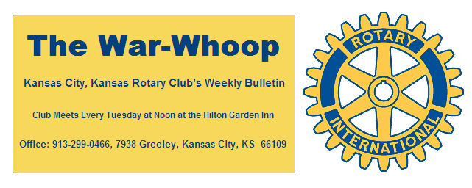
Websites: Club: www.rotarydowntownkck.org, District: www.rotary5710.org, International: www.rotary.org

Volume 78 June 9, 2017 No. 48

PROGRAM LAST WEEK-Jeremy Rogers, Director of Parks and Recreation for the United Government showed a slide presentation on the master plan for the department. According to Rogers, “Everything in our system needs updating”. There is a need for trails, shelters, playgrounds, tables and indoor facilties to name a few additons to the park system. He went on to say that the park system has been negelected for many years.
He gave a little history of the local park’s system. A local man, George Kessler was instrumental in setting up the National Park System. In the beginning there were 7 or 8 Swimming pools and now we are down to one. These pools were used for baptisms, swimming and fishing derbys in the early days.
The department has did a survey that included over 10,000 people to find out what the public wants. The western part of Wyandotte County, with the excepton of the County lake, is not served very well. The county has some parks that do not have any entrances. During the survey, they found that citizens would not be opposed to use sales taxes or pay user fees to upgrade the system.
In 2009 there were 142 staff members and now there are half that many and they are doing a more efficient job. He added that some of the staffers have been on staff for many years and they need to be replaced when they retire. He answered many questions after his presentation.

President Ashley opened the meeting and Daniel Silva gave the invocation. Frank Simonich led the singing and Karole Bradford introduced the visitors for the day.

NEXT WEEK AT ROTARY- Phil Dixon, free lance writer in the area, will talk about the Negro Museum.

Dan Duncan is the program chairman for the day.

PAUL HARRIS DRAWING- Wendell Maddox won the right to draw for the joker last week. Wendell did not draw the joker and the amount will go to $29.00 for next week’s drawing.

HAPPY BIRTHDAY- Frank led members in singing’” Happy Bithday” to Wendell Maddox and Greg Shondell.

KANSAS CITY DAY- President Ashley presented Andrea Speere, staff member with the Rosedale Development Association, with a check for $363.33 to help send day campers to their local Camp Wildwood. The other half of our monies raised on Kansas City Day will go to the Boy Scouts in the coming week. Monies raised on Kansas City Day is split with each Rotary Club and with the Rotary Youth Camp.

T BONES BASEBALL GAME- The annual night out at the T Bones game will be held on Tuesday, June 20th. The evening will include a tailgating party prior to the game at 5:30pm and then the game at 7;00pm. There will be hamburgers, hot dogs, chips, potato salad and pop and all the trimmings. This is always a fun evening for all members and a great time to bring a guests. If you didn’t make a reservation last Tuesday please call Dan Duncan at 816-223-3863 or Jim Knight at 913-299-0466. Cost of the is $11.00 per person and members will be billed on their quarterly statement.

INSTALLATION DINNER- The Installation Dinner is scheduled for Tuesday, June 27th in the Eisenhower Room at the Hilton Garden Inn. The cost will be $30.00 per person and members will receive a $13.00 credit towards the dinner event. This is always a fun event, so mark the date on your calendars.

LEVEE FEST- There will be a celebration of food, fun and family activities on the Armourdale Levee Trail on Saturday, June 10th from 11:00am- 2:00pm. The trail starts just west of 18th Street below the Kansas Ave bridge near Proctor and Gamble. There will be signs.
For details call (913) 321-9622 ext 305.

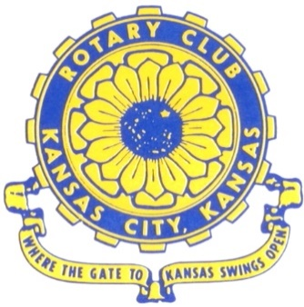
Where the Gate to Kansas Swings Open

The Kansas City, Kansas Rotary Club was organized on November 2, 1915 and received its charter as Club No. 195 in January 1916. Its members take pride in more than 100 years of Rotary service to the community and to international fellowship. From this Club have come five District Governors and two Directors of Rotary International. The Club’s history is as rich as that of the community it represents.

Following the Lewis and Clark expedition which camped at the confluence of the Kansas and Missouri rivers on June 26, 1804, in present day Kansas City, Kansas, this area became an important center for fur trappers. In the following years, many Indian tribes were relocated here from the East. In 1842 the Wyandot Indians acquired land here and founded a town. During this period, and for the next five decades, this area became the main gateway to the inviting majesty of the sprawling Kansas Prairie and the American West. This was where the frontier began. Pioneers found river transportation, outfitters and the beginning of the Santa Fe and Oregon Trails. After the covered wagons came major trunk railroads and barge lines.

In 1886, Kansas City, Kansas received its charter as an incorporated city, combining the towns of Wyandot, Argentine and Armourdale. (Rosedale was added in 1922.) Kansas City, Kansas is the site of the first industrial park in the United States, home of the prestigious University of Kansas Medical Center, and the location of the National Agricultural Hall of Fame and the nationally recognized Kansas Speedway.

Near the geographical and population centers of the contiguous United States, it is in the temperate latitudes at an elevation of 726 feet above sea level. The average rainfall is 35 inches. The average mean temperature ranges from 30°F in January to 80°F in July. The lowest recorded temperature was -23°F on December 23, 1989, and the highest was 113°F on August 14, 1936. Our city’s population of 145,000 and 155 square miles rank it 158th among cities in the United States.

Welcome to Kansas City, Kansas Rotary, and the vibrant community it represents.

Service Above Self

Rotary Websites:
KCK Club: www.rotarydowntownkck.org, District: www.rotary5710.org, International: www.rotary.org

WHERE NEARBY TO MAKE UP ATTENDANCE
MONDAY
Bonner Springs (11:45am) --------------------------------- Twister Bar & Grill, 13100 Kansas Ave.
Overland Park (11:30am) ----------------------------------- Doubletree Hotel, 10100 College Blvd.
TUESDAY
Gladstone (7:00am) -------------------------------------- Fairview Christian Church, 1800 N.E. 65th
Johnson County-Sunset (5:15pm) ------------------------- Hilton Garden Inn Olathe, 119th & I-35
WEDNESDAY
Overland Park South (7:15am) ------------------------ Deer Creek Country Club, 7000 W. 133rd
Leavenworth (Noon) --------------------------- Riverfront Community Center, 123 S. Esplanade
KCI, Missouri (Noon) -------------------------------- KCI Expo Center, 11730 N. Ambassador Dr.
Shawnee Mission (Noon) ----------------------------- Sylvester Powell Center, Martway & Lamar
Olathe (Noon) ------------------------------ Mahaffie/Heritage Center, 1200 E. Kansas City Road
Kansas City South, Missouri (Noon) ----------------------------- EBT, 1310 Carondolet, 2nd Floor
THURSDAY
South Platte, Missouri (7:00am) ----------------------- Trezo Mare, 4105 Mulberry Drive, KCMO
Johnson County (7:15am) --------------------------- Crowne Plaza Hotel, 12601 W. 95th, Lenexa
Leawood (7:15am) ---------------------------------- Hallbrook Country Club, 11200 Overbrook Rd
Village West (7:15am) -------------------------- Dave & Buster’s, 1843 Village West Pkwy., KCK
Gardner (7:30am) ---------------------------------------------------- Senior Citizen Bldg., 128 E. Park
Olathe Santa Fe Trail (7:30am) --- Mid-Am Nazarene U, 2030 E. College Way, Campus Ctr.
Kansas City, Missouri (Noon) -------------------------------- The Gallery, 61 E. 14th Street, KCMO
FRIDAY
Desoto (7:00am) ------------------------ Desoto United Methodist Church, 8760 Kill Creek Road
Shawnee (7:15am) --------------------------------------------------- Town Hall, 11600 Johnson Drive
Plaza, Missouri (7:15am) -------------------------------- Intercontinental Hotel, 401 Ward Parkway
North Kansas City, Missouri (Noon) ------------------------------ NKC Library, 2251 Howell Street
Parkville, Missouri (Noon) ------------------------ Park University Underground, Woodard Center
Lenexa (Noon) ------------------------------- Lakeview Village, Northpointe Bldg., 91st & Park St.

Meeting make ups can be made 14 days before or after the missed meeting.
Please see the Secretary for the world directory of all Rotary Club’s meeting times, days and places.

2016-2017 Board of Directors
Officers Directors
Ashley Adorante Rick Behrens
President Karole Bradford
Fred Zimmerman John Freshnock
Vice President Phil Gibbs
Greg Shondell Wendell Maddox
Treasurer Melissa Mundt
Jim Knight Bruce Schlosser
Secretary Donna Severance
Rosemary Podrebarac Fred Zimmerman
Sergeant at Arms
Hank Chamberlain
Past President

