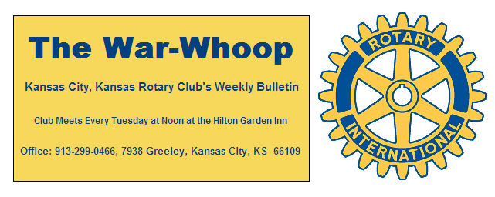
Websites: Club: www.rotarydowntownkck.org, District: www.rotary5710.org, International: www.rotary.org

Volume 78 June 16, 2017 No. 49

PROGRAM LAST WEEK- Phil Dixon, local sports writer, talked about the black history of baseball in Kansas City, Kansas, and he showed a power point progam on many of the players that played in the area. He talked about many of the baseball players that older members remembered. Dixon told members that he got into the baseball business due to his love of baseball. He went on to say that he became a collector of baseball cards at the age of nineteen and had 50,000 cards at that time.
He also told of a man by the name of J.L. Wilkerson who founded an all nations team. He wanted a team that had a diversity players. He also was one of the first people to try a portable lighting system during a game which was at Haskell Institute.
Some history points that he stated:
Monarchs baseball game played their first game in KCKs.
1971- One night game in the World Series
1985- All night games were played in the World Series

President Ashley opened the meeting and Fred Zimmerman gave the invocation. Scott Kaufmann led the singing and Pat Crilly introduced the visitors for the day.

OUR ROAMING ROTARIAN
Village West----------------------------------------Ashley Adorante

NEXT WEEK AT ROTARY- T-BONES BASEBALL GAME- The annual night out at the T Bones game will be held next Tuesday, June 20th. The evening will include a tailgating party prior to the game at 5:30pm and then the game at 7;00pm. There will be hamburgers, hot dogs, chips, potato salad, drinks and all the trimmings. This is always a fun evening for all members and a great time to bring a guests. If you didn’t make a reservation last Tuesday please call Dan Duncan at 816-223-3863 or Jim Knight at 913-299-0466. Cost is $11.00 per person and members will be billed on their quarterly statement. The tailgating will be held in the northwest corner of the parking lot.
Members not able to be at the evening event can sign in at noon at the hotel from 12:00 to 12:30pm.

INSTALLATION DINNER- The Installation Dinner set for Tuesday, June 27th in the Eisenhower Room at the Hilton Garden Inn. The cost will be $30.00 per person and members will receive a $13.00 credit towards the dinner event. The dinner will be a buffet. There will be an open bar available duirng the social hour starting at 6:00 pm and dinner at 7:00pm. The signup sheet did not get around to all the tables last Tuesday, so if a member did not signup PLEASE send an email to the secretary with your reservation. The email address is jknight26@ kc.rr.com or call Jim at 913-299-0466. It is important to make a reservation.
Members not able to be at the Installation Dinner can sign in at noon at the hotel from 12:00 to 12:30pm.

KANSAS CITY DAY- President Ashley presented Janell Neal, staff member with the local district of the Boy Scouts, with a check for $363.33 from Kansas City Day. Our club receives half of what is raised on Kansas City day. The other half of the funds raised goes to the Rotary Youth Camp operated by the Kansas City Rotary Club 13. Janell will soon be joining our Club. She was the secretary for the Raytown Rotary Club for several years.

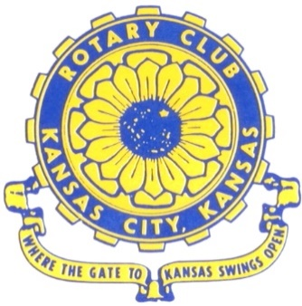
Where the Gate to Kansas Swings Open

The Kansas City, Kansas Rotary Club was organized on November 2, 1915 and received its charter as Club No. 195 in January 1916. Its members take pride in more than 100 years of Rotary service to the community and to international fellowship. From this Club have come five District Governors and two Directors of Rotary International. The Club’s history is as rich as that of the community it represents.

Following the Lewis and Clark expedition which camped at the confluence of the Kansas and Missouri rivers on June 26, 1804, in present day Kansas City, Kansas, this area became an important center for fur trappers. In the following years, many Indian tribes were relocated here from the East. In 1842 the Wyandot Indians acquired land here and founded a town. During this period, and for the next five decades, this area became the main gateway to the inviting majesty of the sprawling Kansas Prairie and the American West. This was where the frontier began. Pioneers found river transportation, outfitters and the beginning of the Santa Fe and Oregon Trails. After the covered wagons came major trunk railroads and barge lines.

In 1886, Kansas City, Kansas received its charter as an incorporated city, combining the towns of Wyandot, Argentine and Armourdale. (Rosedale was added in 1922.) Kansas City, Kansas is the site of the first industrial park in the United States, home of the prestigious University of Kansas Medical Center, and the location of the National Agricultural Hall of Fame and the nationally recognized Kansas Speedway.

Near the geographical and population centers of the contiguous United States, it is in the temperate latitudes at an elevation of 726 feet above sea level. The average rainfall is 35 inches. The average mean temperature ranges from 30°F in January to 80°F in July. The lowest recorded temperature was -23°F on December 23, 1989, and the highest was 113°F on August 14, 1936. Our city’s population of 145,000 and 155 square miles rank it 158th among cities in the United States.

Welcome to Kansas City, Kansas Rotary, and the vibrant community it represents.

Service Above Self

Rotary Websites:
KCK Club: www.rotarydowntownkck.org, District: www.rotary5710.org, International: www.rotary.org

WHERE NEARBY TO MAKE UP ATTENDANCE
MONDAY
Bonner Springs (11:45am) --------------------------------- Twister Bar & Grill, 13100 Kansas Ave.
Overland Park (11:30am) ----------------------------------- Doubletree Hotel, 10100 College Blvd.
TUESDAY
Gladstone (7:00am) -------------------------------------- Fairview Christian Church, 1800 N.E. 65th
Johnson County-Sunset (5:15pm) ------------------------- Hilton Garden Inn Olathe, 119th & I-35
WEDNESDAY
Overland Park South (7:15am) ------------------------ Deer Creek Country Club, 7000 W. 133rd
Leavenworth (Noon) --------------------------- Riverfront Community Center, 123 S. Esplanade
KCI, Missouri (Noon) -------------------------------- KCI Expo Center, 11730 N. Ambassador Dr.
Shawnee Mission (Noon) ----------------------------- Sylvester Powell Center, Martway & Lamar
Olathe (Noon) ------------------------------ Mahaffie/Heritage Center, 1200 E. Kansas City Road
Kansas City South, Missouri (Noon) ----------------------------- EBT, 1310 Carondolet, 2nd Floor
THURSDAY
South Platte, Missouri (7:00am) ----------------------- Trezo Mare, 4105 Mulberry Drive, KCMO
Johnson County (7:15am) --------------------------- Crowne Plaza Hotel, 12601 W. 95th, Lenexa
Leawood (7:15am) ---------------------------------- Hallbrook Country Club, 11200 Overbrook Rd
Village West (7:15am) -------------------------- Dave & Buster’s, 1843 Village West Pkwy., KCK
Gardner (7:30am) ---------------------------------------------------- Senior Citizen Bldg., 128 E. Park
Olathe Santa Fe Trail (7:30am) --- Mid-Am Nazarene U, 2030 E. College Way, Campus Ctr.
Kansas City, Missouri (Noon) -------------------------------- The Gallery, 61 E. 14th Street, KCMO
FRIDAY
Desoto (7:00am) ------------------------ Desoto United Methodist Church, 8760 Kill Creek Road
Shawnee (7:15am) --------------------------------------------------- Town Hall, 11600 Johnson Drive
Plaza, Missouri (7:15am) -------------------------------- Intercontinental Hotel, 401 Ward Parkway
North Kansas City, Missouri (Noon) ------------------------------ NKC Library, 2251 Howell Street
Parkville, Missouri (Noon) ------------------------ Park University Underground, Woodard Center
Lenexa (Noon) ------------------------------- Lakeview Village, Northpointe Bldg., 91st & Park St.

Meeting make ups can be made 14 days before or after the missed meeting.
Please see the Secretary for the world directory of all Rotary Club’s meeting times, days and places.

2016-2017 Board of Directors
Officers Directors
Ashley Adorante Rick Behrens
President Karole Bradford
Fred Zimmerman John Freshnock
Vice President Phil Gibbs
Greg Shondell Wendell Maddox
Treasurer Melissa Mundt
Jim Knight Bruce Schlosser
Secretary Donna Severance
Rosemary Podrebarac Fred Zimmerman
Sergeant at Arms
Hank Chamberlain
Past President

