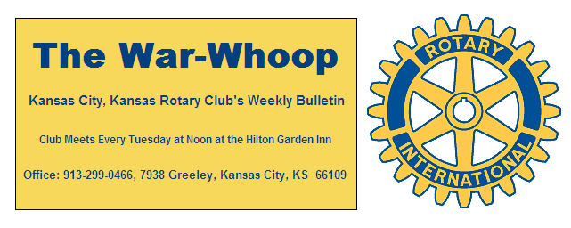
Websites: Club: www.rotarydowntownkck.org, District: www.rotary5710.org, International: www.rotary.org

Volume 78 June 23, 2017 No. 50

PROGRAM LAST WEEK – Tailgating and T-Bones baseball game was on the agenda last Tuesday. Over 45 people were in attendance at the tailgating picnic last Tuesday evening. We could not really get an accurate account as they were on the move most of the time. The weather was warm, but the wind kept the evening pleasant. A big “thank you” goes to the cooks, Pat Crilly and Chris McCord. They kept the hamburgers and hot dogs available for people in attendance. Another big “Thank You” goes to Pat and Rosie Crilly for buying all the food for the event. Fred Zimmerman provded his home made brew. Thanks goes to Dan Duncan for planning the annual event.
It was also United Way night at the ball park and member Wendell Maddox threw out the frst pitch of the evening.

INSTALLATION DINNER - If you haven't signed up for our annual installation dinner there's still time. Dave Skidgel has agreed to come out of his self-imposed retirement and do a final encore stint as MC for the evening. Dave, referred to as the best MC in KCK Rotary history, promises a fun evening that will go down in KCK Rotary history as the best, and most memorable, installation dinner ever. You really don't want to miss this event.

SIGN UP FOR THE DINNER BY FRIDAY, JUNE 23rd.

INSTALLATION DINNER- The Installation Dinner is set for next Tuesday evening in the Eisenhower Room at the Hilton Garden Inn. The cost will be $30.00 per person and members will receive a $13.00 credit towards the dinner event. The dinner will be a buffet. There will be an open cash bar available duirng the social hour starting at 5:30pm and dinner at 6:30pm. For reservations PLEASE send your emails or phone call to the secretary. The email address is jknight26@ kc.rr.com or call Jim at 913-299-0466. It is important to make a reservation. The deadline for reservations is Friday, June 23rd (Tomorrrow)
Members not able to be at the Installation Dinner can sign in at noon at the hotel from 12:00 to 12:30pm.

DOOR PRIZES- Rosemary needs door prizes for the dinner. Any member that has a gift or gifts that they might pass on to someone else should call Rosemary at 913-432-4687. Door prizes always add to the fun during the evening.

ATTENDANCE- Just a reminder that a new year begins on July 1st, so members have two weeks to make up their attendance for the 2016-17 Rotary year. Members can make up two weeks in advance or two weeks after a meeting date. Making up is a great way to make new friends and business acquaintances.

CLUB RECOGNITON POINTS- There are twelve members that have enough recognition points to name another person as a Paul Harris Fellow. Check with the secretary to see if you have enough recognition points to name someone else as a Paul Harris Fellow. This could be a relative or another member, your choice.

BOOK DONATION- The Overland Park Rotary Club has donated 75,000 books to the Kansas City, Kansas School District. Forty-nine schools (elementary thru high school) and head start programs received the books. The entire book donation had a monetary value of $825,000.

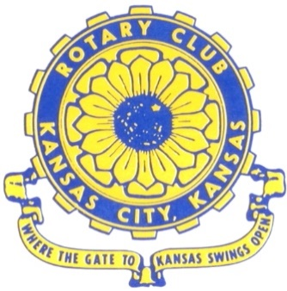
Where the Gate to Kansas Swings Open

The Kansas City, Kansas Rotary Club was organized on November 2, 1915 and received its charter as Club No. 195 in January 1916. Its members take pride in more than 100 years of Rotary service to the community and to international fellowship. From this Club have come five District Governors and two Directors of Rotary International. The Club’s history is as rich as that of the community it represents.

Following the Lewis and Clark expedition which camped at the confluence of the Kansas and Missouri rivers on June 26, 1804, in present day Kansas City, Kansas, this area became an important center for fur trappers. In the following years, many Indian tribes were relocated here from the East. In 1842 the Wyandot Indians acquired land here and founded a town. During this period, and for the next five decades, this area became the main gateway to the inviting majesty of the sprawling Kansas Prairie and the American West. This was where the frontier began. Pioneers found river transportation, outfitters and the beginning of the Santa Fe and Oregon Trails. After the covered wagons came major trunk railroads and barge lines.

In 1886, Kansas City, Kansas received its charter as an incorporated city, combining the towns of Wyandot, Argentine and Armourdale. (Rosedale was added in 1922.) Kansas City, Kansas is the site of the first industrial park in the United States, home of the prestigious University of Kansas Medical Center, and the location of the National Agricultural Hall of Fame and the nationally recognized Kansas Speedway.

Near the geographical and population centers of the contiguous United States, it is in the temperate latitudes at an elevation of 726 feet above sea level. The average rainfall is 35 inches. The average mean temperature ranges from 30°F in January to 80°F in July. The lowest recorded temperature was -23°F on December 23, 1989, and the highest was 113°F on August 14, 1936. Our city’s population of 145,000 and 155 square miles rank it 158th among cities in the United States.

Welcome to Kansas City, Kansas Rotary, and the vibrant community it represents.

Service Above Self

Rotary Websites:
KCK Club: www.rotarydowntownkck.org, District: www.rotary5710.org, International: www.rotary.org

WHERE NEARBY TO MAKE UP ATTENDANCE
MONDAY
Bonner Springs (11:45am) --------------------------------- Twister Bar & Grill, 13100 Kansas Ave.
Overland Park (11:30am) ----------------------------------- Doubletree Hotel, 10100 College Blvd.
TUESDAY
Gladstone (7:00am) -------------------------------------- Fairview Christian Church, 1800 N.E. 65th
Johnson County-Sunset (5:15pm) ------------------------- Hilton Garden Inn Olathe, 119th & I-35
WEDNESDAY
Overland Park South (7:15am) ------------------------ Deer Creek Country Club, 7000 W. 133rd
Leavenworth (Noon) --------------------------- Riverfront Community Center, 123 S. Esplanade
KCI, Missouri (Noon) -------------------------------- KCI Expo Center, 11730 N. Ambassador Dr.
Shawnee Mission (Noon) ----------------------------- Sylvester Powell Center, Martway & Lamar
Olathe (Noon) ------------------------------ Mahaffie/Heritage Center, 1200 E. Kansas City Road
Kansas City South, Missouri (Noon) ----------------------------- EBT, 1310 Carondolet, 2nd Floor
THURSDAY
South Platte, Missouri (7:00am) ----------------------- Trezo Mare, 4105 Mulberry Drive, KCMO
Johnson County (7:15am) --------------------------- Crowne Plaza Hotel, 12601 W. 95th, Lenexa
Leawood (7:15am) ---------------------------------- Hallbrook Country Club, 11200 Overbrook Rd
Village West (7:15am) -------------------------- Dave & Buster’s, 1843 Village West Pkwy., KCK
Gardner (7:30am) ---------------------------------------------------- Senior Citizen Bldg., 128 E. Park
Olathe Santa Fe Trail (7:30am) --- Mid-Am Nazarene U, 2030 E. College Way, Campus Ctr.
Kansas City, Missouri (Noon) -------------------------------- The Gallery, 61 E. 14th Street, KCMO
FRIDAY
Desoto (7:00am) ------------------------ Desoto United Methodist Church, 8760 Kill Creek Road
Shawnee (7:15am) --------------------------------------------------- Town Hall, 11600 Johnson Drive
Plaza, Missouri (7:15am) -------------------------------- Intercontinental Hotel, 401 Ward Parkway
North Kansas City, Missouri (Noon) ------------------------------ NKC Library, 2251 Howell Street
Parkville, Missouri (Noon) ------------------------ Park University Underground, Woodard Center
Lenexa (Noon) ------------------------------- Lakeview Village, Northpointe Bldg., 91st & Park St.

Meeting make ups can be made 14 days before or after the missed meeting.
Please see the Secretary for the world directory of all Rotary Club’s meeting times, days and places.

2016-2017 Board of Directors
Officers Directors
Ashley Adorante Rick Behrens
President Karole Bradford
Fred Zimmerman John Freshnock
Vice President Phil Gibbs
Greg Shondell Wendell Maddox
Treasurer Melissa Mundt
Jim Knight Bruce Schlosser
Secretary Donna Severance
Rosemary Podrebarac Fred Zimmerman
Sergeant at Arms
Hank Chamberlain
Past President

