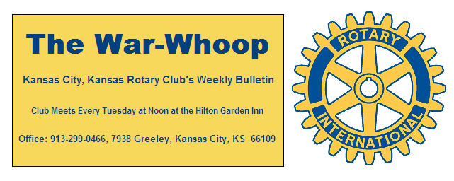

**Websites: Club:** [**www.rotarydowntownkck.org**](http://www.rotarydowntownkck.org)**, District:** [**www.rotary5710.org**](http://www.rotary5710.org)**, International:** [**www.rotary.org**](http://www.rotary.org)

**Volume 78 June 30, 2017 No. 52**

**PROGRAM LAST WEEK –** The numbers were small last Tuesday evening, but Master of Ceremonies **Dave Skidgel,** lived up to his reputation. **Dave** entertained the members in attendance during the evening. There wereThirty four members and guests that wre entertained by **Dave** during the evening.

**Karen Hostetler** gave the invocation and **Dan Duncan** installed the new officers and directors.

President **Ashley** passed the president’s pin on to **Fred** **Zimmerman** and he in turn passed the past president’s pin and plaque back to **Ashley**.

Before **Ashley** turned the president’s pin over to **Fred**, she passed out Paul Harris awards to:

**Greg Shondell (6 years)**

**Jim Knight (2 years)**

**Bruce Schlosser (2 years)**

**George Turner (1 year)**

**Rosemary Podrebarac**

**Bill Strumillo**

New members that were recognized were:

**Ted Garcia**

**Tim Ryan**

**Daniel Silva**

**Andrea Spalding**

**There will not be a meeting next Tuesday, July 4th**

**DEATH**-It is with a great deal of sadness that we report that **Connie Moritz** passed away last Saturday. Her services will be held this Saurday at St. Patrick’s Church in Kansas City, Kansas.Visitation will be at 9:30 and funeral will be at 10:30am. **Connie** was a great member and suppporter of our Rotary and our activities over the years.

**2017-2018 Board of Directors**

President----------------**Fred Zimmerman**

Vice President---------**Melissa Mundt Sieben**

Teasurer-----------------**Greg Shondell**

Secretary----------------**Jim Knight**

Sgt-At-Arms-------------**Rosemary Podrebarac**

Past Pesident-----------**Ashley Adorante**

Program Chairman----**John Freshnock**

**2017-2018 Board Members**

**Rick Behrens Wendell Maddox**

**Karole Bradford Tony Martinez**

**John Freshnock Terry Robinson**

**Phil Gibbs Bruce Schlosser**

**ATTENDANCE-** Members with 100% for this year:

**Terry Robinson Dave Skidgel Dave Tyler**

**DOOR PRIZES-** Members that won door prizes were:

**Terry Robinson Frank Simonich**

**Ashley Adorante Chris McCord Daniel Silva**

**Rosemary Podrebarac**

**OUR ROMING ROTARIAN**

Village West---------------------------------------**Greg Shondell**

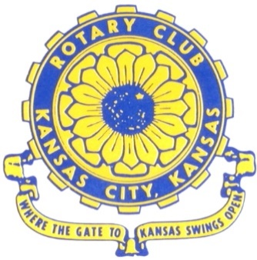

**Where the Gate to Kansas Swings Open**

The Kansas City, Kansas Rotary Club was organized on November 2, 1915 and received its charter as Club No. 195 in January 1916. Its members take pride in more than 100 years of Rotary service to the community and to international fellowship. From this Club have come five District Governors and two Directors of Rotary International. The Club’s history is as rich as that of the community it represents.

Following the Lewis and Clark expedition which camped at the confluence of the Kansas and Missouri rivers on June 26, 1804, in present day Kansas City, Kansas, this area became an important center for fur trappers. In the following years, many Indian tribes were relocated here from the East. In 1842 the Wyandot Indians acquired land here and founded a town. During this period, and for the next five decades, this area became the main gateway to the inviting majesty of the sprawling Kansas Prairie and the American West. This was where the frontier began. Pioneers found river transportation, outfitters and the beginning of the Santa Fe and Oregon Trails. After the covered wagons came major trunk railroads and barge lines.

In 1886, Kansas City, Kansas received its charter as an incorporated city, combining the towns of Wyandot, Argentine and Armourdale. (Rosedale was added in 1922.) Kansas City, Kansas is the site of the first industrial park in the United States, home of the prestigious University of Kansas Medical Center, and the location of the National Agricultural Hall of Fame and the nationally recognized Kansas Speedway.

Near the geographical and population centers of the contiguous United States, it is in the temperate latitudes at an elevation of 726 feet above sea level. The average rainfall is 35 inches. The average mean temperature ranges from 30°F in January to 80°F in July. The lowest recorded temperature was -23°F on December 23, 1989, and the highest was 113°F on August 14, 1936. Our city’s population of 145,000 and 155 square miles rank it 158th among cities in the United States.

Welcome to Kansas City, Kansas Rotary, and the vibrant community it represents.

*Service Above Self*

**Rotary Websites:**

**KCK Club:** [**www.rotarydowntownkck.org**](http://www.rotarydowntownkck.org)**, District:** [**www.rotary5710.org**](http://www.rotary5710.org)**, International:** [**www.rotary.org**](http://www.rotary.org)



**WHERE NEARBY TO MAKE UP ATTENDANCE**

MONDAY

Bonner Springs (11:45am) --------------------------------- Twister Bar & Grill, 13100 Kansas Ave.

Overland Park (11:30am) ----------------------------------- Doubletree Hotel, 10100 College Blvd.

TUESDAY

Gladstone (7:00am) -------------------------------------- Fairview Christian Church, 1800 N.E. 65th

Johnson County-Sunset (5:15pm) ------------------------- Hilton Garden Inn Olathe, 119th & I-35

WEDNESDAY

Overland Park South (7:15am) ------------------------ Deer Creek Country Club, 7000 W. 133rd

Leavenworth (Noon) --------------------------- Riverfront Community Center, 123 S. Esplanade

KCI, Missouri (Noon) -------------------------------- KCI Expo Center, 11730 N. Ambassador Dr.

Shawnee Mission (Noon) ----------------------------- Sylvester Powell Center, Martway & Lamar

Olathe (Noon) ------------------------------ Mahaffie/Heritage Center, 1200 E. Kansas City Road

Kansas City South, Missouri (Noon) ----------------------------- EBT, 1310 Carondolet, 2nd Floor

THURSDAY

South Platte, Missouri (7:00am) ----------------------- Trezo Mare, 4105 Mulberry Drive, KCMO

Johnson County (7:15am) --------------------------- Crowne Plaza Hotel, 12601 W. 95th, Lenexa

Leawood (7:15am) ---------------------------------- Hallbrook Country Club, 11200 Overbrook Rd

Village West (7:15am) -------------------------- Dave & Buster’s, 1843 Village West Pkwy., KCK

Gardner (7:30am) ---------------------------------------------------- Senior Citizen Bldg., 128 E. Park

Olathe Santa Fe Trail (7:30am) --- Mid-Am Nazarene U, 2030 E. College Way, Campus Ctr.

Kansas City, Missouri (Noon) -------------------------------- The Gallery, 61 E. 14th Street, KCMO

FRIDAY

Desoto (7:00am) ------------------------ Desoto United Methodist Church, 8760 Kill Creek Road

Shawnee (7:15am) --------------------------------------------------- Town Hall, 11600 Johnson Drive

Plaza, Missouri (7:15am) -------------------------------- Intercontinental Hotel, 401 Ward Parkway

North Kansas City, Missouri (Noon) ------------------------------ NKC Library, 2251 Howell Street

Parkville, Missouri (Noon) ------------------------ Park University Underground, Woodard Center

Lenexa (Noon) ------------------------------- Lakeview Village, Northpointe Bldg., 91st & Park St.

Meeting make ups can be made 14 days before or after the missed meeting.

Please see the Secretary for the world directory of all Rotary Club’s meeting times, days and places.

**2016-2017 Board of Directors**

***Officers*** ***Directors***

Ashley Adorante Rick Behrens

President Karole Bradford

Fred Zimmerman John Freshnock

Vice President Phil Gibbs

Greg Shondell Wendell Maddox

Treasurer Melissa Mundt

Jim Knight Bruce Schlosser

Secretary Donna Severance

Rosemary Podrebarac Fred Zimmerman

Sergeant at Arms

Hank Chamberlain

Past President