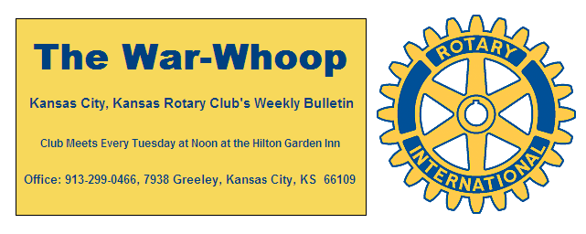
Websites: Club: www.rotarydowntownkck.org, District: www.rotary5710.org, International: www.rotary.org

Volume 79 July 14, 2017 No. 2

LAST WEEK AT ROTARY- Mike Calwell opened the new year by talking about his favorite pass time “Kaw Point Park.” Mike became involved with Kaw Point in 2003 after Captain Flynn died. His first project was building a boat ramp and the history of growth began after that. Actually, the history of the boat landing dates back to the early 1800s. He describes the work at the park as his passion. Many events have been held at the park. The park is located at the point of the Kaw and Missouri Rivers. There are six acres at the point.
The park is sponsoring a Blues Festival this weekend. It is called “Blues on the River. It will be held on Saturday and Sunday (July 15th and 16th) from 3:00pm to 10:30pm. Mike expects about five thousand people to attend the festival.
One of the biggest events held every year is the canoe race to St Louis. It was pointed out that the race is the longest canoe race in the world. While the entries are full at this time Mike pointed out that 30% of the canonists drop out, after the race starts, due to being tired and in pain. Some of our Rotarians helped out with registering and at the boat ramp last year.
Mike handed out two free tickets to Dan Duncan for this year’s event and Bill Epperheimer won the artist drawing that was painted by local artist Ernie Ulmer. Mike answered questions afterward his presentation.

President Fred opened the meeting and Dan Duncan gave the invocation. Scott Kaufmann led the singing and Dave Skidgel introduce the visitors.
NEXT WEEK AT ROTARY- Lisa Pena from the Girl Scouts will be the speaker next week. No subject was announced, but assume the Girl Scouts will be the subject matter.

Past President Ashley will be the program chair for the first month of the new year.

HAPPY BIRTHDAY- Scott led members in singing “Happy Birthday” to members with birthdays in July. Members not in attendance with birthdays in July were Don Gray and Mary Viveros.

PAUL HARRIS DRAWING- the new year started off with $29.00 in the pot. Greg Shondell won the right to draw the joker. Greg did not draw the joker and the amount for next week will be $42.00.

QUARTERLY STATEMENTS- The quarterly statements were handed out on Tuesday and members not in attendance will received their statements in the mail. Some of the statements contained fourth payment of Foundation payment from last year’s pledge. If there are any questions regarding statement, members can call the secretary.

T-BONES GAME-Dan Duncan thanked all the members who helped out at the T-Bones game last month. They were Pat and Rosie Crilly for buying all the food for the event. Chris McCord and Pat for grilling the food. President Fred for bringing his homemade beer and Terry Robinson and Dave Tyler for bringing the soft drinks. It was a fun event.

DISTRICT NEWSLETTER- Adam Ehlert, member of the Village West Club, is the District Governor for the new year.
Rotary International theme for the new year is “Rotary: Making a Difference”
Pictures of KCKs students and teachers were included in the district newsletter. Take time to read what is happening in our district.
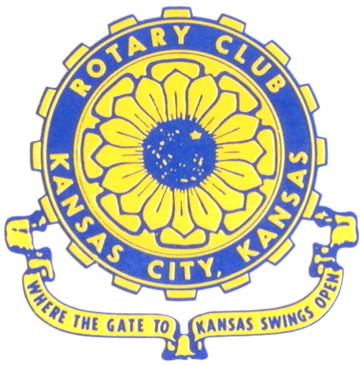
Where the Gate to Kansas Swings Open

The Kansas City, Kansas Rotary Club was organized on November 2, 1915 and received its charter as Club No. 195 in January 1916. Its members take pride in more than 100 years of Rotary service to the community and to international fellowship. From this Club have come five District Governors and two Directors of Rotary International. The Club’s history is as rich as that of the community it represents.

Following the Lewis and Clark expedition which camped at the confluence of the Kansas and Missouri rivers on June 26, 1804, in present day Kansas City, Kansas, this area became an important center for fur trappers. In the following years, many Indian tribes were relocated here from the East. In 1842 the Wyandot Indians acquired land here and founded a town. During this period, and for the next five decades, this area became the main gateway to the inviting majesty of the sprawling Kansas Prairie and the American West. This was where the frontier began. Pioneers found river transportation, outfitters and the beginning of the Santa Fe and Oregon Trails. After the covered wagons came major trunk railroads and barge lines.

In 1886, Kansas City, Kansas received its charter as an incorporated city, combining the towns of Wyandot, Argentine and Armourdale. (Rosedale was added in 1922.) Kansas City, Kansas is the site of the first industrial park in the United States, home of the prestigious University of Kansas Medical Center, and the location of the National Agricultural Hall of Fame and the nationally recognized Kansas Speedway.

Near the geographical and population centers of the contiguous United States, it is in the temperate latitudes at an elevation of 726 feet above sea level. The average rainfall is 35 inches. The average mean temperature ranges from 30°F in January to 80°F in July. The lowest recorded temperature was -23°F on December 23, 1989, and the highest was 113°F on August 14, 1936. Our city’s population of 145,000 and 155 square miles rank it 158th among cities in the United States.

Welcome to Kansas City, Kansas Rotary, and the vibrant community it represents.

Service Above Self

Rotary Websites:
KCK Club: www.rotarydowntownkck.org, District: www.rotary5710.org, International: www.rotary.org



WHERE NEARBY TO MAKE UP ATTENDANCE
MONDAY
Bonner Springs (11:45am) --------------------------------- Twister Bar & Grill, 13100 Kansas Ave.
Overland Park (11:30am) ----------------------------------- Doubletree Hotel, 10100 College Blvd.
TUESDAY
Gladstone (7:00am) -------------------------------------- Fairview Christian Church, 1800 N.E. 65th
Johnson County-Sunset (5:15pm) ------------------------- Hilton Garden Inn Olathe, 119th & I-35
WEDNESDAY
Overland Park South (7:15am) ------------------------ Deer Creek Country Club, 7000 W. 133rd
Leavenworth (Noon) --------------------------- Riverfront Community Center, 123 S. Esplanade
KCI, Missouri (Noon) -------------------------------- Granite City Pub, 8461 NW Prairie View Rd.
Shawnee Mission (Noon) ----------------------------- Sylvester Powell Center, Martway & Lamar
Olathe (Noon) -------------------------------- Olathe Community Ctr, 1205 E. Kansas City Road
Kansas City South, Missouri (Noon) ------------------------------- Jess & Jim’s, 517 E. 135th St.
Waldo-Brookside, Missouri (5:15pm) ----------------------------- Waldo Pizza, 7433 Broadway
THURSDAY
Johnson County (7:15am) --------------------------- Crowne Plaza Hotel, 12601 W. 95th, Lenexa
Leawood (7:15am) ---------------------------------- Hallbrook Country Club, 11200 Overbrook Rd
Village West (7:15am) -------------------------- Famous Dave’s, 1320 Village West Pkwy., KCK
Gardner (7:30am) ---------------------------------------------- Gardner Community Ctr., 128 E. Park
Santa Fe Trail (7:30am) --- Mid-Am Nazarene U, 2030 E. College Way, Campus Ctr.,Olathe
Kansas City, Missouri (Noon) -------------------------------- The Gallery, 61 E. 14th Street, KCMO
FRIDAY
Desoto (7:00am) ------------------------ Desoto United Methodist Church, 8760 Kill Creek Road
Shawnee (7:15am) --------------------------------------------------- Town Hall, 11600 Johnson Drive
Plaza, Missouri (7:15am) ------------------------------------ Grand Street Cafe, 4740 Grand Ave.
North Kansas City, Missouri (Noon) ------------------------------ NKC Library, 2251 Howell Street
Parkville, Missouri (Noon) ------------------------ Park University Underground, Woodard Center
Lenexa (Noon) ------------------------------- Lakeview Village, Southridge Bldg., 14001 W. 92nd

Meeting make ups can be made 14 days before or after the missed meeting.
Please see the Secretary for the world directory of all Rotary Club’s meeting times, days and places.

2017-2018 Board of Directors
Officers Directors
Fred Zimmerman Rick Behrens
President Karole Bradford
Melissa Sieben John Freshnock
Vice President Phil Gibbs
Greg Shondell Wendell Maddox
Treasurer Tony Martinez
Jim Knight Terry Robinson
Secretary Bruce Schlosser
Rosemary Podrebarac
Sergeant at Arms
Ashley Adorante
Past President

