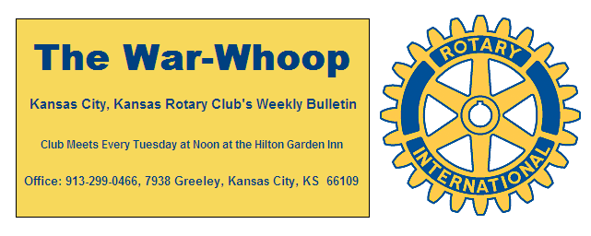
Websites: Club: www.rotarydowntownkck.org, District: www.rotary5710.org, International: www.rotary.org

Volume 79 August 25, 2017 No. 8

LAST WEEK AT ROTARY- Leo Prieto, sportscaster for Tico productions talked about his life as a Latino growing up in Garden City, Kansas and his travels around the United States and actually the world. He has traveled extensively and has had many titles at a young age. He went to South America on a scholarship from the Manhattan Rotary Club. He has a law degree from the University of Kansas and a degree from Kansas State. He has also worked for the Justice Department in Washington DC and for a Congressman from Chicago.
He told of his younger days in Garden City. While in high school, there were twenty one different languages and now there is forty five. The high school is 78% Latino.
Tico sports is part of the Tico production company. He is the sportscaster for the Spanish broadcast station for the Chiefs. The group is trying to introduce football to the Latino population. The group also has a contract with the Oakland Raiders. They sponsored a football game last year in Mexico and sold out in ten minutes. He spends a lot of time flying back and forth from Las Vegas (new home of the Chargers) and KC.
When asked about staff he told Rotarians that the company has a twelve-man staff, but with the addition of the west coast, they expect to grow. He answered any questions after his presentation. Listening to him talk left you with the idea that the Chiefs are in good hands in the Latino community. Thank you Daniel for a most interesting month of programs.

President Fred opened the meeting and John Bukaty gave the invocation. Scott Kaufmann led the singing and Bruce Schlosser introduced the visitors. George Turner’s wife, Mauri, and former member Joe Ozbolt were guests. Mauri is playing chauffer for George as his shoulder heals from surgery.

OUR ROAMING ROTARIAN
Lenexa--------------------------------------------George Turner
Carnival Cruise Line---------------------------Dan Duncan

PROGRAM FOR NEXT WEEK – Next week is our fifth Tuesday of the month and a social has been planned by Dan Duncan. Dan announced last Tuesday that we will be going to the “Mason Jar” located at 941North 74th Drive. The social will begin at 4:00 and go to ??. Just a reminder that Rotary will be paying for drinks and appetizers only. Other food orders will be at the expense of the member.
The secretary will be at the hotel lobby from 12:00- 12;30 for members wanting to make up.

SEPTEMBER PROGRAMS- Tony Martinez will be the program chairman for the month of September.

NEW MEMBER INTRODUCED- President Fred introduced Todd Jordan for the second time. Todd is the new executive director at the United Way. His classification will be “United Way”. President Fred presented Todd with his Rotary plaque.

PAUL HARRIS DRAWING- Joe Ozbolt won the right to draw for the joker. Joe did not draw a joker and the amount goes to $29.00 for next week’s drawing. Joe is back from Florida watching a few Royal’s games.

ROOM CHANGE: Rotary met in the Shawnee room last Tuesday due to power outage in our regular meeting room.

ATTENDANCE- After seven weeks into the new year, the number went to fifteen members with perfect attendance. And there are two more members could still be 100% if they made up over the next two weeks. Remember that members also receive financial credit when YOU make up.

JUST A THOUGHT-Some people try to turn back their odometers. Not me, I want people to know "why" I look this way. I've traveled a long way and some of the roads weren’t paved.
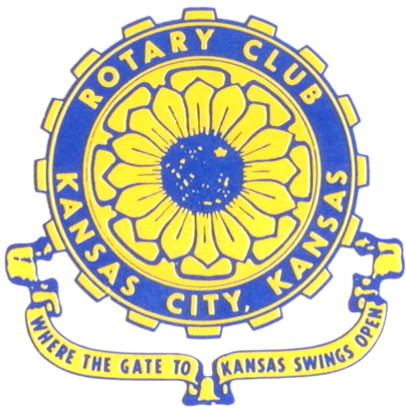
Where the Gate to Kansas Swings Open

The Kansas City, Kansas Rotary Club was organized on November 2, 1915 and received its charter as Club No. 195 in January 1916. Its members take pride in more than 100 years of Rotary service to the community and to international fellowship. From this Club have come five District Governors and two Directors of Rotary International. The Club’s history is as rich as that of the community it represents.

Following the Lewis and Clark expedition which camped at the confluence of the Kansas and Missouri rivers on June 26, 1804, in present day Kansas City, Kansas, this area became an important center for fur trappers. In the following years, many Indian tribes were relocated here from the East. In 1842 the Wyandot Indians acquired land here and founded a town. During this period, and for the next five decades, this area became the main gateway to the inviting majesty of the sprawling Kansas Prairie and the American West. This was where the frontier began. Pioneers found river transportation, outfitters and the beginning of the Santa Fe and Oregon Trails. After the covered wagons came major trunk railroads and barge lines.

In 1886, Kansas City, Kansas received its charter as an incorporated city, combining the towns of Wyandot, Argentine and Armourdale. (Rosedale was added in 1922.) Kansas City, Kansas is the site of the first industrial park in the United States, home of the prestigious University of Kansas Medical Center, and the location of the National Agricultural Hall of Fame and the nationally recognized Kansas Speedway.

Near the geographical and population centers of the contiguous United States, it is in the temperate latitudes at an elevation of 726 feet above sea level. The average rainfall is 35 inches. The average mean temperature ranges from 30°F in January to 80°F in July. The lowest recorded temperature was -23°F on December 23, 1989, and the highest was 113°F on August 14, 1936. Our city’s population of 145,000 and 155 square miles rank it 158th among cities in the United States.

Welcome to Kansas City, Kansas Rotary, and the vibrant community it represents.

Service Above Self

Rotary Websites:
KCK Club: www.rotarydowntownkck.org, District: www.rotary5710.org, International: www.rotary.org



WHERE NEARBY TO MAKE UP ATTENDANCE
MONDAY
Bonner Springs (11:45am) --------------------------------- Twister Bar & Grill, 13100 Kansas Ave.
Overland Park (11:30am) ----------------------------------- Doubletree Hotel, 10100 College Blvd.
TUESDAY
Gladstone (7:00am) -------------------------------------- Fairview Christian Church, 1800 N.E. 65th
Johnson County-Sunset (5:15pm) ------------------------- Hilton Garden Inn Olathe, 119th & I-35
WEDNESDAY
Overland Park South (7:15am) ------------------------ Deer Creek Country Club, 7000 W. 133rd
Leavenworth (Noon) --------------------------- Riverfront Community Center, 123 S. Esplanade
KCI, Missouri (Noon) -------------------------------- Granite City Pub, 8461 NW Prairie View Rd.
Shawnee Mission (Noon) ----------------------------- Sylvester Powell Center, Martway & Lamar
Olathe (Noon) -------------------------------- Olathe Community Ctr, 1205 E. Kansas City Road
Kansas City South, Missouri (Noon) ------------------------------- Jess & Jim’s, 517 E. 135th St.
Waldo-Brookside, Missouri (5:15pm) ----------------------------- Waldo Pizza, 7433 Broadway
THURSDAY
Johnson County (7:15am) --------------------------- Crowne Plaza Hotel, 12601 W. 95th, Lenexa
Leawood (7:15am) ---------------------------------- Hallbrook Country Club, 11200 Overbrook Rd
Village West (7:15am) -------------------------- Famous Dave’s, 1320 Village West Pkwy., KCK
Gardner (7:30am) ---------------------------------------------- Gardner Community Ctr., 128 E. Park
Santa Fe Trail (7:30am) --- Mid-Am Nazarene U, 2030 E. College Way, Campus Ctr.,Olathe
Kansas City, Missouri (Noon) -------------------------------- The Gallery, 61 E. 14th Street, KCMO
FRIDAY
Desoto (7:00am) ------------------------ Desoto United Methodist Church, 8760 Kill Creek Road
Shawnee (7:15am) --------------------------------------------------- Town Hall, 11600 Johnson Drive
Plaza, Missouri (7:15am) ------------------------------------ Grand Street Cafe, 4740 Grand Ave.
North Kansas City, Missouri (Noon) ------------------------------ NKC Library, 2251 Howell Street
Parkville, Missouri (Noon) ------------------------ Park University Underground, Woodard Center
Lenexa (Noon) ------------------------------- Lakeview Village, Southridge Bldg., 14001 W. 92nd

Meeting make ups can be made 14 days before or after the missed meeting.
Please see the Secretary for the world directory of all Rotary Club’s meeting times, days and places.

2017-2018 Board of Directors
Officers Directors
Fred Zimmerman Rick Behrens
President Karole Bradford
Melissa Sieben John Freshnock
Vice President Phil Gibbs
Greg Shondell Wendell Maddox
Treasurer Tony Martinez
Jim Knight Terry Robinson
Secretary Bruce Schlosser
Rosemary Podrebarac
Sergeant at Arms
Ashley Adorante
Past President

