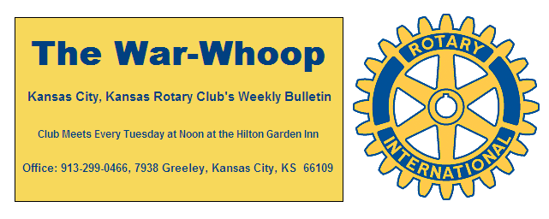
Websites: Club: www.rotarydowntownkck.org, District: www.rotary5710.org, International: www.rotary.org

Volume 79 September 15, 2017 No. 11

LAST WEEK AT ROTARY – Carlos Gomez, CEO and President of the KCMO Hispanic Chamber of Commerce talked about the history of the Chamber. ”TELL YOUR STORY” was the message that Mr. Gomez told. He went on to talk about immigration and its importance to the United States. He went on to tell several stories about the successes of immigrates. The Hispanic Chamber is the eleventh largest chamber out of forty-five in the metro area. The chamber is celebrating the 40th anniversary this year.
He went on to tell Rotarians that 46% of startup business were successful in Missouri and 76% were successful in Kansas. The reason was that the businesses were service orientated.
Mr. Gomez is a third generation Hispanic man, but does not speak Spanish. He said that he was an American. However, his staff is bilingual. When asked what the chamber did he responded that they helped opening new businesses, networking and helped in one on one situations. Their services are opened to everyone, not just Latinos. He touched on DACA and told members that the program was important in the growth of the country.

President Fred opened the meeting and Scott Kaufmann gave the invocation. Scott led the singing and Pat Crilly introduced the visitors for the day.

FOUNDATION LETTER- Foundation letter and pledge sheet is included in this week’s email. Please read the letter and give the local foundation some consideration with a pledge for the year. The foundation is the only way that our club supports projects for the year.

PROGRAM NEXT WEEK- A representative from Sumner Academy will present the program next week. The speaker will talk about the history of the school and its future and the status of one of the top schools in the United States.

Tony Martinez will be the program chair for the day and for the month.

NEWEST MEMBER-President Fred introduced Mark Dupree for the second time and presented him with the “Objects of Rotary” plaque. Mark’s classification in Rotary will be Christian Minister.

PAUL HARRIS DRAWING- Merle Parks won the right to draw for the joker. Merle did not draw the
joker and the amount goes to $58.00 for next week’s drawing.

INCREASE DUES/MEALS- President Fred announced that There will be an increase in the DUES and MEALS effective October 1st. Our meal cost for luncheons were increased from $15.00 to $19.67 per week when Brancato’s Catering Service took over the catering last April. The board has struggled over how to absorb the increase since that time. They have looked at several alternatives since the increase. The last increase in DUES and MEALS COSTS were in October 2011. Currently members are paying $47.00 for dues per quarter and $169.00 for meals per quarter.
Effective October 1st, the dues charge will go to $55.00 per quarter and meal costs will go to $195.00 per quarter.
After this fiscal year (since we are only increasing for three of the four quarters), the increased annual cost per member is $136.00 per year or $2.62 per week.
Makeup costs will be increased to $15.00 from the present $13.00

OLD AGE-“I was thinking about old age and decided that old age is when you still have something on the ball, but you are just too tired to bounce it.”
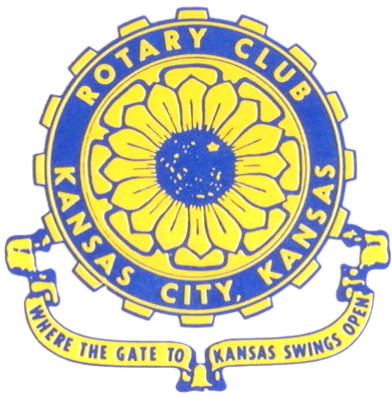
Where the Gate to Kansas Swings Open

The Kansas City, Kansas Rotary Club was organized on November 2, 1915 and received its charter as Club No. 195 in January 1916. Its members take pride in more than 100 years of Rotary service to the community and to international fellowship. From this Club have come five District Governors and two Directors of Rotary International. The Club’s history is as rich as that of the community it represents.

Following the Lewis and Clark expedition which camped at the confluence of the Kansas and Missouri rivers on June 26, 1804, in present day Kansas City, Kansas, this area became an important center for fur trappers. In the following years, many Indian tribes were relocated here from the East. In 1842 the Wyandot Indians acquired land here and founded a town. During this period, and for the next five decades, this area became the main gateway to the inviting majesty of the sprawling Kansas Prairie and the American West. This was where the frontier began. Pioneers found river transportation, outfitters and the beginning of the Santa Fe and Oregon Trails. After the covered wagons came major trunk railroads and barge lines.

In 1886, Kansas City, Kansas received its charter as an incorporated city, combining the towns of Wyandot, Argentine and Armourdale. (Rosedale was added in 1922.) Kansas City, Kansas is the site of the first industrial park in the United States, home of the prestigious University of Kansas Medical Center, and the location of the National Agricultural Hall of Fame and the nationally recognized Kansas Speedway.

Near the geographical and population centers of the contiguous United States, it is in the temperate latitudes at an elevation of 726 feet above sea level. The average rainfall is 35 inches. The average mean temperature ranges from 30°F in January to 80°F in July. The lowest recorded temperature was -23°F on December 23, 1989, and the highest was 113°F on August 14, 1936. Our city’s population of 145,000 and 155 square miles rank it 158th among cities in the United States.

Welcome to Kansas City, Kansas Rotary, and the vibrant community it represents.

Service Above Self

Rotary Websites:
KCK Club: www.rotarydowntownkck.org, District: www.rotary5710.org, International: www.rotary.org



WHERE NEARBY TO MAKE UP ATTENDANCE
MONDAY
Bonner Springs (11:45am) --------------------------------- Twister Bar & Grill, 13100 Kansas Ave.
Overland Park (11:30am) ----------------------------------- Doubletree Hotel, 10100 College Blvd.
TUESDAY
Gladstone (7:00am) -------------------------------------- Fairview Christian Church, 1800 N.E. 65th
Johnson County-Sunset (5:15pm) ------------------------- Hilton Garden Inn Olathe, 119th & I-35
WEDNESDAY
Overland Park South (7:15am) ------------------------ Deer Creek Country Club, 7000 W. 133rd
Leavenworth (Noon) --------------------------- Riverfront Community Center, 123 S. Esplanade
KCI, Missouri (Noon) -------------------------------- Granite City Pub, 8461 NW Prairie View Rd.
Shawnee Mission (Noon) ----------------------------- Sylvester Powell Center, Martway & Lamar
Olathe (Noon) -------------------------------- Olathe Community Ctr, 1205 E. Kansas City Road
Kansas City South, Missouri (Noon) ------------------------------- Jess & Jim’s, 517 E. 135th St.
Waldo-Brookside, Missouri (5:15pm) ----------------------------- Waldo Pizza, 7433 Broadway
THURSDAY
Johnson County (7:15am) --------------------------- Crowne Plaza Hotel, 12601 W. 95th, Lenexa
Leawood (7:15am) ---------------------------------- Hallbrook Country Club, 11200 Overbrook Rd
Village West (7:15am) -------------------------- Famous Dave’s, 1320 Village West Pkwy., KCK
Gardner (7:30am) ---------------------------------------------- Gardner Community Ctr., 128 E. Park
Santa Fe Trail (7:30am) --- Mid-Am Nazarene U, 2030 E. College Way, Campus Ctr.,Olathe
Kansas City, Missouri (Noon) -------------------------------- The Gallery, 61 E. 14th Street, KCMO
FRIDAY
Desoto (7:00am) ------------------------ Desoto United Methodist Church, 8760 Kill Creek Road
Shawnee (7:15am) --------------------------------------------------- Town Hall, 11600 Johnson Drive
Plaza, Missouri (7:15am) ------------------------------------ Grand Street Cafe, 4740 Grand Ave.
North Kansas City, Missouri (Noon) ------------------------------ NKC Library, 2251 Howell Street
Parkville, Missouri (Noon) ------------------------ Park University Underground, Woodard Center
Lenexa (Noon) ------------------------------- Lakeview Village, Southridge Bldg., 14001 W. 92nd

Meeting make ups can be made 14 days before or after the missed meeting.
Please see the Secretary for the world directory of all Rotary Club’s meeting times, days and places.

2017-2018 Board of Directors
Officers Directors
Fred Zimmerman Rick Behrens
President Karole Bradford
Melissa Sieben John Freshnock
Vice President Phil Gibbs
Greg Shondell Wendell Maddox
Treasurer Tony Martinez
Jim Knight Terry Robinson
Secretary Bruce Schlosser
Rosemary Podrebarac
Sergeant at Arms
Ashley Adorante
Past President

