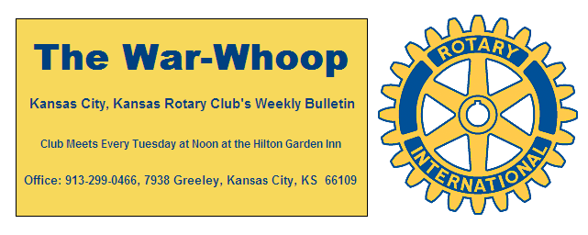
Websites: Club: www.rotarydowntownkck.org, District: www.rotary5710.org, International: www.rotary.org

Volume 79 November 3, 2017 No. 17
.
LAST WEEK AT ROTARY- Detective Michael Simmons was recognized by Rotary and his own officers last Tuesday for his work with the Sheriff’s Department. Sheriff Don Ash and five of his fellow officers and wife were in attendance. Detective Simmons has been with the department since 2008. He is the son of a Kansas City, Kansas police officer. He has divided some of his official duties with the Federal Marshall’s Service over the years. When asked about his duties and how they catch the bad guys he reported that many times “it is by Face Book”. He went on to say that “offenders” will stand in front of their homes when pictures are taken. He also told members that he does not take his work home with him. He is the father of a new born baby boy.

President Fred opened the meeting and Merle Parks gave the invocation. Scott Kaufmann, in his Elvis costume led the members in singing an Elvis song. Dave Tyler introduced the guests. We had a full house last week. Claudine Sanders was in attendance again this week. It was also good to see Bill Porter back from Oregon

PAUL HARRIS DRAWING- Hank Chamberlain won the right to draw for the joker last week. Hank did not draw the joker and the amount goes to $68.00 for next week’s drawing.

DECEMBER 12TH- The Sumner Academy Choir will again be with us at Rotary. Mark this date down.

NEXT WEEK AT ROTARY- Peter Newman, a survivor of a concentration camp, during World War II will be the speaker next week. He will talk about his experience becoming an American citizen. Scott has named the month as “Thank God for America month”.

Scott Kaufmann will be the program chairman for month of November.

BOARD OF DIRECTORS ELECTION- The board of director’s election for 2018-19 will be held on the second Tuesday of December. The nominating committee consist of Ashley Adorante chair, Hank Chamberlain and Ken Davis. The Nominating Committee is made up of the three past presidents.

OUR ROAMING ROTARIAN-
Rotary South------------------------------------------Dave Skidgel
Lenexa Rotary ---------------------------------------Dave Skidgel

PARKING- Just another reminder that members are able to park in the parking lot behind the hotel during the paving of the lot across from the convention center. Members will have to pick up a ticket at the back table upon leaving each week. Parking is through the courtesy of the hotel and member Tim Ryan.

THANKSGIVING HELP- New Bethel Church Food Pantry needs a group or groups to donate 150 bags of groceries for their Nov 18th Thanksgiving festival, which serves 500 families. One of the community partners backed out at the last minute. For info, call Karole Bradford or Pat at Riverview 913-371-7070.
The board met this week and approved a contribution of $250 to this effort by the local church. President Fred will also check with Karole to see if they could use volunteers for this effort of helping fill the grocery bags for these families

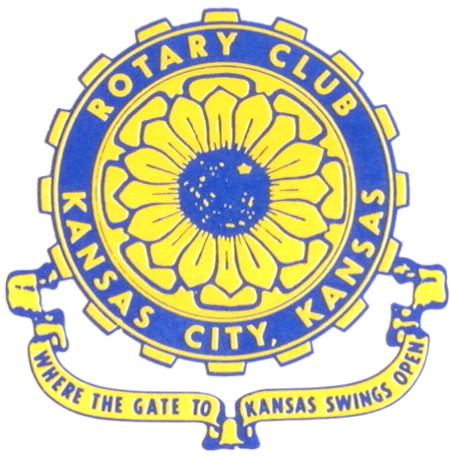
Where the Gate to Kansas Swings Open
The Kansas City, Kansas Rotary Club was organized on November 2, 1915 and received its charter as Club No. 195 in January 1916. Its members take pride in more than 100 years of Rotary service to the community and to international fellowship. From this Club have come five District Governors and two Directors of Rotary International. The Club’s history is as rich as that of the community it represents. Following the Lewis and Clark expedition which camped at the confluence of the Kansas and Missouri rivers on June 26, 1804, in present day Kansas City, Kansas, this area became an important center for fur trappers. In the following years, many Indian tribes were relocated here from the East. In 1842 the Wyandot Indians acquired land here and founded a town. During this period, and for the next five decades, this area became the main gateway to the inviting majesty of the sprawling Kansas Prairie and the American West. This was where the frontier began. Pioneers found river transportation, outfitters and the beginning of the Santa Fe and Oregon Trails. After the covered wagons came major trunk railroads and barge lines.
In 1886, Kansas City, Kansas received its charter as an incorporated city, combining the towns of Wyandot, Argentine and Armourdale. (Rosedale was added in 1922.) Kansas City, Kansas is the site of the first industrial park in the United States, home of the prestigious University of Kansas Medical Center, and the location of the National Agricultural Hall of Fame and the nationally recognized Kansas Speedway.

Near the geographical and population centers of the contiguous United States, it is in the temperate latitudes at an elevation of 726 feet above sea level. The average rainfall is 35 inches. The average mean temperature ranges from 30°F in January to 80°F in July. The lowest recorded temperature was -23°F on December 23, 1989, and the highest was 113°F on August 14, 1936. Our city’s population of 145,000 and 155 square miles rank it 158th among cities in the United States.

Welcome to Kansas City, Kansas Rotary, and the vibrant community it represents.

Rotary Websites:
KCK Club: www.rotarydowntownkck.org, District: www.rotary5710.org, International: www.rotary.org



WHERE NEARBY TO MAKE UP ATTENDANCE
MONDAY
Bonner Springs (11:45am) --------------------------------- Twister Bar & Grill, 13100 Kansas Ave.
Overland Park (11:30am) ----------------------------------- Doubletree Hotel, 10100 College Blvd.
TUESDAY
Gladstone (7:00am) -------------------------------------- Fairview Christian Church, 1800 N.E. 65th
Johnson County-Sunset (5:15pm) ------------------------- Hilton Garden Inn Olathe, 119th & I-35
WEDNESDAY
Overland Park South (7:15am) ------------------------ Deer Creek Country Club, 7000 W. 133rd
Leavenworth (Noon) --------------------------- Riverfront Community Center, 123 S. Esplanade
KCI, Missouri (Noon) -------------------------------- Granite City Pub, 8461 NW Prairie View Rd.
Shawnee Mission (Noon) ----------------------------- Sylvester Powell Center, Martway & Lamar
Olathe (Noon) -------------------------------- Olathe Community Ctr, 1205 E. Kansas City Road
Kansas City South, Missouri (Noon) ------------------------------- Jess & Jim’s, 517 E. 135th St.
Waldo-Brookside, Missouri (5:15pm) ----------------------------- Waldo Pizza, 7433 Broadway
THURSDAY
Johnson County (7:15am) --------------------------- Crowne Plaza Hotel, 12601 W. 95th, Lenexa
Leawood (7:15am) ---------------------------------- Hallbrook Country Club, 11200 Overbrook Rd
Village West (7:15am) -------------------------- Famous Dave’s, 1320 Village West Pkwy., KCK
Gardner (7:30am) ---------------------------------------------- Gardner Community Ctr., 128 E. Park
Santa Fe Trail (7:30am) --- Mid-Am Nazarene U, 2030 E. College Way, Campus Ctr.,Olathe
Kansas City, Missouri (Noon) -------------------------------- The Gallery, 61 E. 14th Street, KCMO
FRIDAY
Desoto (7:00am) ------------------------ Desoto United Methodist Church, 8760 Kill Creek Road
Shawnee (7:15am) --------------------------------------------------- Town Hall, 11600 Johnson Drive
Plaza, Missouri (7:15am) ------------------------------------ Grand Street Cafe, 4740 Grand Ave.
North Kansas City, Missouri (Noon) ------------------------------ NKC Library, 2251 Howell Street
Parkville, Missouri (Noon) ------------------------ Park University Underground, Woodard Center
Lenexa (Noon) ------------------------------- Lakeview Village, Southridge Bldg., 14001 W. 92nd

Meeting make ups can be made 14 days before or after the missed meeting.
Please see the Secretary for the world directory of all Rotary Club’s meeting times, days and places.

2017-2018 Board of Directors
Officers Directors
Fred Zimmerman Rick Behrens
President Karole Bradford
Melissa Sieben John Freshnock
Vice President Phil Gibbs
Greg Shondell Wendell Maddox
Treasurer Tony Martinez
Jim Knight Terry Robinson
Secretary Bruce Schlosser
Rosemary Podrebarac
Sergeant at Arms
Ashley Adorante
Past President

