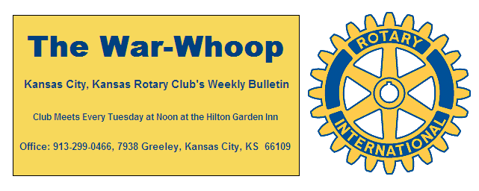
Websites: Club: www.rotarydowntownkck.org, District: www.rotary5710.org, International: www.rotary.org

Volume 79 November 10, 2017 No. 18
.
LAST WEEK AT ROTARY- Peter Newman told a great story about how he and his family came to America and to Kansas City. According to Newman his story was one of “LUCK”. While he is of the Jewish faith, his name,” Newman” sounded more like the name of the Catholic faith and rather than being killed, he was sent to a concertation camp in Italy close to the Vatican City where there was no killings or torture of the prisoners. In 1943, 1,000 prisoners were selected to go to America with the idea that they would go back to their native country when the war was over. He talked about his family’s interment in Oswego, New York which was another camp with barbed wire around the camp. Harry Truman became President and gave his family a FREEDOM TICKET to stay in America. Had Franklin Roosevelt remained president, his family would have been sent back to Austria. He did not have any kind words to say about Roosevelt. When asked where his family wanted to go they said “some place where it was moderately warm”. They came to KCMO with very little cash and no possessions, but they were FREE. According to Newman, there were 61/2 million children slaughtered during the war.
He was so passionate about his story and the land so many of us take for granted, he broke down several times during his presentation. He is so thankful for being in America “Land of the Free”. He kept using the word “Lucky” for all of us that live in America where we can agree to disagree. There are only three things he does not like taxes, age and government. It was a great story and one that a movie or book could have been made.

THANKS- A big “thank you” to Tim Ryan for coming to our rescue and providing a power point lab top to help the speaker last week.

NEXT WEEK AT ROTARY- American Funds agent Jason Young will be discussing some of the amazing things that are occurring because of entrepreneurial discoveries.

Scott Kaufmann will be the program chairman the day and month of November.

President Fred opened the meeting and Dan Duncan gave the invocation. Scott Kaufmann led members in singing and George Turner introduced the guests. We had nine guests in attendance last week to hear the speaker. Former member Leon Daggett was in attendance.

NEW MEMBER PROPOSAL-The following person has been proposed for membership and has passed the board of directors. Any objections o the person listed below, must be made, in writing, within seven days of the date of this bulletin.
Proposer: Phil Gibbs
CLAUDINE SANDERS
Classification: Refrigeration/Administration
Business Address: 400 Shawnee Ave (CSTK,Inc)
Business Telephone:913-371-0868
Residence Address: 8309 Isabel St KCKs.
Residence Telephone: 913-271-2961
No previous Rotary experience

HAPPY BIRTHDAY- Scott led members in singing “Happy Birthday” to Karen Hostetler, Chris McCord, Ken Davis, John Bukaty and Mark Holland.

BOARD OF DIRECTORS ELECTION- The board of director’s election for 2018-19 will be held on the second Tuesday of December. The nominating committee consist of Ashley Adorante chair, Hank Chamberlain and Ken Davis. The Nominating Committee is made up of the three past presidents.
They need some suggestions and volunteers,

PAUL HARRIS DRAWING- A guest won the drawing last week. He did not draw the joker. Amount goes to $81.00 for next week’s drawing.

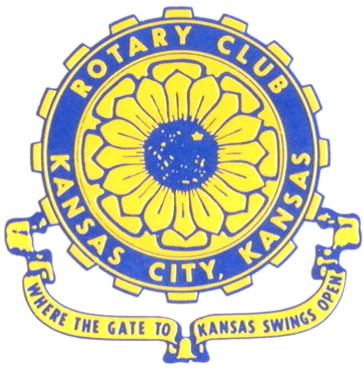
Where the Gate to Kansas Swings Open
The Kansas City, Kansas Rotary Club was organized on November 2, 1915 and received its charter as Club No. 195 in January 1916. Its members take pride in more than 100 years of Rotary service to the community and to international fellowship. From this Club have come five District Governors and two Directors of Rotary International. The Club’s history is as rich as that of the community it represents. Following the Lewis and Clark expedition which camped at the confluence of the Kansas and Missouri rivers on June 26, 1804, in present day Kansas City, Kansas, this area became an important center for fur trappers. In the following years, many Indian tribes were relocated here from the East. In 1842 the Wyandot Indians acquired land here and founded a town. During this period, and for the next five decades, this area became the main gateway to the inviting majesty of the sprawling Kansas Prairie and the American West. This was where the frontier began. Pioneers found river transportation, outfitters and the beginning of the Santa Fe and Oregon Trails. After the covered wagons came major trunk railroads and barge lines.
In 1886, Kansas City, Kansas received its charter as an incorporated city, combining the towns of Wyandot, Argentine and Armourdale. (Rosedale was added in 1922.) Kansas City, Kansas is the site of the first industrial park in the United States, home of the prestigious University of Kansas Medical Center, and the location of the National Agricultural Hall of Fame and the nationally recognized Kansas Speedway.

Near the geographical and population centers of the contiguous United States, it is in the temperate latitudes at an elevation of 726 feet above sea level. The average rainfall is 35 inches. The average mean temperature ranges from 30°F in January to 80°F in July. The lowest recorded temperature was -23°F on December 23, 1989, and the highest was 113°F on August 14, 1936. Our city’s population of 145,000 and 155 square miles rank it 158th among cities in the United States.

Welcome to Kansas City, Kansas Rotary, and the vibrant community it represents.

Rotary Websites:
KCK Club: www.rotarydowntownkck.org, District: www.rotary5710.org, International: www.rotary.org



WHERE NEARBY TO MAKE UP ATTENDANCE
MONDAY
Bonner Springs (11:45am) --------------------------------- Twister Bar & Grill, 13100 Kansas Ave.
Overland Park (11:30am) ----------------------------------- Doubletree Hotel, 10100 College Blvd.
TUESDAY
Gladstone (7:00am) -------------------------------------- Fairview Christian Church, 1800 N.E. 65th
Johnson County-Sunset (5:15pm) ------------------------- Hilton Garden Inn Olathe, 119th & I-35
WEDNESDAY
Overland Park South (7:15am) ------------------------ Deer Creek Country Club, 7000 W. 133rd
Leavenworth (Noon) --------------------------- Riverfront Community Center, 123 S. Esplanade
KCI, Missouri (Noon) -------------------------------- Granite City Pub, 8461 NW Prairie View Rd.
Shawnee Mission (Noon) ----------------------------- Sylvester Powell Center, Martway & Lamar
Olathe (Noon) -------------------------------- Olathe Community Ctr, 1205 E. Kansas City Road
Kansas City South, Missouri (Noon) ------------------------------- Jess & Jim’s, 517 E. 135th St.
Waldo-Brookside, Missouri (5:15pm) ----------------------------- Waldo Pizza, 7433 Broadway
THURSDAY
Johnson County (7:15am) --------------------------- Crowne Plaza Hotel, 12601 W. 95th, Lenexa
Leawood (7:15am) ---------------------------------- Hallbrook Country Club, 11200 Overbrook Rd
Village West (7:15am) -------------------------- Famous Dave’s, 1320 Village West Pkwy., KCK
Gardner (7:30am) ---------------------------------------------- Gardner Community Ctr., 128 E. Park
Santa Fe Trail (7:30am) --- Mid-Am Nazarene U, 2030 E. College Way, Campus Ctr.,Olathe
Kansas City, Missouri (Noon) -------------------------------- The Gallery, 61 E. 14th Street, KCMO
FRIDAY
Desoto (7:00am) ------------------------ Desoto United Methodist Church, 8760 Kill Creek Road
Shawnee (7:15am) --------------------------------------------------- Town Hall, 11600 Johnson Drive
Plaza, Missouri (7:15am) ------------------------------------ Grand Street Cafe, 4740 Grand Ave.
North Kansas City, Missouri (Noon) ------------------------------ NKC Library, 2251 Howell Street
Parkville, Missouri (Noon) ------------------------ Park University Underground, Woodard Center
Lenexa (Noon) ------------------------------- Lakeview Village, Southridge Bldg., 14001 W. 92nd

Meeting make ups can be made 14 days before or after the missed meeting.
Please see the Secretary for the world directory of all Rotary Club’s meeting times, days and places.

2017-2018 Board of Directors
Officers Directors
Fred Zimmerman Rick Behrens
President Karole Bradford
Melissa Sieben John Freshnock
Vice President Phil Gibbs
Greg Shondell Wendell Maddox
Treasurer Tony Martinez
Jim Knight Terry Robinson
Secretary Bruce Schlosser
Rosemary Podrebarac
Sergeant at Arms
Ashley Adorante
Past President

