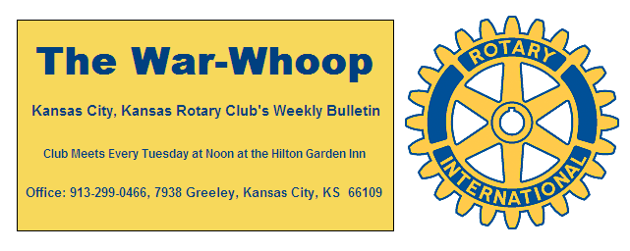
Websites: Club: www.rotarydowntownkck.org, District: www.rotary5710.org, International: www.rotary.org

Volume 79 December 1, 2017 No. 21
.
LAST WEEK AT ROTARY – Leo Prieto continued his life’s journey with us last Tuesday. He talked about his education and how he was helped and hindered along the way. He told about how some of his teachers that encouraged him and he also talked about a teacher that discouraged him in athletics. He talked about his trip to South America as a college student at Kansas State though the courtesy of the Rotary Exchange Program. His father told him to “use your head and not your arms” though some of his difficult times”. He had a passion to become at citizen of the U.S. He helped his father to become a citizen later.
Scott read a poem that ended with “America, We are the dream that other people dream”.

President Fred, back from vacation, opened the meeting and Karole Bradford gave the invocation. Scott Kaufmann led members in singing and John Bukaty introduced the guests. Carl Brewer, Wichita, Kansas candidate for Kansas Governor was a guest of Karole Bradford.

PAUL HARRIS DRAWING- Frank Simonich won the right to draw for the joker. Frank did not draw the magic card and the drawing will go to $108.00 for next week’s drawing.

EMAIL ADDRESS- Secretary’s email in roster book is incorrect. The email should be jknight26@kc.rr.com.

NEXT WEEK AT ROTARY- Lou Eisenbandt, an Army nurse will speak on her experiences in Vietnam.
Dan Duncan is the program chairman for the day and for the month.

PROGRAM-December 12th- The Sumner Academy choir singers will be the program. Rotary will meet downstairs at the Reardon Center. Please make reservations for any guests that YOU may have. With the cost of meals, it is important for us to know how many guests there may be.

NEW MEMBER INTRODUCED- Phil Gibbs introduced the newest member in Rotary in the person of Claudine Sanders for the second time. Claudine is a native of Iowa. Claudine is the Administrative Manager for the CSTK Refrigeration Company. Her classification in Rotary will be “Refrigeration/ Administration Please say “Hello” to her when you meet her next week.

SALVATION ARMY BELL RINGING- Phil Gibbs offered Rotarians a choice of dates to ring bells for the Salvation Army last Tuesday. Members took this week (December 2nd) as their choice and filled up all the slots but one. This was late, but Phil has been trying to get a response from the Army for some time. The schedule looks like:
10:00-11:00- Scott Kaufmann/Greg Shondell
11:00-12:00- Melissa Sieben/Merle Parks
12:00-1:00- Bruce Schlosser (need a volunteer)
1:00-2:00- John Bukaty/ Terry Robinson
Any changes should be made through Phil Gibbs. His telephone number is 913:642-6642 or email pg2@ccengineers.com.

PARKING STICKERS- The hotel desk has asked us to pick up the parking stickers from their
front desk.

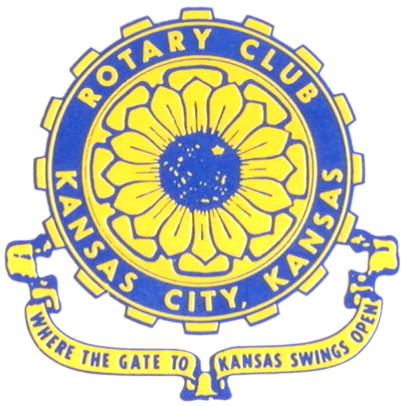
Where the Gate to Kansas Swings Open
The Kansas City, Kansas Rotary Club was organized on November 2, 1915 and received its charter as Club No. 195 in January 1916. Its members take pride in more than 100 years of Rotary service to the community and to international fellowship. From this Club have come five District Governors and two Directors of Rotary International. The Club’s history is as rich as that of the community it represents. Following the Lewis and Clark expedition which camped at the confluence of the Kansas and Missouri rivers on June 26, 1804, in present day Kansas City, Kansas, this area became an important center for fur trappers. In the following years, many Indian tribes were relocated here from the East. In 1842 the Wyandot Indians acquired land here and founded a town. During this period, and for the next five decades, this area became the main gateway to the inviting majesty of the sprawling Kansas Prairie and the American West. This was where the frontier began. Pioneers found river transportation, outfitters and the beginning of the Santa Fe and Oregon Trails. After the covered wagons came major trunk railroads and barge lines.
In 1886, Kansas City, Kansas received its charter as an incorporated city, combining the towns of Wyandot, Argentine and Armourdale. (Rosedale was added in 1922.) Kansas City, Kansas is the site of the first industrial park in the United States, home of the prestigious University of Kansas Medical Center, and the location of the National Agricultural Hall of Fame and the nationally recognized Kansas Speedway.

Near the geographical and population centers of the contiguous United States, it is in the temperate latitudes at an elevation of 726 feet above sea level. The average rainfall is 35 inches. The average mean temperature ranges from 30°F in January to 80°F in July. The lowest recorded temperature was -23°F on December 23, 1989, and the highest was 113°F on August 14, 1936. Our city’s population of 145,000 and 155 square miles rank it 158th among cities in the United States.

Welcome to Kansas City, Kansas Rotary, and the vibrant community it represents.

Rotary Websites:
KCK Club: www.rotarydowntownkck.org, District: www.rotary5710.org, International: www.rotary.org

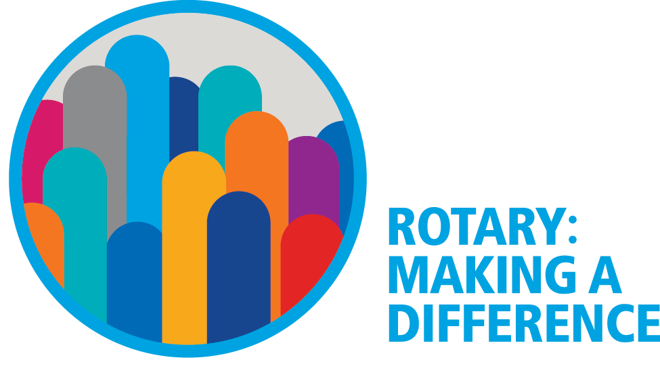

WHERE NEARBY TO MAKE UP ATTENDANCE
MONDAY
Bonner Springs (11:45am) --------------------------------- Twister Bar & Grill, 13100 Kansas Ave.
Overland Park (11:30am) ----------------------------------- Doubletree Hotel, 10100 College Blvd.
TUESDAY
Gladstone (7:00am) -------------------------------------- Fairview Christian Church, 1800 N.E. 65th
Johnson County-Sunset (5:15pm) ------------------------- Hilton Garden Inn Olathe, 119th & I-35
WEDNESDAY
Overland Park South (7:15am) ------------------------ Deer Creek Country Club, 7000 W. 133rd
Leavenworth (Noon) --------------------------- Riverfront Community Center, 123 S. Esplanade
KCI, Missouri (Noon) -------------------------------- Granite City Pub, 8461 NW Prairie View Rd.
Shawnee Mission (Noon) ----------------------------- Sylvester Powell Center, Martway & Lamar
Olathe (Noon) -------------------------------- Olathe Community Ctr, 1205 E. Kansas City Road
Kansas City South, Missouri (Noon) ------------------------------- Jess & Jim’s, 517 E. 135th St.
Waldo-Brookside, Missouri (5:15pm) ----------------------------- Waldo Pizza, 7433 Broadway
THURSDAY
Johnson County (7:15am) --------------------------- Crowne Plaza Hotel, 12601 W. 95th, Lenexa
Leawood (7:15am) ---------------------------------- Hallbrook Country Club, 11200 Overbrook Rd
Village West (7:15am) -------------------------- Famous Dave’s, 1320 Village West Pkwy., KCK
Gardner (7:30am) ---------------------------------------------- Gardner Community Ctr., 128 E. Park
Santa Fe Trail (7:30am) --- Mid-Am Nazarene U, 2030 E. College Way, Campus Ctr.,Olathe
Kansas City, Missouri (Noon) -------------------------------- The Gallery, 61 E. 14th Street, KCMO
FRIDAY
Desoto (7:00am) ------------------------ Desoto United Methodist Church, 8760 Kill Creek Road
Shawnee (7:15am) --------------------------------------------------- Town Hall, 11600 Johnson Drive
Plaza, Missouri (7:15am) ------------------------------------ Grand Street Cafe, 4740 Grand Ave.
North Kansas City, Missouri (Noon) ------------------------------ NKC Library, 2251 Howell Street
Parkville, Missouri (Noon) ------------------------ Park University Underground, Woodard Center
Lenexa (Noon) ------------------------------- Lakeview Village, Southridge Bldg., 14001 W. 92nd

Meeting make ups can be made 14 days before or after the missed meeting.
Please see the Secretary for the world directory of all Rotary Club’s meeting times, days and places.

2017-2018 Board of Directors
Officers Directors
Fred Zimmerman Rick Behrens
President Karole Bradford
Melissa Sieben John Freshnock
Vice President Phil Gibbs
Greg Shondell Wendell Maddox
Treasurer Tony Martinez
Jim Knight Terry Robinson
Secretary Bruce Schlosser
Rosemary Podrebarac
Sergeant at Arms
Ashley Adorante
Past President

