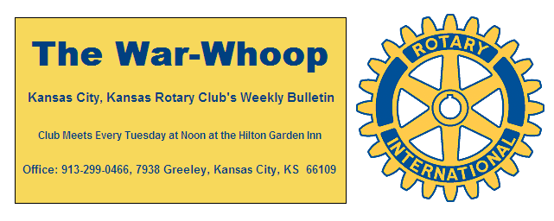
Websites: Club: www.rotarydowntownkck.org, District: www.rotary5710.org, International: www.rotary.org

Volume 79 March 9, 2018 No. 34

LAST WEEK AT ROTARY – Stan Weber, color analysist for the Kansas State Wildcats, brought Rotarians up to date on the status of Big Twelve basketball. He told members that the tournament will be most unusual tournament that we have ever had. Weber maintains that the conference is one of the toughest leagues. However, teams do have a difficult time when the NCAA tournament comes around. Several teams could end up in the final four and yet some could lose out in the second round. When commenting on officiating at Kansas, he told members that the other schools feel that Kansas gets the favorite calls at home. When asked about players getting paid he told members that these athletes are pampered, get the best food and clothing and all school fees always enter-taining and an interesting speaker. Stan, at the present time, has the longest tenure as a broadcaster in the Big Twelve,

President Fred opened the meeting and Merle Parks gave the invocation. Scott Kaufmann led the singing and Chris McCord introduced the visitors. Jim Larkin, visiting Rotarian from Lawrence, was in attendance.

HAPPY BIRTHDAY- Scott led members in singing “Happy Birthday” to members with birthdays in February. They are Hank Chamberlain, Dan Duncan and Terry Robinson.

NEXT WEEK AT ROTARY- Rick Behrens will talk about his recent trip to Puerto Rico. Rick led a group from his church that provided some Water filters to a town in Puerto Rico. Our club contributed financial help in the purchase of the filters and water buckets.

John Freshnock will be the program chairman for the day and for the month.

PAUL HARRIS DRAWING- Todd Jordan won the right to draw for the joker last week. Todd did not draw the joker and the amount goes to $79.00 for next week’s drawing.

KANSAS CITY DAY- Chairman Dan Duncan once again reminded members to sign up for a corner spot for Kansas City Day. KC Day is March 29th. See Dan if you have not signed up for a corner. Fifty-year flags for the Royals are available from Dan for members wanting a memento for $10.00. They will cost $40.00 at the ball park. Check with Dan.

SURVEY- A reminder for all members to fill out the survey that President-elect Melissa has handed out. A copy of the survey will be sent out with the bulletin again this week. Copies are also available at the luncheon’s back table for members that do not have printers at home.

BOARD NOTES- The board has approved a contribution of $125 to the district project to purchase items for Women’s Hygiene Kits that will distributed by Heart To Heart Intl to disaster areas and underserved countries. These kits will be assembled at the District Conference.

YEAR 1955- There is no sense going on short trips any more for a weekend, it costs nearly $2.00 a night to stay in a motel.
-The fast food restaurant is convenient for a quick meal, but
I seriously doubt they will ever catch on.

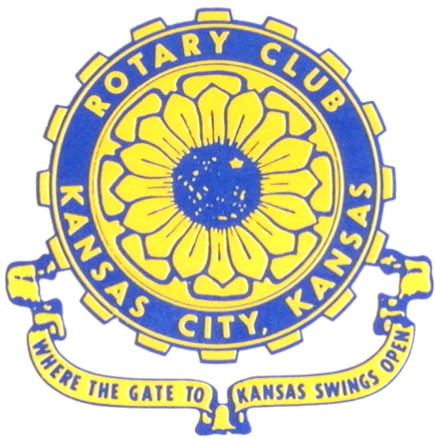
Where the Gate to Kansas Swings Open
The Kansas City, Kansas Rotary Club was organized on November 2, 1915 and received its charter as Club No. 195 in January 1916. Its members take pride in more than 100 years of Rotary service to the community and to international fellowship. From this Club have come five District Governors and two Directors of Rotary International. The Club’s history is as rich as that of the community it represents. Following the Lewis and Clark expedition which camped at the nsas City, Kansas, this area became an important center for fur trappers. In the following years, many Indian tribes were relocated here from the East. In 1842 the Wyandot Indians acquired land here and founded a town. During this period, and for the next five decades, this area became the main gateway to the inviting majesty of the sprawling Kansas Prairie and the American West. This was where the frontier began. Pioneers found river transportation, outfitters and the beginning of the Santa Fe and Oregon Trails. After the covered wagons came major trunk railroads and barge lines.
In 1886, Kansas City, Kansas received its charter as an incorporated city, combining the towns of Wyandot, Argentine and Armourdale. (Rosedale was added in 1922.) Kansas City, Kansas is the site of the first industrial park in the United States, home of the prestigious University of Kansas Medical Center, and the location of the National Agricultural Hall of Fame and the nationally recognized Kansas Speedway.

Near the geographical and population centers of the contiguous United States, it is in the temperate latitudes at an elevation of 726 feet above sea level. The average rainfall is 35 inches. The average mean temperature ranges from 30°F in January to 80°F in July. The lowest recorded temperature was -23°F on December 23, 1989, and the highest was 113°F on August 14, 1936. Our city’s population of 145,000 and 155 square miles rank it 158th among cities in the United States.

Welcome to Kansas City, Kansas Rotary, and the vibrant community it represents.

Rotary Websites:
KCK Club: www.rotarydowntownkck.org, District: www.rotary5710.org, International: www.rotary.org



WHERE NEARBY TO MAKE UP ATTENDANCE
MONDAY
Bonner Springs (11:45am) --------------------------------- Twister Bar & Grill, 13100 Kansas Ave.
Overland Park (11:30am) ----------------------------------- Doubletree Hotel, 10100 College Blvd.
TUESDAY
Gladstone (7:00am) -------------------------------------- Fairview Christian Church, 1800 N.E. 65th
Johnson County-Sunset (5:15pm) ------------------------- Hilton Garden Inn Olathe, 119th & I-35
WEDNESDAY
Overland Park South (7:15am) ------------------------ Deer Creek Country Club, 7000 W. 133rd
Leavenworth (Noon) --------------------------- Riverfront Community Center, 123 S. Esplanade
KCI, Missouri (Noon) -------------------------------- Granite City Pub, 8461 NW Prairie View Rd.
Shawnee Mission (Noon) ----------------------------- Sylvester Powell Center, Martway & Lamar
Olathe (Noon) -------------------------------- Olathe Community Ctr, 1205 E. Kansas City Road
Kansas City South, Missouri (Noon) ------------------------------- Jess & Jim’s, 517 E. 135th St.
Waldo-Brookside, Missouri (5:15pm) ----------------------------- Waldo Pizza, 7433 Broadway
THURSDAY
Johnson County (7:15am) --------------------------- Crowne Plaza Hotel, 12601 W. 95th, Lenexa
Leawood (7:15am) ---------------------------------- Hallbrook Country Club, 11200 Overbrook Rd
Village West (7:15am) -------------------------- Famous Dave’s, 1320 Village West Pkwy., KCK
Gardner (7:30am) ---------------------------------------------- Gardner Community Ctr., 128 E. Park
Santa Fe Trail (7:30am) --- Mid-Am Nazarene U, 2030 E. College Way, Campus Ctr.,Olathe
Kansas City, Missouri (Noon) -------------------------------- The Gallery, 61 E. 14th Street, KCMO
FRIDAY
Desoto (7:00am) ------------------------ Desoto United Methodist Church, 8760 Kill Creek Road
Shawnee (7:15am) --------------------------------------------------- Town Hall, 11600 Johnson Drive
Plaza, Missouri (7:15am) ------------------------------------ Grand Street Cafe, 4740 Grand Ave.
North Kansas City, Missouri (Noon) ------------------------------ NKC Library, 2251 Howell Street
Parkville, Missouri (Noon) ------------------------ Park University Underground, Woodard Center
Lenexa (Noon) ------------------------------- Lakeview Village, Southridge Bldg., 14001 W. 92nd

Meeting make ups can be made 14 days before or after the missed meeting.
Please see the Secretary for the world directory of all Rotary Club’s meeting times, days and places.

2017-2018 Board of Directors
Officers Directors
Fred Zimmerman Rick Behrens
President Karole Bradford
Melissa Sieben John Freshnock
Vice President Phil Gibbs
Greg Shondell Wendell Maddox
Treasurer Tony Martinez
Jim Knight Terry Robinson
Secretary Bruce Schlosser
Rosemary Podrebarac
Sergeant at Arms
Ashley Adorante
Past President

