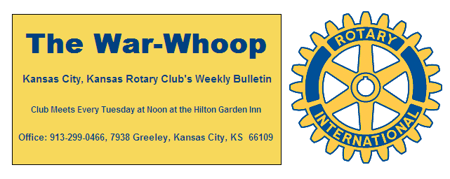
Websites: Club: www.rotarydowntownkck.org, District: www.rotary5710.org, International: www.rotary.org

Volume 79 April 20, 2018 No. 40

LAST WEEK AT ROTARY-Female students from the local high schools spoke to Rotarians last Tuesday. The students were from seven local high schools. Only two schools from the area did not participate this year. All the young ladies were well prepared as they presented themselves to Rotarians. The master of ceremonies for the event was Ted Garcia. One of the students reported that her grandfather had perfect attendance in Rotary for forty years, so she understood some of the Rotary traditions. The ladies talked about current events and their family background. The judges this week were Terry Robinson, Claudine Sanders, Ken Davis, Bob Kimball, George Turner and Phil Gibbs.

President Fred opened the meeting and George Turner gave the invocation. Merle Parks introduced the visitors. A former Rotarian from Denver, Robert Hofman was introduced and has applied for membership in our Club. Robert was a guest of John Freshnock.

PAUL HARRIS DRAWING- Bruce Schlosser won the right to draw the right to draw for the joker last Tuesday. Bruce did not draw the joker and the amount will go $146.00 for next week’s drawing.

KC DAY- Kansas City Day raised over $250,000 to help camp and other local charities.

NEXT WEEK AT ROTARY- Shanelle Dupree will present a program on the Wildwood Outdoor Education Center. The camp is located on 150 acres in Miami County, Kansas. The mission of the camp is to bring kids outside and grow together transforming summer into a season of learning, youth development and outdoor adventure for low-income Kansas City area youth. Mrs. Dupree is the wife of Mark Dupree.

Ted Garcia is the program chair for the month of April.

NEW MEMBER PROPOSAL- The following person has been proposed for membership and has the approval of the board of directors. Any objections to the person listed must be made within seven days of the date of this War Whoop.

PROPOSER: Karole Bradford

JENNIFER VEWERS
Classification: Non Profit/Dir of Development
Business Address: 636 Tauromee (Duchesne Clinic)
Business telephone: 913-321-2626
Residence Address: 5708 West 98th St (Overland Park)
Residence: Telephone: 913-375-5335

No previous Rotary Experience

ROTARY DISTRICT CONFERENCE- This is the last week to register for the 2018 Rotary District Conference. The deadline is this Sunday, April 22nd.

HEALTH REPORT- Pat Crilly reports that his wife, Rosie is doing well after recent hip removal surgery.

CONVERSATION(in 1955)-“Did you hear that the post office is thinking about charging seven cents just to mail a letter”.

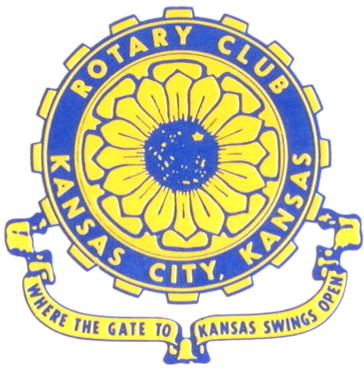
Where the Gate to Kansas Swings Open
The Kansas City, Kansas Rotary Club was organized on November 2, 1915 and received its charter as Club No. 195 in January 1916. Its members take pride in more than 100 years of Rotary service to the community and to international fellowship. From this Club have come five District Governors and two Directors of Rotary International. The Club’s history is as rich as that of the community it represents. Following the Lewis and Clark expedition which camped at the nsas City, Kansas, this area became an important center for fur trappers. In the following years, many Indian tribes were relocated here from the East. In 1842 the Wyandot Indians acquired land here and founded a town. During this period, and for the next five decades, this area became the main gateway to the inviting majesty of the sprawling Kansas Prairie and the American West. This was where the frontier began. Pioneers found river transportation, outfitters and the beginning of the Santa Fe and Oregon Trails. After the covered wagons came major trunk railroads and barge lines.
In 1886, Kansas City, Kansas received its charter as an incorporated city, combining the towns of Wyandot, Argentine and Armourdale. (Rosedale was added in 1922.) Kansas City, Kansas is the site of the first industrial park in the United States, home of the prestigious University of Kansas Medical Center, and the location of the National Agricultural Hall of Fame and the nationally recognized Kansas Speedway.

Near the geographical and population centers of the contiguous United States, it is in the temperate latitudes at an elevation of 726 feet above sea level. The average rainfall is 35 inches. The average mean temperature ranges from 30°F in January to 80°F in July. The lowest recorded temperature was -23°F on December 23, 1989, and the highest was 113°F on August 14, 1936. Our city’s population of 145,000 and 155 square miles rank it 158th among cities in the United States.

Welcome to Kansas City, Kansas Rotary, and the vibrant community it represents.

Rotary Websites:
KCK Club: www.rotarydowntownkck.org, District: www.rotary5710.org, International: www.rotary.org

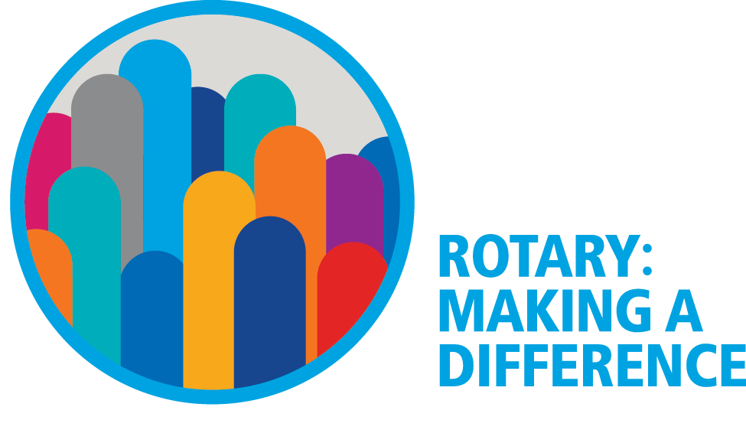

WHERE NEARBY TO MAKE UP ATTENDANCE
MONDAY
Bonner Springs (11:45am) --------------------------------- Twister Bar & Grill, 13100 Kansas Ave.
Overland Park (11:30am) ----------------------------------- Doubletree Hotel, 10100 College Blvd.
TUESDAY
Gladstone (7:00am) -------------------------------------- Fairview Christian Church, 1800 N.E. 65th
Johnson County-Sunset (5:15pm) ------------------------- Hilton Garden Inn Olathe, 119th & I-35
WEDNESDAY
Overland Park South (7:15am) ------------------------ Deer Creek Country Club, 7000 W. 133rd
Leavenworth (Noon) --------------------------- Riverfront Community Center, 123 S. Esplanade
KCI, Missouri (Noon) -------------------------------- Granite City Pub, 8461 NW Prairie View Rd.
Shawnee Mission (Noon) ----------------------------- Sylvester Powell Center, Martway & Lamar
Olathe (Noon) -------------------------------- Olathe Community Ctr, 1205 E. Kansas City Road
Kansas City South, Missouri (Noon) ------------------------------- Jess & Jim’s, 517 E. 135th St.
Waldo-Brookside, Missouri (5:15pm) ----------------------------- Waldo Pizza, 7433 Broadway
THURSDAY
Johnson County (7:15am) --------------------------- Crowne Plaza Hotel, 12601 W. 95th, Lenexa
Leawood (7:15am) ---------------------------------- Hallbrook Country Club, 11200 Overbrook Rd
Village West (7:15am) -------------------------- Famous Dave’s, 1320 Village West Pkwy., KCK
Gardner (7:30am) ---------------------------------------------- Gardner Community Ctr., 128 E. Park
Santa Fe Trail (7:30am) --- Mid-Am Nazarene U, 2030 E. College Way, Campus Ctr.,Olathe
Kansas City, Missouri (Noon) -------------------------------- The Gallery, 61 E. 14th Street, KCMO
FRIDAY
Desoto (7:00am) ------------------------ Desoto United Methodist Church, 8760 Kill Creek Road
Shawnee (7:15am) --------------------------------------------------- Town Hall, 11600 Johnson Drive
Plaza, Missouri (7:15am) ------------------------------------ Grand Street Cafe, 4740 Grand Ave.
North Kansas City, Missouri (Noon) ------------------------------ NKC Library, 2251 Howell Street
Parkville, Missouri (Noon) ------------------------ Park University Underground, Woodard Center
Lenexa (Noon) ------------------------------- Lakeview Village, Southridge Bldg., 14001 W. 92nd

Meeting make ups can be made 14 days before or after the missed meeting.
Please see the Secretary for the world directory of all Rotary Club’s meeting times, days and places.

2017-2018 Board of Directors
Officers Directors
Fred Zimmerman Rick Behrens
President Karole Bradford
Melissa Sieben John Freshnock
Vice President Phil Gibbs
Greg Shondell Wendell Maddox
Treasurer Tony Martinez
Jim Knight Terry Robinson
Secretary Bruce Schlosser
Rosemary Podrebarac
Sergeant at Arms
Ashley Adorante
Past President

