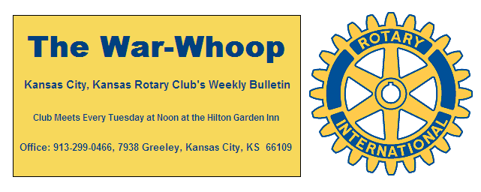
Websites: Club: www.rotarydowntownkck.org, District: www.rotary5710.org, International: www.rotary.org

Volume 79 April 27, 2018 No. 41

LAST WEEK AT ROTARY- Shanelle Dupree and Robyn Radcliff talked about the Wildwood Education Center. The Camp is located on 150 acres in Miami County, Kansas. The Wildwood property was originally owned by George and Hilda Powell. In 1980, the land and facilities were donated and became the Wildwood Center. A variety of outdoor classroom environments include ponds, meadows and wooded hills and a staff to provide a great experience for inter-city youth. They showed a power point presentation on what the camp offers campers and what the camp looks like. The camp is open to youth between the ages of 8 to 18 years. Eighty percent of the kids attending need financial aide. Bus transportation is provided for the campers. Each summer campers experience a season of learning, youth development, and outdoor adventure for low-income Kansas City area youth.

President Fred opened the meeting and Chris MCord gave the invocation. Scott Kaufmann led the singing and Mike Calwell introduced the visitors.

PAUL HARRIS DRAWING- Bruce Schlosser won the right to draw for the joker last Tuesday for the second week in a row. However, this week Bruce drew the joker and split the $157.00.

DISTRICT CONFERENCE- The Annual District Conference will be held this weekend, April 27-28th in Lenexa.

NEXT WEEK AT ROTARY- Rotary will honor our teachers of the year next week. This annual recognition program will honor local teachers that are picked by the local high school administrators.
Tim Ryan is the program chair for the month of May.

ANNUAL PROGRAM CHAIRS- Chair Andrea Spalding announced last Tuesday that she has only two months to fill for next year’s program chairs. Members interested in serving as a monthly program chair should contact Andrea at 913-219-8568. This might be an opportunity for two members to take one month.

EARTH DAY-Twelve Rotarians celebrated Earth Day by planting a tree at city park last Tuesday afternoon after our regular luncheon meeting. The pictures of the event are in face book under Ashley Adorante’s name. Rotary members in attendance were Rick Behrens, Pat Crilly, Dan Duncan, Scott Martens, Bruce Schlosser, Andrea Spalding, Melissa Sieben, Donna Severance, Frank Simonich, Kathleen VonAchen and president Fred Zimmerman.

OUR ROAMING ROTARIANS
North Kansas City------------------------------------Dave Tyler
Louisburg, Kansas----------------------------------- Bill Strumillo
Dave continues to be 100% with his makeup. Bill tells us that this was his first makeup and the experience was fun.
.
2018-2019 DISTRICT GOVERNOR- The District Governor for next year will be Blanche Parks, member of the Topeka Downtown Club.

THINK-‘SOME THINGS are better left unsaid which I generally realize that right after I have said them”.

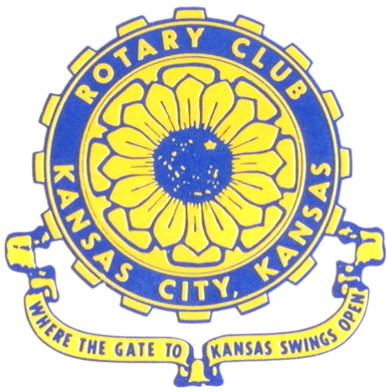
Where the Gate to Kansas Swings Open
The Kansas City, Kansas Rotary Club was organized on November 2, 1915 and received its charter as Club No. 195 in January 1916. Its members take pride in more than 100 years of Rotary service to the community and to international fellowship. From this Club have come five District Governors and two Directors of Rotary International. The Club’s history is as rich as that of the community it represents. Following the Lewis and Clark expedition which camped at the nsas City, Kansas, this area became an important center for fur trappers. In the following years, many Indian tribes were relocated here from the East. In 1842 the Wyandot Indians acquired land here and founded a town. During this period, and for the next five decades, this area became the main gateway to the inviting majesty of the sprawling Kansas Prairie and the American West. This was where the frontier began. Pioneers found river transportation, outfitters and the beginning of the Santa Fe and Oregon Trails. After the covered wagons came major trunk railroads and barge lines.
In 1886, Kansas City, Kansas received its charter as an incorporated city, combining the towns of Wyandot, Argentine and Armourdale. (Rosedale was added in 1922.) Kansas City, Kansas is the site of the first industrial park in the United States, home of the prestigious University of Kansas Medical Center, and the location of the National Agricultural Hall of Fame and the nationally recognized Kansas Speedway.

Near the geographical and population centers of the contiguous United States, it is in the temperate latitudes at an elevation of 726 feet above sea level. The average rainfall is 35 inches. The average mean temperature ranges from 30°F in January to 80°F in July. The lowest recorded temperature was -23°F on December 23, 1989, and the highest was 113°F on August 14, 1936. Our city’s population of 145,000 and 155 square miles rank it 158th among cities in the United States.

Welcome to Kansas City, Kansas Rotary, and the vibrant community it represents.

Rotary Websites:
KCK Club: www.rotarydowntownkck.org, District: www.rotary5710.org, International: www.rotary.org

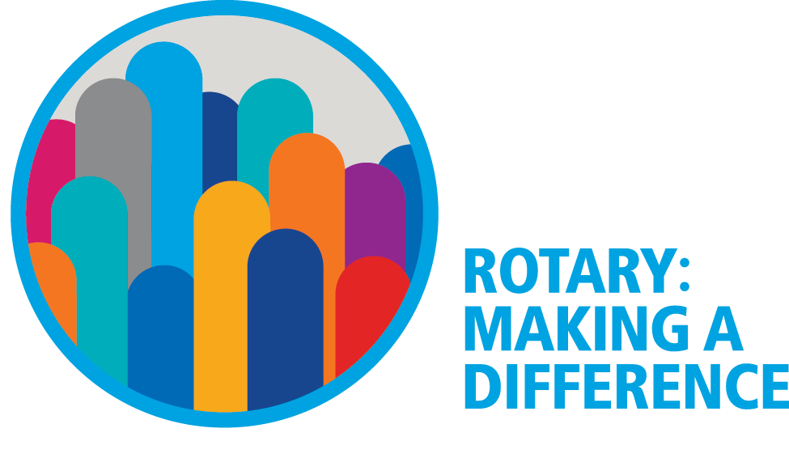

WHERE NEARBY TO MAKE UP ATTENDANCE
MONDAY
Bonner Springs (11:45am) --------------------------------- Twister Bar & Grill, 13100 Kansas Ave.
Overland Park (11:30am) ----------------------------------- Doubletree Hotel, 10100 College Blvd.
TUESDAY
Gladstone (7:00am) -------------------------------------- Fairview Christian Church, 1800 N.E. 65th
Johnson County-Sunset (5:15pm) ------------------------- Hilton Garden Inn Olathe, 119th & I-35
WEDNESDAY
Overland Park South (7:15am) ------------------------ Deer Creek Country Club, 7000 W. 133rd
Leavenworth (Noon) --------------------------- Riverfront Community Center, 123 S. Esplanade
KCI, Missouri (Noon) -------------------------------- Granite City Pub, 8461 NW Prairie View Rd.
Shawnee Mission (Noon) ----------------------------- Sylvester Powell Center, Martway & Lamar
Olathe (Noon) -------------------------------- Olathe Community Ctr, 1205 E. Kansas City Road
Kansas City South, Missouri (Noon) ------------------------------- Jess & Jim’s, 517 E. 135th St.
Waldo-Brookside, Missouri (5:15pm) ----------------------------- Waldo Pizza, 7433 Broadway
THURSDAY
Johnson County (7:15am) --------------------------- Crowne Plaza Hotel, 12601 W. 95th, Lenexa
Leawood (7:15am) ---------------------------------- Hallbrook Country Club, 11200 Overbrook Rd
Village West (7:15am) -------------------------- Famous Dave’s, 1320 Village West Pkwy., KCK
Gardner (7:30am) ---------------------------------------------- Gardner Community Ctr., 128 E. Park
Santa Fe Trail (7:30am) --- Mid-Am Nazarene U, 2030 E. College Way, Campus Ctr.,Olathe
Kansas City, Missouri (Noon) -------------------------------- The Gallery, 61 E. 14th Street, KCMO
FRIDAY
Desoto (7:00am) ------------------------ Desoto United Methodist Church, 8760 Kill Creek Road
Shawnee (7:15am) --------------------------------------------------- Town Hall, 11600 Johnson Drive
Plaza, Missouri (7:15am) ------------------------------------ Grand Street Cafe, 4740 Grand Ave.
North Kansas City, Missouri (Noon) ------------------------------ NKC Library, 2251 Howell Street
Parkville, Missouri (Noon) ------------------------ Park University Underground, Woodard Center
Lenexa (Noon) ------------------------------- Lakeview Village, Southridge Bldg., 14001 W. 92nd

Meeting make ups can be made 14 days before or after the missed meeting.
Please see the Secretary for the world directory of all Rotary Club’s meeting times, days and places.

2017-2018 Board of Directors
Officers Directors
Fred Zimmerman Rick Behrens
President Karole Bradford
Melissa Sieben John Freshnock
Vice President Phil Gibbs
Greg Shondell Wendell Maddox
Treasurer Tony Martinez
Jim Knight Terry Robinson
Secretary Bruce Schlosser
Rosemary Podrebarac
Sergeant at Arms
Ashley Adorante
Past President

