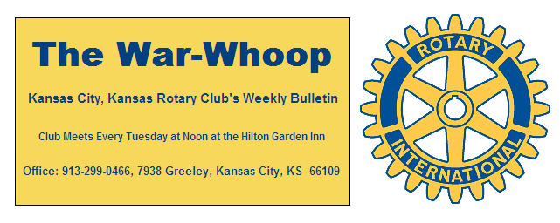
Websites: Club: www.rotarydowntownkck.org, District: www.rotary5710.org, International: www.rotary.org

Volume 79 May 4, 2018 No. 42

LAST WEEK AT ROTARY – The Club presented Educator of the Year Awards to teachers from the nine Wyandotte County high schools. An administrator from each school introduced the honoree to the Club and provided background on the reason for the individual’s selection. The 2018 KCK Rotary Educator of the Year award winners are: Maggi Schoonover from J.C. Harmon High School; Mark Western from F. L. Schlagle High School; Sean Kepple from Sumner Academy; Jacqueline Smola from Washington High School; Joanne Postlewait from Wyandotte High School; Tierney Thompson from Bonner Springs High School; Katheryn Smith from Turner High School; Dr. Cindy Horchem from Piper High School; and Kevin Walterbach from Bishop Ward High School. Congratulations to all these wonderful teachers!

President Fred opened the meeting, David Bluford gave the invocation, and Bill Epperheimer introduced the visitors. Scott Kaufmann led the Club in singing Happy Birthday to those members with May birthdays: Bob Kimball, Jim Knight, Karla Nichols, and Tim Ryan.

President Fred also introduced our newest member, Jennifer Wewers, for the first time. Jennifer’s classification in the Club will be Non-profit. Please welcome Jennifer to KCK Rotary!

PAUL HARRIS DRAWING – The Paul Harris drawing will return next week, beginning with a new zero balance after Bruce Schlosser won half of the pot, and President Fred presented him with a check for $78.50.

NEXT WEEK AT ROTARY - Kurt Mayo, Executive Director of the Greater Kansas City Hotel and Lodging Association, will be our speaker next week. Members will recall Kurt from his time as the former General Manager of the Hilton Garden Inn. Kurt will present about the hotel environment in the Kansas City area, including information on new hotel projects and some current challenges for the organization and its members.
Tim Ryan is the program chair for the month of May.

VETERANS VILLAGE PROJECT – At its meeting on Wednesday, May 2nd, the Board packed 13 personal hygiene kits for the veterans currently living at the Veterans Village – Kansas City, a community of tiny homes run by Veterans Community Project – Kansas City and located at 8900 Troost. Thanks to all members who donated the personal care products that we used to pack the boxes. For anyone still interested in donating to the veterans living at the Veterans Village, Andrea Spalding, who is heading up this project, reports that the program coordinator advises that gift cards for gas (such as a QuikTrip gift card) or gift cards to Dollar Tree are always needed to assist veterans who are low on funds.

NEW DIRECTORY – It’s that time again! With the new Rotary year beginning on July 1st, we will need member photos for all new members. Greg Shondell will be available at our meeting on May 15th to take photos for any new members who wish to have their picture taken, as well as for seasoned members who wish to update their photos. If you already have a photo that you would like to use for the Club Directory, please forward the digital image to Secretary Jim.

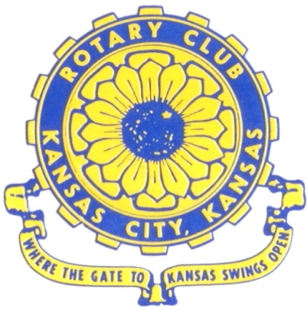
Where the Gate to Kansas Swings Open
The Kansas City, Kansas Rotary Club was organized on November 2, 1915 and received its charter as Club No. 195 in January 1916. Its members take pride in more than 100 years of Rotary service to the community and to international fellowship. From this Club have come five District Governors and two Directors of Rotary International. The Club’s history is as rich as that of the community it represents. Following the Lewis and Clark expedition which camped at the nsas City, Kansas, this area became an important center for fur trappers. In the following years, many Indian tribes were relocated here from the East. In 1842 the Wyandot Indians acquired land here and founded a town. During this period, and for the next five decades, this area became the main gateway to the inviting majesty of the sprawling Kansas Prairie and the American West. This was where the frontier began. Pioneers found river transportation, outfitters and the beginning of the Santa Fe and Oregon Trails. After the covered wagons came major trunk railroads and barge lines.
In 1886, Kansas City, Kansas received its charter as an incorporated city, combining the towns of Wyandot, Argentine and Armourdale. (Rosedale was added in 1922.) Kansas City, Kansas is the site of the first industrial park in the United States, home of the prestigious University of Kansas Medical Center, and the location of the National Agricultural Hall of Fame and the nationally recognized Kansas Speedway.

Near the geographical and population centers of the contiguous United States, it is in the temperate latitudes at an elevation of 726 feet above sea level. The average rainfall is 35 inches. The average mean temperature ranges from 30°F in January to 80°F in July. The lowest recorded temperature was -23°F on December 23, 1989, and the highest was 113°F on August 14, 1936. Our city’s population of 145,000 and 155 square miles rank it 158th among cities in the United States.

Welcome to Kansas City, Kansas Rotary, and the vibrant community it represents.

Rotary Websites:
KCK Club: www.rotarydowntownkck.org, District: www.rotary5710.org, International: www.rotary.org

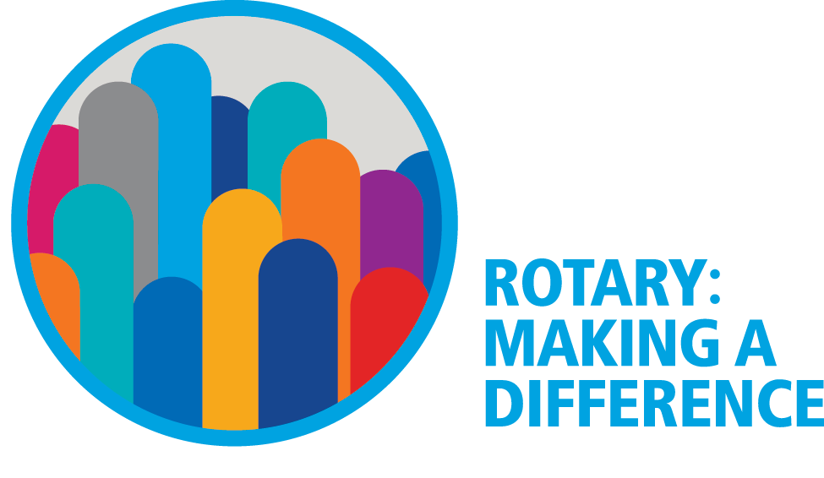

WHERE NEARBY TO MAKE UP ATTENDANCE
MONDAY
Bonner Springs (11:45am) --------------------------------- Twister Bar & Grill, 13100 Kansas Ave.
Overland Park (11:30am) ----------------------------------- Doubletree Hotel, 10100 College Blvd.
TUESDAY
Gladstone (7:00am) -------------------------------------- Fairview Christian Church, 1800 N.E. 65th
Johnson County-Sunset (5:15pm) ------------------------- Hilton Garden Inn Olathe, 119th & I-35
WEDNESDAY
Overland Park South (7:15am) ------------------------ Deer Creek Country Club, 7000 W. 133rd
Leavenworth (Noon) --------------------------- Riverfront Community Center, 123 S. Esplanade
KCI, Missouri (Noon) -------------------------------- Granite City Pub, 8461 NW Prairie View Rd.
Shawnee Mission (Noon) ----------------------------- Sylvester Powell Center, Martway & Lamar
Olathe (Noon) -------------------------------- Olathe Community Ctr, 1205 E. Kansas City Road
Kansas City South, Missouri (Noon) ------------------------------- Jess & Jim’s, 517 E. 135th St.
Waldo-Brookside, Missouri (5:15pm) ----------------------------- Waldo Pizza, 7433 Broadway
THURSDAY
Johnson County (7:15am) --------------------------- Crowne Plaza Hotel, 12601 W. 95th, Lenexa
Leawood (7:15am) ---------------------------------- Hallbrook Country Club, 11200 Overbrook Rd
Village West (7:15am) -------------------------- Famous Dave’s, 1320 Village West Pkwy., KCK
Gardner (7:30am) ---------------------------------------------- Gardner Community Ctr., 128 E. Park
Santa Fe Trail (7:30am) --- Mid-Am Nazarene U, 2030 E. College Way, Campus Ctr.,Olathe
Kansas City, Missouri (Noon) -------------------------------- The Gallery, 61 E. 14th Street, KCMO
FRIDAY
Desoto (7:00am) ------------------------ Desoto United Methodist Church, 8760 Kill Creek Road
Shawnee (7:15am) --------------------------------------------------- Town Hall, 11600 Johnson Drive
Plaza, Missouri (7:15am) ------------------------------------ Grand Street Cafe, 4740 Grand Ave.
North Kansas City, Missouri (Noon) ------------------------------ NKC Library, 2251 Howell Street
Parkville, Missouri (Noon) ------------------------ Park University Underground, Woodard Center
Lenexa (Noon) ------------------------------- Lakeview Village, Southridge Bldg., 14001 W. 92nd

Meeting make ups can be made 14 days before or after the missed meeting.
Please see the Secretary for the world directory of all Rotary Club’s meeting times, days and places.

2017-2018 Board of Directors
Officers Directors
Fred Zimmerman Rick Behrens
President Karole Bradford
Melissa Sieben John Freshnock
Vice President Phil Gibbs
Greg Shondell Wendell Maddox
Treasurer Tony Martinez
Jim Knight Terry Robinson
Secretary Bruce Schlosser
Rosemary Podrebarac
Sergeant at Arms
Ashley Adorante
Past President

