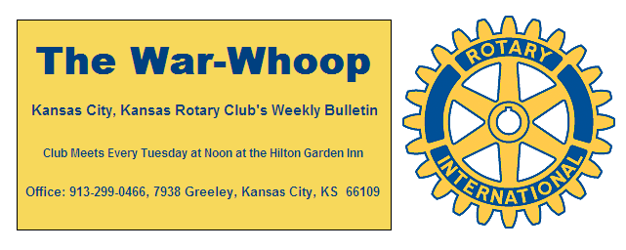
Websites: Club: www.rotarydowntownkck.org, District: www.rotary5710.org, International: www.rotary.org

Volume 80 October 5, 2018 No.13

LAST WEEK AT ROTARY-Jim Mattes, Past District Gove-rnor and Rotary Foundation chairman for this year talked about and showed a power point presentation on the foundation. While October is Polio Plus month, November is Rotary Foundation month. According to Mattes, the Foundation is transforming the world “one child at a time”. Rotary is dedicated to six areas of focus to build international relationships, improve lives and create a better world to support our peace efforts and end polio. The six areas are (1) Promoting Peace, (2) Fighting Diseases, (3)Providing Clean Water, Sanitation and Hygiene,(4) Saving Mothers and Children, (5)Supporting Education, and (6)Improving Local Economies.
Our Club was a Star Club last year as we averaged $100 per member. He went on to say that the money our club members give is doubled by the Foundation. Our District returned $79,000 in grants to projects in our district.
Jim encouraged all members to attend the Foundation Dinner on November 3rd. Registration for the time and place can be found in District newsletter.

President elect John Freshnock filled in for President Melissa and opened the meeting. Karole Bradford gave the invocation. Scott Kaufmann, back from Germany, led the singing and Ted Garcia introduced the visitors.

NEXT WEEK AT ROTARY- October is Polio Plus month. Jim Arnott, District Polio Plus Chairman will be our speaker next week. Jim’s wife is a polio survivor

President Melissa will be the program chair for the day and for the month.

PAUL HARRIS DRAWING- Todd Jordan, for the second week in a row won the right to draw for the joker last week. And for the second week in a row, Todd did not draw the joker and the amount goes to $184.00 for next week’s drawing.
Half of the winner’s pot goes to Rotary Foundation at the end of the year.

HAPPY BIRTHDAY- Scott led members in singing ”Happy Birthday” to Courtney Mikesic, Donna Severance Jen Wewers and George Turner. Members with birthdays in October, but not in attendance are Mark Dupree and Fred Zimmerman.

ROTARY PROJECT- Rotarians will be filling bags for the Flu Shot Clinic on Thursday, October 4th from 2:00- 4:00pn and then will help in registering individuals on Saturday, October 6th from 8:30-11:30am. Location of the Clinic is at 722 Reynolds. Still time to participate at either session.

OUR ROAMNG ROTARIANS
eClub 1 District 5450 Colorado----Terry Robinson
eClub of the Southwest USA------- Rosemary Podrebarac
eClub 1 District 5450 Minnesota—Rosemary Podrebarac

QUARTERLY DUES- Quarterly dues will be given out next week. If members want to be billed for Rotary Foundation and have not turned their pledge sheet, PLEASE contact the secretary by the end of this week BY EMAIL.

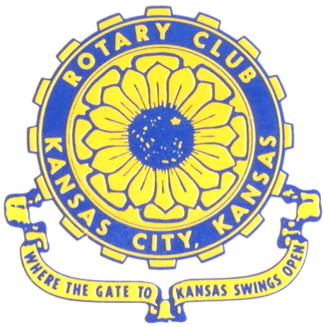
Where the Gate to Kansas Swings Open

The Kansas City, Kansas Rotary Club was organized on November 2, 1915 and received its charter as Club No. 195 in January 1916. Its members take pride in more than 100 years of Rotary service to the community and to international fellowship. From this Club have come five District Governors and two Directors of Rotary International. The Club’s history is as rich as that of the community it represents.

Following the Lewis and Clark expedition which camped at the confluence of the Kansas and Missouri rivers on June 26, 1804, in present day Kansas City, Kansas, this area became an important center for fur trappers. In the following years, many Indian tribes were relocated here from the East. In 1842 the Wyandot Indians acquired land here and founded a town. During this period, and for the next five decades, this area became the main gateway to the inviting majesty of the sprawling Kansas Prairie and the American West. This was where the frontier began. Pioneers found river transportation, outfitters and the beginning of the Santa Fe and Oregon Trails. After the covered wagons came major trunk railroads and barge lines.

In 1886, Kansas City, Kansas received its charter as an incorporated city, combining the towns of Wyandot, Argentine and Armourdale. (Rosedale was added in 1922.) Kansas City, Kansas is the site of the first industrial park in the United States, home of the prestigious University of Kansas Medical Center, and the location of the National Agricultural Hall of Fame and the nationally recognized Kansas Speedway.

Near the geographical and population centers of the contiguous United States, it is in the temperate latitudes at an elevation of 726 feet above sea level. The average rainfall is 35 inches. The average mean temperature ranges from 30°F in January to 80°F in July. The lowest recorded temperature was -23°F on December 23, 1989, and the highest was 113°F on August 14, 1936. Our city’s population of 145,000 and 155 square miles rank it 158th among cities in the United States.

Welcome to Kansas City, Kansas Rotary, and the vibrant community it represents.

Service Above Self

Rotary Websites:
KCK Club: www.rotarydowntownkck.org, District: www.rotary5710.org, International: www.rotary.org



WHERE NEARBY TO MAKE UP ATTENDANCE
MONDAY
Bonner Springs (11:45am) --------------------------------- Twister Bar & Grill, 13100 Kansas Ave.
Overland Park (11:30am) ----------------------------------- Doubletree Hotel, 10100 College Blvd.
TUESDAY
Gladstone (7:00am) -------------------------------------- Fairview Christian Church, 1800 N.E. 65th
Johnson County-Sunset (5:15pm) ------------------------- Hilton Garden Inn Olathe, 119th & I-35
WEDNESDAY
Overland Park South (7:15am) ------------------------ Deer Creek Country Club, 7000 W. 133rd
Leavenworth (Noon) --------------------------- Riverfront Community Center, 123 S. Esplanade
KCI, Missouri (Noon) -------------------------------- Granite City Pub, 8461 NW Prairie View Rd.
Shawnee Mission (Noon) ------------------ Downs Syndrome Guild, 5960 Dearborn, Mission
Olathe (Noon) ------------------------------------- Hilton Garden Inn, 12080 S. Strang Line Road
Kansas City South, Missouri (Noon) ------------------------------- Jess & Jim’s, 517 E. 135th St.
Waldo-Brookside, Missouri (5:15pm) ----------------------------- Waldo Pizza, 7433 Broadway
THURSDAY
Johnson County (7:15am) ----------------------------------- Clarion Hotel, 12601 W. 95th, Lenexa
Leawood (7:15am) ---------------------------------- Hallbrook Country Club, 11200 Overbrook Rd
Village West (7:15am) -------------------------- Famous Dave’s, 1320 Village West Pkwy., KCK
Gardner (7:30am) ---------------------------------------------- Gardner Community Ctr., 128 E. Park
Santa Fe Trail (7:30am) --- Mid-Am Nazarene U, 2030 E. College Way, Campus Ctr.,Olathe
Kansas City, Missouri (Noon) -------------------------------- The Gallery, 61 E. 14th Street, KCMO
FRIDAY
Desoto (7:00am) ------------------------ Desoto United Methodist Church, 8760 Kill Creek Road
Shawnee (7:15am) -------------------------------------- Shawnee Town Hall, 11600 Johnson Drive
Plaza, Missouri (7:15am) ------------------------------------- Grand Street Cafe, 4740 Grand Ave.
North Kansas City, Missouri (Noon) ------------------------------ NKC Library, 2251 Howell Street
Parkville, Missouri (Noon) ------------------------ Park University Underground, Woodard Center
Lenexa (Noon) --------------------- Lakeview Village, Southridge Bldg., 14001 W. 92nd, 5th Floor

Meeting make ups can be made 14 days before or after the missed meeting.
Please see the Secretary for the world directory of all Rotary Club’s meeting times, days and places.

2018-2019 Board of Directors
Officers Directors
Melissa Sieben Ashley Adorante
President Rick Behrens
John Freshnock Karole Bradford
Vice President Phil Gibbs
Greg Shondell Scott Martens
Treasurer Tony Martinez
Jim Knight Terry Robinson
Secretary Andrea Spalding
Rosemary Podrebarac Kathleen VonAchen
Sergeant at Arms
Fred Zimmerman
Past President

