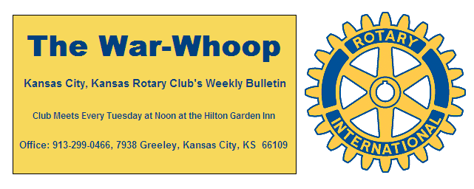
Websites: Club: www.rotarydowntownkck.org, District: www.rotary5710.org, International: www.rotary.org

Volume 80 October 26, 2018 No.16

LAST WEEK AT ROTARY –President Melissa hosted a question and answer period with Wonderous Burns, a polio victim, since an early age. According to Ms. Burns, she ws never told that she was disabled. Ms. Burns, wearing leg braces has led a most productive life working as a nanny and children’s homes. She also volunteers at the UG Offfices. She was born in Memphis, Tennessee and moved to New York and then Kansas City. Her hobby is following the Royal Family.
She told Rotarians that the disease weakens the muscle tissues. The braces have been added to her legs recently to help with a back problem. She added that she has no regrets having her problem.

President Melissa opened the meeting and Pat Crilly gave the invocation. Scott Kaufmann led the singing and Terry Robinson introduced the visitors. Merle Parks was the greeter. James Zeek, a member of the fire department was a guest of President Melissa.

PAUL HARRIS DRAWING- Mary Viveros won the right to joker. Bill Porter, drawing for Mary, did not draw the joker and the amount goes to $27.00 for the drawing in two weeks.

NEXT WEEK AT ROTARY- Next Tuesday is the Polio Costume Party at the Indigo Hotel at 2020 Grand Ave from 6:00-9:00PM. There will be entertainment, wine, beer and Hors D’oeuves plus a silent auction during the evening. The event is a fund raiser for Polio.
Secretary will be at the Hilton Garden Inn from 12:00- 12:30pm on Tuesday for members not able to attend the party that evening.

OUR ROAMING ROTARIANS
Overland Park-------------------------------------Dave Skidgel
eClub District 5450 Toronto, Canada-------Terry Robinson

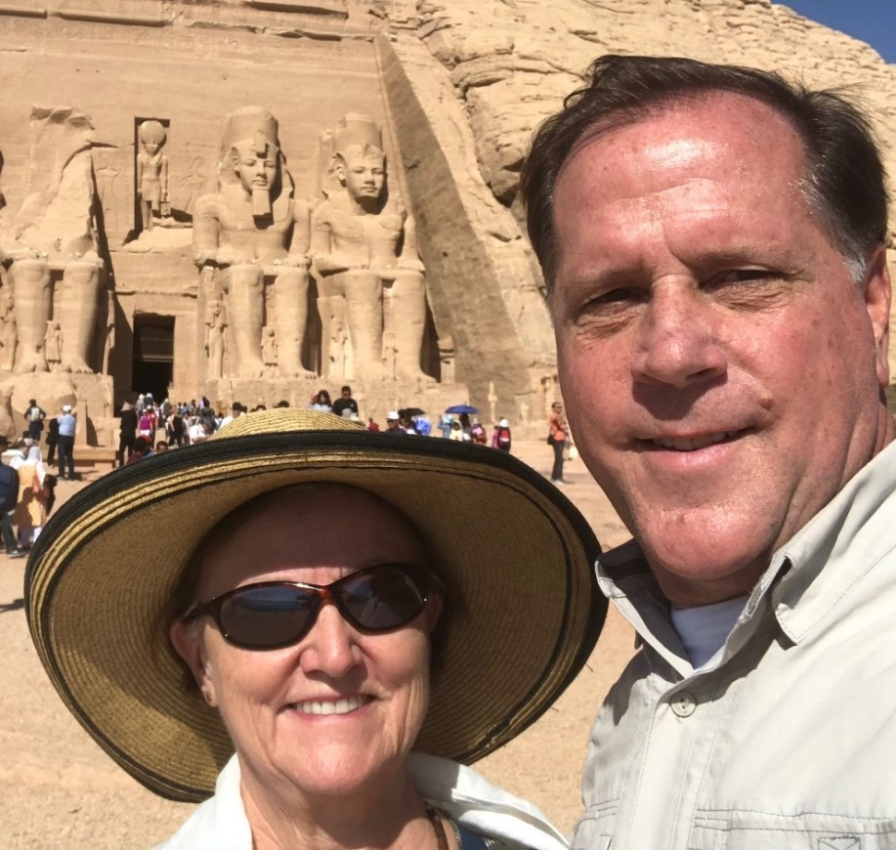
Greg Shondell and Cecelia Woods in Egypt.(Abu Simbel Temple). They said that it was 110 degrees when this photo was taken last week.

FOUNDATION DINNER- District Foundation Dinner will be held on November 3rd at the Overland Park Sheraton. Members interesting in attending should register on line by October 29th .

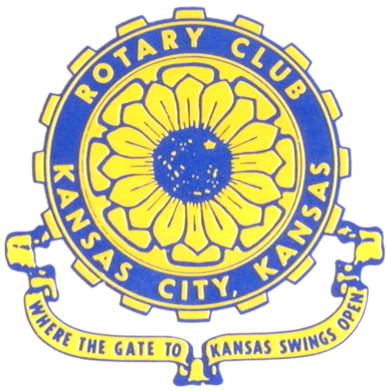
Where the Gate to Kansas Swings Open

The Kansas City, Kansas Rotary Club was organized on November 2, 1915 and received its charter as Club No. 195 in January 1916. Its members take pride in more than 100 years of Rotary service to the community and to international fellowship. From this Club have come five District Governors and two Directors of Rotary International. The Club’s history is as rich as that of the community it represents.

Following the Lewis and Clark expedition which camped at the confluence of the Kansas and Missouri rivers on June 26, 1804, in present day Kansas City, Kansas, this area became an important center for fur trappers. In the following years, many Indian tribes were relocated here from the East. In 1842 the Wyandot Indians acquired land here and founded a town. During this period, and for the next five decades, this area became the main gateway to the inviting majesty of the sprawling Kansas Prairie and the American West. This was where the frontier began. Pioneers found river transportation, outfitters and the beginning of the Santa Fe and Oregon Trails. After the covered wagons came major trunk railroads and barge lines.

In 1886, Kansas City, Kansas received its charter as an incorporated city, combining the towns of Wyandot, Argentine and Armourdale. (Rosedale was added in 1922.) Kansas City, Kansas is the site of the first industrial park in the United States, home of the prestigious University of Kansas Medical Center, and the location of the National Agricultural Hall of Fame and the nationally recognized Kansas Speedway.

Near the geographical and population centers of the contiguous United States, it is in the temperate latitudes at an elevation of 726 feet above sea level. The average rainfall is 35 inches. The average mean temperature ranges from 30°F in January to 80°F in July. The lowest recorded temperature was -23°F on December 23, 1989, and the highest was 113°F on August 14, 1936. Our city’s population of 145,000 and 155 square miles rank it 158th among cities in the United States.

Welcome to Kansas City, Kansas Rotary, and the vibrant community it represents.

Service Above Self

Rotary Websites:
KCK Club: www.rotarydowntownkck.org, District: www.rotary5710.org, International: www.rotary.org



WHERE NEARBY TO MAKE UP ATTENDANCE
MONDAY
Bonner Springs (11:45am) --------------------------------- Twister Bar & Grill, 13100 Kansas Ave.
Overland Park (11:30am) ----------------------------------- Doubletree Hotel, 10100 College Blvd.
TUESDAY
Gladstone (7:00am) -------------------------------------- Fairview Christian Church, 1800 N.E. 65th
Johnson County-Sunset (5:15pm) ------------------------- Hilton Garden Inn Olathe, 119th & I-35
WEDNESDAY
Overland Park South (7:15am) ------------------------ Deer Creek Country Club, 7000 W. 133rd
Leavenworth (Noon) --------------------------- Riverfront Community Center, 123 S. Esplanade
KCI, Missouri (Noon) -------------------------------- Granite City Pub, 8461 NW Prairie View Rd.
Shawnee Mission (Noon) ------------------ Downs Syndrome Guild, 5960 Dearborn, Mission
Olathe (Noon) ------------------------------------- Hilton Garden Inn, 12080 S. Strang Line Road
Kansas City South, Missouri (Noon) ------------------------------- Jess & Jim’s, 517 E. 135th St.
Waldo-Brookside, Missouri (5:15pm) ----------------------------- Waldo Pizza, 7433 Broadway
THURSDAY
Johnson County (7:15am) ----------------------------------- Clarion Hotel, 12601 W. 95th, Lenexa
Leawood (7:15am) ---------------------------------- Hallbrook Country Club, 11200 Overbrook Rd
Village West (7:15am) -------------------------- Famous Dave’s, 1320 Village West Pkwy., KCK
Gardner (7:30am) ---------------------------------------------- Gardner Community Ctr., 128 E. Park
Santa Fe Trail (7:30am) --- Mid-Am Nazarene U, 2030 E. College Way, Campus Ctr.,Olathe
Kansas City, Missouri (Noon) -------------------------------- The Gallery, 61 E. 14th Street, KCMO
FRIDAY
Desoto (7:00am) ------------------------ Desoto United Methodist Church, 8760 Kill Creek Road
Shawnee (7:15am) -------------------------------------- Shawnee Town Hall, 11600 Johnson Drive
Plaza, Missouri (7:15am) ------------------------------------- Grand Street Cafe, 4740 Grand Ave.
North Kansas City, Missouri (Noon) ------------------------------ NKC Library, 2251 Howell Street
Parkville, Missouri (Noon) ------------------------ Park University Underground, Woodard Center
Lenexa (Noon) --------------------- Lakeview Village, Southridge Bldg., 14001 W. 92nd, 5th Floor

Meeting make ups can be made 14 days before or after the missed meeting.
Please see the Secretary for the world directory of all Rotary Club’s meeting times, days and places.

2018-2019 Board of Directors
Officers Directors
Melissa Sieben Ashley Adorante
President Rick Behrens
John Freshnock Karole Bradford
Vice President Phil Gibbs
Greg Shondell Scott Martens
Treasurer Tony Martinez
Jim Knight Terry Robinson
Secretary Andrea Spalding
Rosemary Podrebarac Kathleen VonAchen
Sergeant at Arms
Fred Zimmerman
Past President

