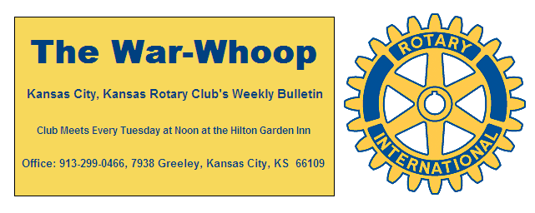
Websites: Club: www.rotarydowntownkck.org, District: www.rotary5710.org, International: www.rotary.org

Volume 80 November 23, 2018 No.20

LAST WEEK AT ROTARY- Cheri Thomas-Lightner, Master Food Volunteer for the K-State Extension Service, talked about food preparation. She told members that there are myths in eating food. They are:
- If it smells ok, it is good to eat. Over 48 million people get sick and 3,000 die from eating spoiled food last year.
- If you get sick, it is usually the last food you ate. You can get sick from food that you have eaten in a six week period.
- People use to never get sick from eating food
- Left over food in a bowl with a cover lid. Needs to be placed in a refrigerator within two hours.
How should a person handle food:
- Wash your hands, wash your hands.
- Wash your produce, vegetables, fruit
- Clean your work area.
- Cook food to the proper temperature.
She answered many questions about food preparation after her presentation. She gave every Rotarian a food thermometer to use in food preparation

President Melissa opened the meeting and Jen Wewers gave the invocation. Scott Kaufmann led the singing and Bill Porter introduced the visitors.

PROGRAM FOR NEXT WEEK- New Superintendent of District 500, Dr. Charles Foust, will be our speaker. When asked what he will be speaking about, we were told “Get to Know Him.” This would be a good program to invite guests and yes get to know who he is.
Robert Hofmann will be the program chair for the day.

INTRODUCTION- President Melissa introduced the newest member of Rotary, Jay Dunlap, for the second time. Jay was presented with his Rotary plaque. Jay is the president of Bishop Ward High School. Jay’s classification in Rotary will be Private Education Administration. Please welcome Jay when you meet him next week.

ELECTION OF OFFICERS AND BOARD MEMBERS- Election of officers and board members will be held on Tuesday, December 11th at our regular luncheon. This year’s Nominating Committee is Fred Zimmerman, chair, Ashley Adorante and Hank Chamberlain.

PAUL HARRIS DRAWING-Greg Shondell won the right to draw the joker. Secretary Jim could not draw the joker for Greg and the amount goes to $68.00 for next week’s drawing.

PROGRAM CHAIRMAN- Scott Martens has agreed to take over the duties as the Program chairman for the rest of the 2018-19 year.

THOUGHT FOR THE DAY- “Sometimes I wish that I could just rewind back to the old days and press pause just for a little while.” (Positive outlook)

The Board of Directors
Wish you and your family
A Happy Thanksgiving
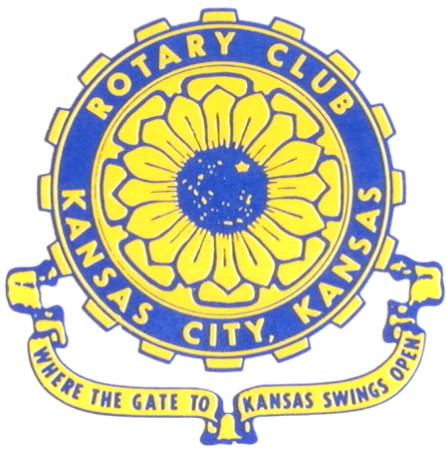
Where the Gate to Kansas Swings Open

The Kansas City, Kansas Rotary Club was organized on November 2, 1915 and received its charter as Club No. 195 in January 1916. Its members take pride in more than 100 years of Rotary service to the community and to international fellowship. From this Club have come five District Governors and two Directors of Rotary International. The Club’s history is as rich as that of the community it represents.

Following the Lewis and Clark expedition which camped at the confluence of the Kansas and Missouri rivers on June 26, 1804, in present day Kansas City, Kansas, this area became an important center for fur trappers. In the following years, many Indian tribes were relocated here from the East. In 1842 the Wyandot Indians acquired land here and founded a town. During this period, and for the next five decades, this area became the main gateway to the inviting majesty of the sprawling Kansas Prairie and the American West. This was where the frontier began. Pioneers found river transportation, outfitters and the beginning of the Santa Fe and Oregon Trails. After the covered wagons came major trunk railroads and barge lines.

In 1886, Kansas City, Kansas received its charter as an incorporated city, combining the towns of Wyandot, Argentine and Armourdale. (Rosedale was added in 1922.) Kansas City, Kansas is the site of the first industrial park in the United States, home of the prestigious University of Kansas Medical Center, and the location of the National Agricultural Hall of Fame and the nationally recognized Kansas Speedway.

Near the geographical and population centers of the contiguous United States, it is in the temperate latitudes at an elevation of 726 feet above sea level. The average rainfall is 35 inches. The average mean temperature ranges from 30°F in January to 80°F in July. The lowest recorded temperature was -23°F on December 23, 1989, and the highest was 113°F on August 14, 1936. Our city’s population of 145,000 and 155 square miles rank it 158th among cities in the United States.
Welcome to Kansas City, Kansas Rotary, and the vibrant community it represents.

Service
Self
Rotary Websites:
KCK Club: www.rotarydowntownkck.org, District: www.rotary5710.org, International: www.rotary.org


WHERE NEARBY TO MAKE UP ATTENDANCE
MONDAY
Bonner Springs (11:45am) --------------------------------- Twister Bar & Grill, 13100 Kansas Ave.
Overland Park (11:30am) ----------------------------------- Doubletree Hotel, 10100 College Blvd.
TUESDAY
Gladstone (7:00am) -------------------------------------- Fairview Christian Church, 1800 N.E. 65th
Johnson County-Sunset (5:15pm) ------------------------- Hilton Garden Inn Olathe, 119th & I-35
WEDNESDAY
Overland Park South (7:15am) ------------------------ Deer Creek Country Club, 7000 W. 133rd
Leavenworth (Noon) --------------------------- Riverfront Community Center, 123 S. Esplanade
KCI, Missouri (Noon) -------------------------------- Granite City Pub, 8461 NW Prairie View Rd.
Shawnee Mission (Noon) ------------------ Downs Syndrome Guild, 5960 Dearborn, Mission
Olathe (Noon) ------------------------------------- Hilton Garden Inn, 12080 S. Strang Line Road
Kansas City South, Missouri (Noon) ------------------------------- Jess & Jim’s, 517 E. 135th St.
Waldo-Brookside, Missouri (5:15pm) ----------------------------- Waldo Pizza, 7433 Broadway
THURSDAY
Johnson County (7:15am) ----------------------------------- Clarion Hotel, 12601 W. 95th, Lenexa
Leawood (7:15am) ---------------------------------- Hallbrook Country Club, 11200 Overbrook Rd
Village West (7:15am) -------------------------- Famous Dave’s, 1320 Village West Pkwy., KCK
Gardner (7:30am) ---------------------------------------------- Gardner Community Ctr., 128 E. Park
Santa Fe Trail (7:30am) --- Mid-Am Nazarene U, 2030 E. College Way, Campus Ctr.,Olathe
Kansas City, Missouri (Noon) -------------------------------- The Gallery, 61 E. 14th Street, KCMO
FRIDAY
Desoto (7:00am) ------------------------ Desoto United Methodist Church, 8760 Kill Creek Road
Shawnee (7:15am) -------------------------------------- Shawnee Town Hall, 11600 Johnson Drive
Plaza, Missouri (7:15am) ------------------------------------- Grand Street Cafe, 4740 Grand Ave.
North Kansas City, Missouri (Noon) ------------------------------ NKC Library, 2251 Howell Street
Parkville, Missouri (Noon) ------------------------ Park University Underground, Woodard Center
Lenexa (Noon) --------------------- Lakeview Village, Southridge Bldg., 14001 W. 92nd, 5th Floor

Meeting make ups can be made 14 days before or after the missed meeting.
Please see the Secretary for the world directory of all Rotary Club’s meeting times, days and places.

2018-2019 Board of Directors
Officers Directors
Melissa Sieben Ashley Adorante
President Rick Behrens
John Freshnock Karole Bradford
Vice President Phil Gibbs
Greg Shondell Scott Martens
Treasurer Tony Martinez
Jim Knight Terry Robinson
Secretary Andrea Spalding
Rosemary Podrebarac Kathleen VonAchen
Sergeant at Arms
Fred Zimmerman
Past President

