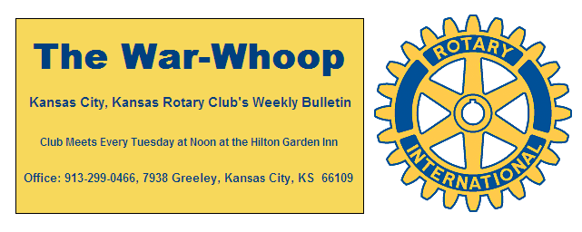
Websites: Club: www.rotarydowntownkck.org, District: www.rotary5710.org, International: www.rotary.org

Volume 80 February 22, 2019 No.31

LAST WEEK AT ROTARY- Alex Martinez, Safe and Welcoming Field Organizer for American Civil Liberties Union of Kansas talked about an effort in Wyandotte County to issue a Municipal ID card to citizens in the county. He stated that as many as 30,000 (1in 5) people in our county live without a government issue photo ID. This ID card can be used to prove a person’s identity with in the city/county limits or to access services from any institution that agrees to accept the card as a proof of identity. This means families can enroll children in school, open bank accounts, pick up prescriptions, and access health care. The ID card does not give driving privileges o take the place of state or federally issued identification cards.

President Melissa opened the meeting and Merle Parks gave the invocation. Scott Kaufmann led the singing. Bud Thurston introduced the visitors.

ROTARY GUESTS- Our Club was the host of seven Rotary members from the Kansas City, Missouri Club 13. The group call themselves ”The Ramblin Rotarians” and they visit other Rotary Clubs in the metro area every quarter. There were three past presidents and present president in the group. We had a full house last Tuesday. Great idea.

PAUL HARRIS DRAWING- Secretary Jim won the right to draw for the joker. Jim did not draw the joker and the amount for next week drawing goes to $181.00.

ROTARY NEXT WEEK- The fire department will provide the program next week as new Chief Michael Callahan will present the Public Safety Award to one of our firefighters. The new chief is from Chicago and this will be the first time our club will have an opportunity to meet the new chief. Make a special effort to be on hand to meet our new chief.
Todd Jordan is the program chairman for the day and for the month.

PAUL HARRIS AWARDS-President Melissa presented Hank Chamberlain and Scott Kaufman with their Paul Harris awards. Hank received his Paul Harris certificate and pin. Scott Kaufmann received his pin for Paul Harris Plus 1 award.

OUR ROAMING ROTARIAN
EClub of the West-------------------------------------Terry Robinson

CROSS LINES PROJECT- Jen Wewers announce that twenty one members have signed up for the Cross Lines project. There is still time to sign up for the project. The date is March 12th and the time is from 1:30-4:30pm. WE will journey down to Cross Lines right after our Rotary luncheon on the above date. Members need to sign up with Jen Wewers.

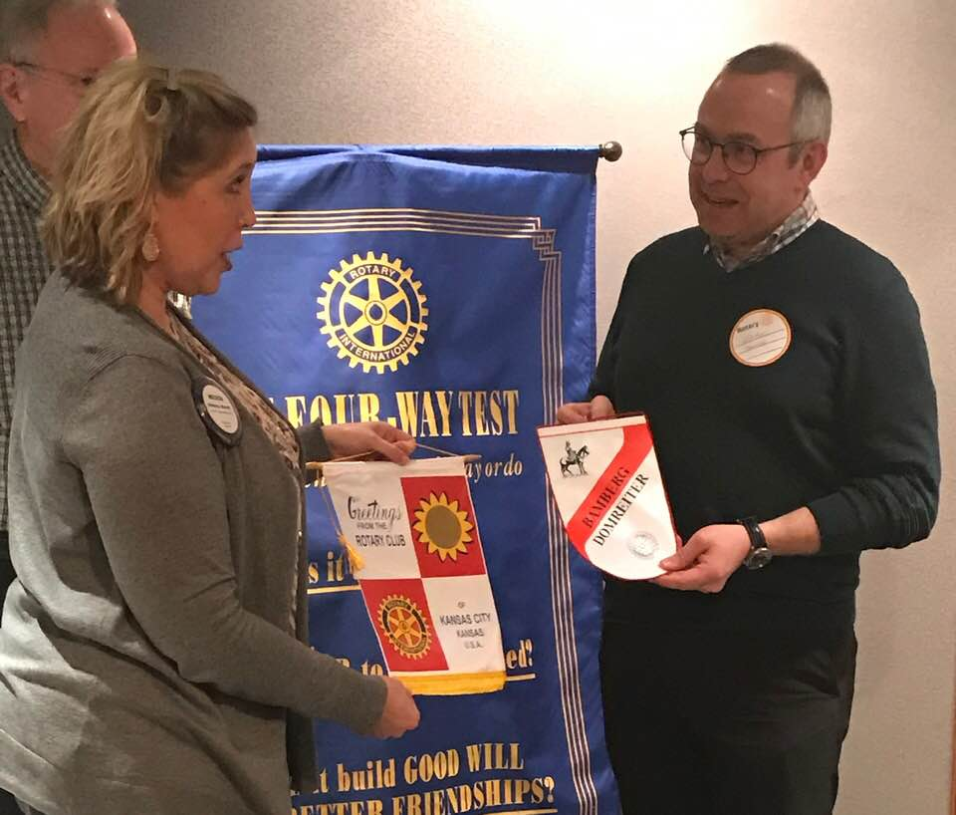
President Melissa exchanging banners with our guest Frank Poehlam, from Bamberg-Domreiter, Germany.

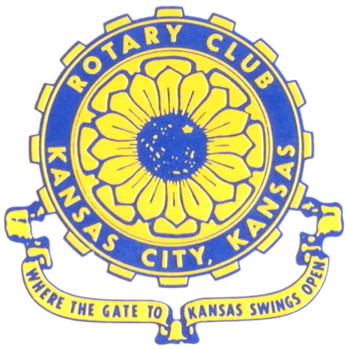
Where the Gate to Kansas Swings Open

The Kansas City, Kansas Rotary Club was organized on November 2, 1915 and received its charter as Club No. 195 in January 1916. Its members take pride in more than 100 years of Rotary service to the community and to international fellowship. From this Club have come five District Governors and two Directors of Rotary International. The Club’s history is as rich as that of the community it represents.

Following the Lewis and Clark expedition which camped at the confluence of the Kansas and Missouri rivers on June 26, 1804, in present day Kansas City, Kansas, this area became an important center for fur trappers. In the following years, many Indian tribes were relocated here from the East. In 1842 the Wyandot Indians acquired land here and founded a town. During this period, and for the next five decades, this area became the main gateway to the inviting majesty of the sprawling Kansas Prairie and the American West. This was where the frontier began. Pioneers found river transportation, outfitters and the beginning of the Santa Fe and Oregon Trails. After the covered wagons came major trunk railroads and barge lines.

In 1886, Kansas City, Kansas received its charter as an incorporated city, combining the towns of Wyandot, Argentine and Armourdale. (Rosedale was added in 1922.) Kansas City, Kansas is the site of the first industrial park in the United States, home of the prestigious University of Kansas Medical Center, and the location of the National Agricultural Hall of Fame and the nationally recognized Kansas Speedway.

Near the geographical and population centers of the contiguous United States, it is in the temperate latitudes at an elevation of 726 feet above sea level. The average rainfall is 35 inches. The average mean temperature ranges from 30°F in January to 80°F in July. The lowest recorded temperature was -23°F on December 23, 1989, and the highest was 113°F on August 14, 1936. Our city’s population of 145,000 and 155 square miles rank it 158th among cities in the United States.
Welcome to Kansas City, Kansas Rotary, and the vibrant community it represents.

Service Above Self
Rotary Websites:
KCK Club: www.rotarydowntownkck.org, District: www.rotary5710.org, International: www.rotary.org


WHERE NEARBY TO MAKE UP ATTENDANCE
MONDAY
Bonner Springs (11:45am) --------------------------------- Twister Bar & Grill, 13100 Kansas Ave.
Overland Park (11:30am) ----------------------------------- Doubletree Hotel, 10100 College Blvd.
TUESDAY
Gladstone (7:00am) -------------------------------------- Fairview Christian Church, 1800 N.E. 65th
Johnson County-Sunset (5:15pm) ------------------------- Hilton Garden Inn Olathe, 119th & I-35
WEDNESDAY
Overland Park South (7:15am) ------------------------ Deer Creek Country Club, 7000 W. 133rd
Leavenworth (Noon) --------------------------- Riverfront Community Center, 123 S. Esplanade
KCI, Missouri (Noon) -------------------------------- Granite City Pub, 8461 NW Prairie View Rd.
Shawnee Mission (Noon) ------------------ Downs Syndrome Guild, 5960 Dearborn, Mission
Olathe (Noon) ------------------------------------- Hilton Garden Inn, 12080 S. Strang Line Road
Kansas City South, Missouri (Noon) ------------------------------- Jess & Jim’s, 517 E. 135th St.
Waldo-Brookside, Missouri (5:15pm) ----------------------------- Waldo Pizza, 7433 Broadway
THURSDAY
Johnson County (7:15am) ----------------------------------- Clarion Hotel, 12601 W. 95th, Lenexa
Leawood (7:15am) ---------------------------------- Hallbrook Country Club, 11200 Overbrook Rd
Village West (7:15am) -------------------------- Famous Dave’s, 1320 Village West Pkwy., KCK
Gardner (7:30am) ---------------------------------------------- Gardner Community Ctr., 128 E. Park
Santa Fe Trail (7:30am) --- Mid-Am Nazarene U, 2030 E. College Way, Campus Ctr.,Olathe
Kansas City, Missouri (Noon) -------------------------------- The Gallery, 61 E. 14th Street, KCMO
FRIDAY
Desoto (7:00am) ------------------------ Desoto United Methodist Church, 8760 Kill Creek Road
Shawnee (7:15am) -------------------------------------- Shawnee Town Hall, 11600 Johnson Drive
Plaza, Missouri (7:15am) ------------------------------------- Grand Street Cafe, 4740 Grand Ave.
North Kansas City, Missouri (Noon) ------------------------------ NKC Library, 2251 Howell Street
Parkville, Missouri (Noon) ------------------------ Park University Underground, Woodard Center
Lenexa (Noon) --------------------- Lakeview Village, Southridge Bldg., 14001 W. 92nd, 5th Floor

Meeting make ups can be made 14 days before or after the missed meeting.
Please see the Secretary for the world directory of all Rotary Club’s meeting times, days and places.

2018-2019 Board of Directors
Officers Directors
Melissa Sieben Ashley Adorante
President Rick Behrens
John Freshnock Karole Bradford
Vice President Phil Gibbs
Greg Shondell Scott Martens
Treasurer Tony Martinez
Jim Knight Terry Robinson
Secretary Andrea Spalding
Rosemary Podrebarac Kathleen VonAchen
Sergeant at Arms
Fred Zimmerman
Past President

