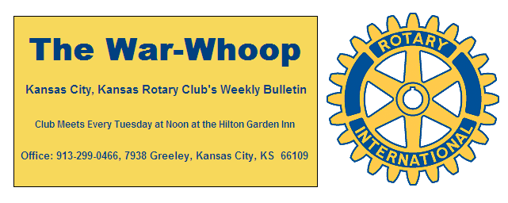
Websites: Club: www.rotarydowntownkck.org, District: www.rotary5710.org, International: www.rotary.org

Volume 80 March 01, 2019 No.32

LAST WEEK AT ROTARY-
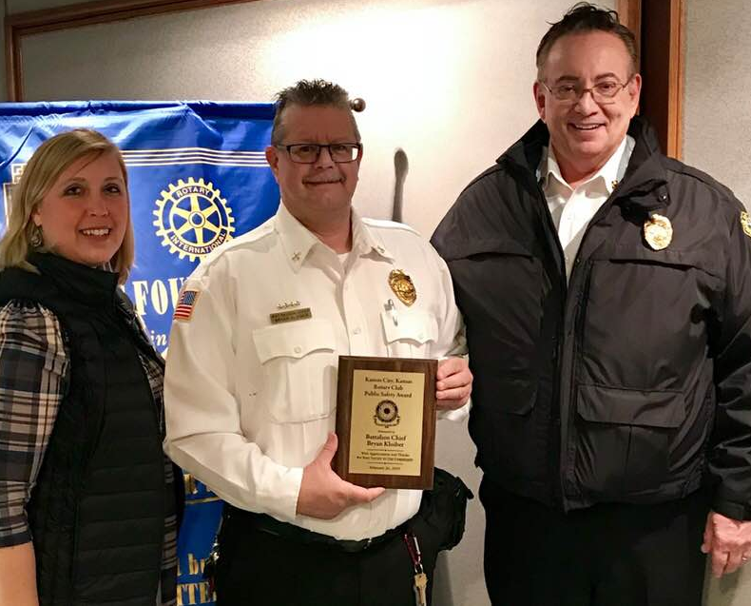
Wyandotte County new chief, Michael Callahan and President Melissa is shown presenting our Annual Public Safety Award to Battalion Chief Bryan Kloiber. Chief Kloiber is the fire investigator for the local fire department. He is also the Kansas State Investigator of the Year. Our program was interesting as Chief Callahan talked about his move from Chicago to our town and the differences. One of the big differences was that he had to drive 90 minutes to work every day in Chicago. Chief Kloiber also told some stories about his eperiences in investigating arson fires and people who were involved. They talked about some of the changes being made in Kansas City, Kansas.

NEXT WEEK AT ROTARY- Laura Loyacomo, Director of Education Engagement with Kansas State University, will talk about building opportunities to bring more multilingual , multi-cultural Wyandotte County kids into the health professions.

Karole Bradford is the program chair for the day and for the month.

President Melissa opened the meeting and Ted Garcia gave the invocation. Scott Kaufmann led the singing and Merle Parks introduced the visitors for the day. Phil Gibbs was the greeter for the day.

PAUL HARRIS DRAWING- Bruce Schlosser won the right to draw for the joker this week. Bruce did not draw the joker and the amount will go to $193.00 for next week.
Over the years there are 97 Kansas City, Kansas Rotarians that are Paul Harris Fellows. A list of those members are listed in the front of your Roster Book.

CROSS LINES PROJECT- Jen Wewers reminded members about the Cross Lines project. There is still time to sign up for the project. The date is March 12th and the time is from 1:30-4:30pm. Members will journey down to Cross Lines right after our Rotary luncheon on the above date. Members need to sign up with Jen Wewers.

APRIL PROJECT- Karole Bradford announced that Rotary will have a project in April. Our club will be a part of the Rosedale cleanup project. Sorry did not hear the date at this time.

THIS WEEK’S ROAMING ROTARIAN
Ruby Princess Cruise Ship----------------------Dan Duncan

THOUGHT FOR THE WEEK- “What automobiles need today is a set of brakes that will stop the car behind us.”

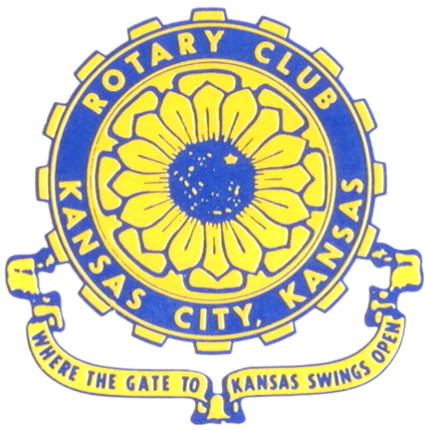
Where the Gate to Kansas Swings Open

The Kansas City, Kansas Rotary Club was organized on November 2, 1915 and received its charter as Club No. 195 in January 1916. Its members take pride in more than 100 years of Rotary service to the community and to international fellowship. From this Club have come five District Governors and two Directors of Rotary International. The Club’s history is as rich as that of the community it represents.
Following the Lewis and Clark expedition which camped at the confluence of the Kansas and Missouri rivers on June 26, 1804, in present day Kansas City, Kansas, this area became an important center for fur trappers. In the following years, many Indian tribes were relocated here from the East. In 1842 the Wyandot Indians acquired land here and founded a town. During this period, and for the next five decades, this area became the main gateway to the inviting majesty of the sprawling Kansas Prairie and the American West. This was where the frontier began. Pioneers found river transportation, outfitters and the beginning of the Santa Fe and Oregon Trails. After the covered wagons came major trunk railroads and barge lines.

In 1886, Kansas City, Kansas received its charter as an incorporated city, combining the towns of Wyandot, Argentine and Armourdale. (Rosedale was added in 1922.) Kansas City, Kansas is the site of the first industrial park in the United States, home of the prestigious University of Kansas Medical Center, and the location of the National Agricultural Hall of Fame and the nationally recognized Kansas Speedway.

Near the geographical and population centers of the contiguous United States, it is in the temperate latitudes at an elevation of 726 feet above sea level. The average rainfall is 35 inches. The average mean temperature ranges from 30°F in January to 80°F in July. The lowest recorded temperature was -23°F on December 23, 1989, and the highest was 113°F on August 14, 1936. Our city’s population of 145,000 and 155 square miles rank it 158th among cities in the United States.
Welcome to Kansas City, Kansas Rotary, and the vibrant community it represents.

Service Above Self
Rotary Websites:
KCK Club: www.rotarydowntownkck.org, District: www.rotary5710.org, International: www.rotary.org


WHERE NEARBY TO MAKE UP ATTENDANCE
MONDAY
Bonner Springs (11:45am) --------------------------------- Twister Bar & Grill, 13100 Kansas Ave.
Overland Park (11:30am) ----------------------------------- Doubletree Hotel, 10100 College Blvd.
TUESDAY
Gladstone (7:00am) -------------------------------------- Fairview Christian Church, 1800 N.E. 65th
Johnson County-Sunset (5:15pm) ------------------------- Hilton Garden Inn Olathe, 119th & I-35
WEDNESDAY
Overland Park South (7:15am) ------------------------ Deer Creek Country Club, 7000 W. 133rd
Leavenworth (Noon) --------------------------- Riverfront Community Center, 123 S. Esplanade
KCI, Missouri (Noon) -------------------------------- Granite City Pub, 8461 NW Prairie View Rd.
Shawnee Mission (Noon) ------------------ Downs Syndrome Guild, 5960 Dearborn, Mission
Olathe (Noon) ------------------------------------- Hilton Garden Inn, 12080 S. Strang Line Road
Kansas City South, Missouri (Noon) ------------------------------- Jess & Jim’s, 517 E. 135th St.
Waldo-Brookside, Missouri (5:15pm) ----------------------------- Waldo Pizza, 7433 Broadway
THURSDAY
Johnson County (7:15am) ----------------------------------- Clarion Hotel, 12601 W. 95th, Lenexa
Leawood (7:15am) ---------------------------------- Hallbrook Country Club, 11200 Overbrook Rd
Village West (7:15am) -------------------------- Famous Dave’s, 1320 Village West Pkwy., KCK
Gardner (7:30am) ---------------------------------------------- Gardner Community Ctr., 128 E. Park
Santa Fe Trail (7:30am) --- Mid-Am Nazarene U, 2030 E. College Way, Campus Ctr.,Olathe
Kansas City, Missouri (Noon) -------------------------------- The Gallery, 61 E. 14th Street, KCMO
FRIDAY
Desoto (7:00am) ------------------------ Desoto United Methodist Church, 8760 Kill Creek Road
Shawnee (7:15am) -------------------------------------- Shawnee Town Hall, 11600 Johnson Drive
Plaza, Missouri (7:15am) ------------------------------------- Grand Street Cafe, 4740 Grand Ave.
North Kansas City, Missouri (Noon) ------------------------------ NKC Library, 2251 Howell Street
Parkville, Missouri (Noon) ------------------------ Park University Underground, Woodard Center
Lenexa (Noon) --------------------- Lakeview Village, Southridge Bldg., 14001 W. 92nd, 5th Floor

Meeting make ups can be made 14 days before or after the missed meeting.
Please see the Secretary for the world directory of all Rotary Club’s meeting times, days and places.

2018-2019 Board of Directors
Officers Directors
Melissa Sieben Ashley Adorante
President Rick Behrens
John Freshnock Karole Bradford
Vice President Phil Gibbs
Greg Shondell Scott Martens
Treasurer Tony Martinez
Jim Knight Terry Robinson
Secretary Andrea Spalding
Rosemary Podrebarac Kathleen VonAchen
Sergeant at Arms
Fred Zimmerman
Past President

