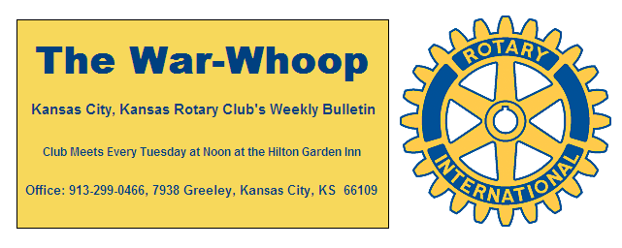
Websites: Club: www.rotarydowntownkck.org, District: www.rotary5710.org, International: www.rotary.org

Volume 80 March 22, 2019 No.35

LAST WEEK AT ROTARY- Marya Aguirre, Vice President of the Hall Family Foundation and a board member of the Hisanic Development Fund talked about the importance of higher education in the latino community. She talked about her life and her family moving from Mexico and the life style that they lived in the United States. She talked about growing up with immigrant parents that could not speak English. She grew up in Idaho, and moved to Kansas at an early age. She went on to say that her life’s story is a common story with many Hispanic families on moving to the states. Her parents understood that the only way to get ahead was to get an education and work hard. She knows how it is to live in a poor neighborhood. One of the big problems for Hispanic students is that they do not understand how to apply for financial help. Their biggest problem the lack of financial means and the second is hope because many do not believe in these students while in high school. A graduate of Emporia State College and Kansas University, she had a choice of becoming lawyer or working in the social area. She left Rotarians with a short statement “You get out of life what you put into it”. This statement came from the World of Rotary.

President Melissa opened the meeting and Jay Dunlap gave the invocation. Scott Kaufmann led the singing and Chris McCord introduced the visitors for the day. Rick Behrens had as his guests, Randy Lopez and Rev Cedric Rowan of the First Baptist Church.

NEXT WEEK AT ROTARY-.Irene Caudillo, President and
CEO of El Centro, will talk about her role on and the work of
the Governor’s Council on Education, and I’ts implications for
KCK Schools, students and employers.

Karole Bradford is the program chair for the day and for the month.

PAUL HARRIS DRAWING- Mark Dupree won the right to draw for the joker this week. Mark did not draw the joker and the amount will go to $241.00 for next week. Just a reminder that there are two steps in winning the drawing. First your ticket number needs to be drawn and then the big step is to draw one of the two jokers from the card deck. There are 16 cards left in the deck, eight to one odds..

5TH TUESDAY SOCIAL- Our next 5th Tuesday social will be in April. Chairman Dan Duncan is looking for help in locating a place for the April date. The date is April 30th.

KANSAS CITY DAY- Dan Duncan stated that Kansas City Day is back on now that the KCMO Rotary Club announced that we will again be able to split the proceeds from the sale between our local charity and the Rotary Camp. Five of the six captains were in attendance and they announced that they would have their crews ready to sell newspapers. Dan will have all the aprons available next Tuesday. He also asked that the captains to drop off their monies off at the Fritz’s restaurant, to Dan, at 18th and Central Ave.

BRACKETOLOGY- John Bukaty reminded members to get their bracketology entries by 11:00am deadline this Thursday. That is the time and date for the first game of the NCAA Tournament.

APRIL PROJECT- Jen Wewers sent a signup sheet around for members to sign up for the April Clean Up in the Rosedale area. The date is Saturday, April 13th.

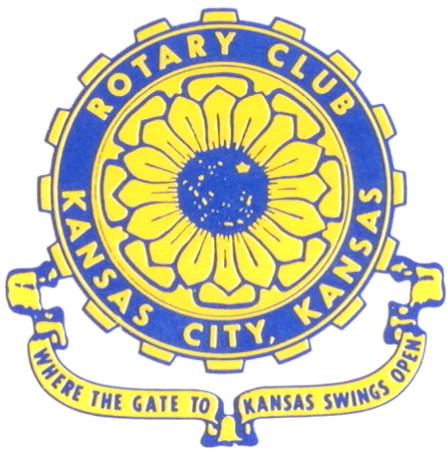
Where the Gate to Kansas Swings Open

The Kansas City, Kansas Rotary Club was organized on November 2, 1915 and received its charter as Club No. 195 in January 1916. Its members take pride in more than 100 years of Rotary service to the community and to international fellowship. From this Club have come five District Governors and two Directors of Rotary International. The Club’s history is as rich as that of the community it represents.
Following the Lewis and Clark expedition which camped at the confluence of the Kansas and Missouri rivers on June 26, 1804, in present day Kansas City, Kansas, this area became an important center for fur trappers. In the following years, many Indian tribes were relocated here from the East. In 1842 the Wyandot Indians acquired land here and founded a town. During this period, and for the next five decades, this area became the main gateway to the inviting majesty of the sprawling Kansas Prairie and the American West. This was where the frontier began. Pioneers found river transportation, outfitters and the beginning of the Santa Fe and Oregon Trails. After the covered wagons came major trunk railroads and barge lines.

In 1886, Kansas City, Kansas received its charter as an incorporated city, combining the towns of Wyandot, Argentine and Armourdale. (Rosedale was added in 1922.) Kansas City, Kansas is the site of the first industrial park in the United States, home of the prestigious University of Kansas Medical Center, and the location of the National Agricultural Hall of Fame and the nationally recognized Kansas Speedway.

Near the geographical and population centers of the contiguous United States, it is in the temperate latitudes at an elevation of 726 feet above sea level. The average rainfall is 35 inches. The average mean temperature ranges from 30°F in January to 80°F in July. The lowest recorded temperature was -23°F on December 23, 1989, and the highest was 113°F on August 14, 1936. Our city’s population of 145,000 and 155 square miles rank it 158th among cities in the United States.
Welcome to Kansas City, Kansas Rotary, and the vibrant community it represents.

Service Above Self
Rotary Websites:
KCK Club: www.rotarydowntownkck.org, District: www.rotary5710.org, International: www.rotary.org


WHERE NEARBY TO MAKE UP ATTENDANCE
MONDAY
Bonner Springs (11:45am) --------------------------------- Twister Bar & Grill, 13100 Kansas Ave.
Overland Park (11:30am) ----------------------------------- Doubletree Hotel, 10100 College Blvd.
TUESDAY
Gladstone (7:00am) -------------------------------------- Fairview Christian Church, 1800 N.E. 65th
Johnson County-Sunset (5:15pm) ------------------------- Hilton Garden Inn Olathe, 119th & I-35
WEDNESDAY
Overland Park South (7:15am) ------------------------ Deer Creek Country Club, 7000 W. 133rd
Leavenworth (Noon) --------------------------- Riverfront Community Center, 123 S. Esplanade
KCI, Missouri (Noon) -------------------------------- Granite City Pub, 8461 NW Prairie View Rd.
Shawnee Mission (Noon) ------------------ Downs Syndrome Guild, 5960 Dearborn, Mission
Olathe (Noon) ------------------------------------- Hilton Garden Inn, 12080 S. Strang Line Road
Kansas City South, Missouri (Noon) ------------------------------- Jess & Jim’s, 517 E. 135th St.
Waldo-Brookside, Missouri (5:15pm) ----------------------------- Waldo Pizza, 7433 Broadway
THURSDAY
Johnson County (7:15am) ----------------------------------- Clarion Hotel, 12601 W. 95th, Lenexa
Leawood (7:15am) ---------------------------------- Hallbrook Country Club, 11200 Overbrook Rd
Village West (7:15am) -------------------------- Famous Dave’s, 1320 Village West Pkwy., KCK
Gardner (7:30am) ---------------------------------------------- Gardner Community Ctr., 128 E. Park
Santa Fe Trail (7:30am) --- Mid-Am Nazarene U, 2030 E. College Way, Campus Ctr.,Olathe
Kansas City, Missouri (Noon) -------------------------------- The Gallery, 61 E. 14th Street, KCMO
FRIDAY
Desoto (7:00am) ------------------------ Desoto United Methodist Church, 8760 Kill Creek Road
Shawnee (7:15am) -------------------------------------- Shawnee Town Hall, 11600 Johnson Drive
Plaza, Missouri (7:15am) ------------------------------------- Grand Street Cafe, 4740 Grand Ave.
North Kansas City, Missouri (Noon) ------------------------------ NKC Library, 2251 Howell Street
Parkville, Missouri (Noon) ------------------------ Park University Underground, Woodard Center
Lenexa (Noon) --------------------- Lakeview Village, Southridge Bldg., 14001 W. 92nd, 5th Floor

Meeting make ups can be made 14 days before or after the missed meeting.
Please see the Secretary for the world directory of all Rotary Club’s meeting times, days and places.

2018-2019 Board of Directors
Officers Directors
Melissa Sieben Ashley Adorante
President Rick Behrens
John Freshnock Karole Bradford
Vice President Phil Gibbs
Greg Shondell Scott Martens
Treasurer Tony Martinez
Jim Knight Terry Robinson
Secretary Andrea Spalding
Rosemary Podrebarac Kathleen VonAchen
Sergeant at Arms
Fred Zimmerman
Past President

