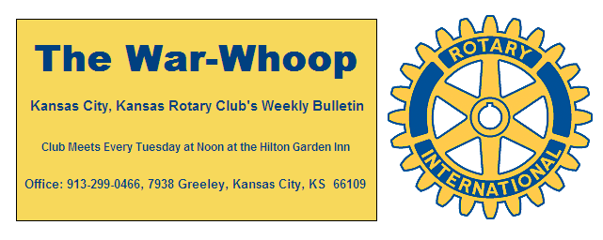
Websites: Club: www.rotarydowntownkck.org, District: www.rotary5710.org, International: www.rotary.org

Volume 80 March 29, 2019 No.37

LAST WEEK AT ROTARY -.Irene Caudillo, President and
CEO of El Centro, talked about her role on, and the work of
the Governor’s Council on Education, and i’ts implications for
KCK Schools, students and employers. She talked about the Executive Order that Governor Kelly gave in January.
*Providing a quality education starting with early childhood ensuring a quality education. Universal access to early learning.
* The order emphasized aligning public private partnership with state agencies and businesss needs.
There were fifty business leaders, educators,non-profits and politicans that were chosen for the task of changing the vision fpr education. The group was then divided up in to four different groups. The council meets on a quartery basis. One of the major difficulties is that the task force is made up of leaders from all over Kansas. Many of the education concerns differ from metropolitan areas and rural areas. Member Robert Hofmann, a facilitator at Wyandotte Hgh School, talked about the value of this type of program. He told members that there was facilitater at each of the local high schools.

President Melissa opened the meeting and Dinie Sanders gave the invocation. Scott Kaufmann led the singing and Fred Zimerman introduced the visitors for the day.

NEXT WEEK AT ROTARY- The program for next week has
not been confirmed as we send out the bullein this week

Ted Garcia is the program chair for the day and for the month.

PAUL HARRIS DRAWING- Secretary Jim won the right to draw for the joker last Tuesday. Jim did not draw the joker and the amount goes to $255.00 for next week’s drawing. There are fourteen cards left and that means that the winning number has an seven to on chance to drawing the joker.

5TH TUESDAY SOCIAL- Our next 5th Tuesday social will be in April. Chairman Dan Duncan is looking for help in locating a place for the April date. The date is April 30th.

KANSAS CITY DAY Dan Duncan was busy passing out aprons and the hats to corner captains last Tuesday for Kansas City Day.

BRACKETOLOGY- Have you checked your bracket yet? Have you busted yet? Your secretary busted several times. There are over 250 participants in the Bukaty bracket.

APRIL PROJECT- Jen Wewers sent a signup sheet around for members to sign up for the April Clean Up in the Rosedale area. The date is Saturday, April 13th. The committee was busy meeting after lunch planning for another project.

ATTENDANCE REPORT- Attendance for the month was 65.8%.

DISTRICT CONFERENCE- Just another reminder that the District Conference will be held on Friday April 26 thru the 27th in Topeka. The conference is a great way to make new friends and learn more about Rotary.

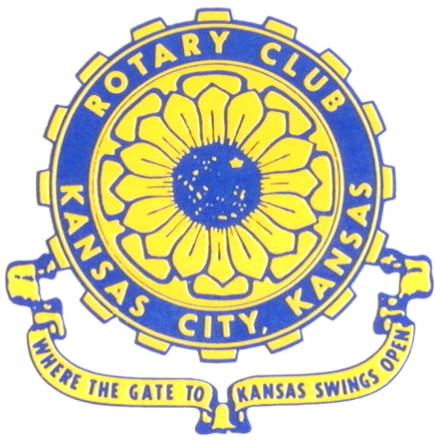
Where the Gate to Kansas Swings Open

The Kansas City, Kansas Rotary Club was organized on November 2, 1915 and received its charter as Club No. 195 in January 1916. Its members take pride in more than 100 years of Rotary service to the community and to international fellowship. From this Club have come five District Governors and two Directors of Rotary International. The Club’s history is as rich as that of the community it represents.
Following the Lewis and Clark expedition which camped at the confluence of the Kansas and Missouri rivers on June 26, 1804, in present day Kansas City, Kansas, this area became an important center for fur trappers. In the following years, many Indian tribes were relocated here from the East. In 1842 the Wyandot Indians acquired land here and founded a town. During this period, and for the next five decades, this area became the main gateway to the inviting majesty of the sprawling Kansas Prairie and the American West. This was where the frontier began. Pioneers found river transportation, outfitters and the beginning of the Santa Fe and Oregon Trails. After the covered wagons came major trunk railroads and barge lines.

In 1886, Kansas City, Kansas received its charter as an incorporated city, combining the towns of Wyandot, Argentine and Armourdale. (Rosedale was added in 1922.) Kansas City, Kansas is the site of the first industrial park in the United States, home of the prestigious University of Kansas Medical Center, and the location of the National Agricultural Hall of Fame and the nationally recognized Kansas Speedway.

Near the geographical and population centers of the contiguous United States, it is in the temperate latitudes at an elevation of 726 feet above sea level. The average rainfall is 35 inches. The average mean temperature ranges from 30°F in January to 80°F in July. The lowest recorded temperature was -23°F on December 23, 1989, and the highest was 113°F on August 14, 1936. Our city’s population of 145,000 and 155 square miles rank it 158th among cities in the United States.
Welcome to Kansas City, Kansas Rotary, and the vibrant community it represents.

Service Above Self
Rotary Websites:
KCK Club: www.rotarydowntownkck.org, District: www.rotary5710.org, International: www.rotary.org


WHERE NEARBY TO MAKE UP ATTENDANCE
MONDAY
Bonner Springs (11:45am) --------------------------------- Twister Bar & Grill, 13100 Kansas Ave.
Overland Park (11:30am) ----------------------------------- Doubletree Hotel, 10100 College Blvd.
TUESDAY
Gladstone (7:00am) -------------------------------------- Fairview Christian Church, 1800 N.E. 65th
Johnson County-Sunset (5:15pm) ------------------------- Hilton Garden Inn Olathe, 119th & I-35
WEDNESDAY
Overland Park South (7:15am) ------------------------ Deer Creek Country Club, 7000 W. 133rd
Leavenworth (Noon) --------------------------- Riverfront Community Center, 123 S. Esplanade
KCI, Missouri (Noon) -------------------------------- Granite City Pub, 8461 NW Prairie View Rd.
Shawnee Mission (Noon) ------------------ Downs Syndrome Guild, 5960 Dearborn, Mission
Olathe (Noon) ------------------------------------- Hilton Garden Inn, 12080 S. Strang Line Road
Kansas City South, Missouri (Noon) ------------------------------- Jess & Jim’s, 517 E. 135th St.
Waldo-Brookside, Missouri (5:15pm) ----------------------------- Waldo Pizza, 7433 Broadway
THURSDAY
Johnson County (7:15am) ----------------------------------- Clarion Hotel, 12601 W. 95th, Lenexa
Leawood (7:15am) ---------------------------------- Hallbrook Country Club, 11200 Overbrook Rd
Village West (7:15am) -------------------------- Famous Dave’s, 1320 Village West Pkwy., KCK
Gardner (7:30am) ---------------------------------------------- Gardner Community Ctr., 128 E. Park
Santa Fe Trail (7:30am) --- Mid-Am Nazarene U, 2030 E. College Way, Campus Ctr.,Olathe
Kansas City, Missouri (Noon) -------------------------------- The Gallery, 61 E. 14th Street, KCMO
FRIDAY
Desoto (7:00am) ------------------------ Desoto United Methodist Church, 8760 Kill Creek Road
Shawnee (7:15am) -------------------------------------- Shawnee Town Hall, 11600 Johnson Drive
Plaza, Missouri (7:15am) ------------------------------------- Grand Street Cafe, 4740 Grand Ave.
North Kansas City, Missouri (Noon) ------------------------------ NKC Library, 2251 Howell Street
Parkville, Missouri (Noon) ------------------------ Park University Underground, Woodard Center
Lenexa (Noon) --------------------- Lakeview Village, Southridge Bldg., 14001 W. 92nd, 5th Floor

Meeting make ups can be made 14 days before or after the missed meeting.
Please see the Secretary for the world directory of all Rotary Club’s meeting times, days and places.

2018-2019 Board of Directors
Officers Directors
Melissa Sieben Ashley Adorante
President Rick Behrens
John Freshnock Karole Bradford
Vice President Phil Gibbs
Greg Shondell Scott Martens
Treasurer Tony Martinez
Jim Knight Terry Robinson
Secretary Andrea Spalding
Rosemary Podrebarac Kathleen VonAchen
Sergeant at Arms
Fred Zimmerman
Past President

