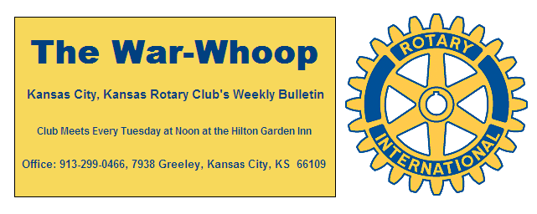
Websites: Club: www.rotarydowntownkck.org, District: www.rotary5710.org, International: www.rotary.org

Volume 80 June 14, 2019 No. 48

LAST WEEK AT ROTARY- Member Robert Hofmann talked about a very important addition to the high school education in the KCK school system. Robert is the coordinator of the program, Diploma +. The goals are:
Completion of one full year of college.
Completion of an industry recognized certificate or credential
At least 21 on the ACT or 1060 on the SAT
Completion of the 1B Diploma Programme or Career-Related Programme
Acceptance in the Military
Completion of a qualified Internship or industry approved project.
An approved Plan for Post-Secondary Transition.
Basically the program gives the students an opportunity to do something in life that they want to do and be good at it. The program went from 7 internships two years ago to 57 interns last year. Rather than having industry to say no to this program he is asking industry to have a “conversation” about the program. He is chairman of an Advisory Board that meets 3 times a year. John Freshnock is a member of the board. Wish we had more space to talk about this program.

President Mellissa opened her last official meeting and David Bluford gave the invocation. Scott Kaufmann led the singing. Dave Skidgel introduced the visitors. Long distance visitor was Laurie Rose and his wife, Jane, from Heibelberg, Australia. Melissa also had her intern as a guest.

PAUL HARRIS DRAWING- Terry Robinson won the right to draw for the joker last Tuesday. Terry did not draw the joker and the amount goes to $59.00 for next week’s drawing.

NEXT WEEK AT ROTARY- T Bones game is next week. This is a fun event and there is still time to sign up. The Tailgating begins at 5:00pm and the game is at 7:00. Cost is $10.00 per person for game ticket and food prior to the game. The evening is a lot of fun and a great time to bring out the family and guests. WE DO NEED RESERVATIONS, so that Pat and Rosie Crilly can order the food. It is not magic and show up, FOOD needs to be ordered. For Reservations call Dan Duncan at 816-223-5863 or Jim Knight at 913-299-0466.
Secretary Jim will be in the hotel lobby from 12:00-12:30 for members to make up if they are not able to attend the event.

ILLNESS- Mike Calwell entered St Luke’s Hospital last week suffering from pneumonia. Following routine tests, Mike was determined to have leukemia. According to Ken Davis, they will have to clear up the pneumonia before treating the leukemia. Mike is in Room 214, St Luke’s South, 123 Metcalf Ave Overland Park 66213.. No visitors at this time, but cards would be great. (update) He is feeling better as we go to print. Ken advises that any visits should check with his wife, Laura. Her phone number is 913-963-3460.

APOLOGY- Dave and Carol Skidgel for not recognizing their 50th Wedding Anniversary two weeks ago. Remember it only comes around once in lifetime. A belated “Happy Anniversary” to the Skidgel family.

BELATED BIRTHDAY- I was reminded this week, that Bill Porter celebrated a birthday in June also. Sorry Bill, I didn’t realize that they celebrated birthdays in Oregon.

INSTALLATION DINNER- Location of the Installation has not been determined as we go to print today. The event will be held on Tuesday, June 24th. Mark this date on your calendars and we will get back to you.

WINNER- Scott Martens was the winner of two tickets to the Speedway this weekend. Phil Gibbs auctioned off the tickets for Polio Plus.

THOUGHT FOR THE DAY- “When you have nothing to say--- Say nothing”. I end this week’s bulletin with the above THOUGHT.
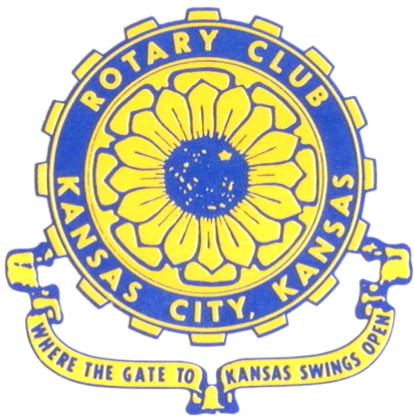
Where the Gate to Kansas Swings Open

The Kansas City, Kansas Rotary Club was organized on November 2, 1915 and received its charter as Club No. 195 in January 1916. Its members take pride in more than 100 years of Rotary service to the community and to international fellowship. From this Club have come five District Governors and two Directors of Rotary International. The Club’s history is as rich as that of the community it represents.

Following the Lewis and Clark expedition which camped at the confluence of the Kansas and Missouri rivers on June 26, 1804, in present day Kansas City, Kansas, this area became an important center for fur trappers. In the following years, many Indian tribes were relocated here from the East. In 1842 the Wyandot Indians acquired land here and founded a town. During this period, and for the next five decades, this area became the main gateway to the inviting majesty of the sprawling Kansas Prairie and the American West. This was where the frontier began. Pioneers found river transportation, outfitters and the beginning of the Santa Fe and Oregon Trails. After the covered wagons came major trunk railroads and barge lines.

In 1886, Kansas City, Kansas received its charter as an incorporated city, combining the towns of Wyandot, Argentine and Armourdale. (Rosedale was added in 1922.) Kansas City, Kansas is the site of the first industrial park in the United States, home of the prestigious University of Kansas Medical Center, and the location of the National Agricultural Hall of Fame and the nationally recognized Kansas Speedway.

Near the geographical and population centers of the contiguous United States, it is in the temperate latitudes at an elevation of 726 feet above sea level. The average rainfall is 35 inches. The average mean temperature ranges from 30°F in January to 80°F in July. The lowest recorded temperature was -23°F on December 23, 1989, and the highest was 113°F on August 14, 1936. Our city’s population of 145,000 and 155 square miles rank it 158th among cities in the United States.

Welcome to Kansas City, Kansas Rotary, and the vibrant community it represents.

Service Above Self

Rotary Websites:
KCK Club: www.rotarydowntownkck.org, District: www.rotary5710.org, International: www.rotary.org



WHERE NEARBY TO MAKE UP ATTENDANCE
MONDAY
Bonner Springs (11:45am) --------------------------------- Twister Bar & Grill, 13100 Kansas Ave.
Overland Park (11:30am) ----------------------------------- Doubletree Hotel, 10100 College Blvd.
TUESDAY
Gladstone (7:00am) -------------------------------------- Fairview Christian Church, 1800 N.E. 65th
Johnson County-Sunset (5:15pm) ------------------------- Hilton Garden Inn Olathe, 119th & I-35
WEDNESDAY
Overland Park South (7:15am) ------------------------ Deer Creek Country Club, 7000 W. 133rd
Leavenworth (Noon) --------------------------- Riverfront Community Center, 123 S. Esplanade
KCI, Missouri (Noon) -------------------------------- Granite City Pub, 8461 NW Prairie View Rd.
Shawnee Mission (Noon) ------------------ Downs Syndrome Guild, 5960 Dearborn, Mission
Olathe (Noon) ------------------------------------- Hilton Garden Inn, 12080 S. Strang Line Road
Kansas City South, Missouri (Noon) ------------------------------- Jess & Jim’s, 517 E. 135th St.
Waldo-Brookside, Missouri (5:15pm) ----------------------------- Waldo Pizza, 7433 Broadway
THURSDAY
Johnson County (7:15am) ----------------------------------- Clarion Hotel, 12601 W. 95th, Lenexa
Leawood (7:15am) ---------------------------------- Hallbrook Country Club, 11200 Overbrook Rd
Village West (7:15am) -------------------------- Famous Dave’s, 1320 Village West Pkwy., KCK
Gardner (7:30am) ---------------------------------------------- Gardner Community Ctr., 128 E. Park
Santa Fe Trail (7:30am) --- Mid-Am Nazarene U, 2030 E. College Way, Campus Ctr.,Olathe
Kansas City, Missouri (Noon) -------------------------------- The Gallery, 61 E. 14th Street, KCMO
FRIDAY
Desoto (7:00am) ------------------------ Desoto United Methodist Church, 8760 Kill Creek Road
Shawnee (7:15am) -------------------------------------- Shawnee Town Hall, 11600 Johnson Drive
Plaza, Missouri (7:15am) ------------------------------------- Grand Street Cafe, 4740 Grand Ave.
North Kansas City, Missouri (Noon) ------------------------------ NKC Library, 2251 Howell Street
Parkville, Missouri (Noon) ------------------------ Park University Underground, Woodard Center
Lenexa (Noon) --------------------- Lakeview Village, Southridge Bldg., 14001 W. 92nd, 5th Floor

Meeting make ups can be made 14 days before or after the missed meeting.
Please see the Secretary for the world directory of all Rotary Club’s meeting times, days and places.

2018-2019 Board of Directors
Officers Directors
Melissa Sieben Ashley Adorante
President Rick Behrens
John Freshnock Karole Bradford
Vice President Phil Gibbs
Greg Shondell Scott Martens
Treasurer Tony Martinez
Jim Knight Terry Robinson
Secretary Andrea Spalding
Rosemary Podrebarac Kathleen VonAchen
Sergeant at Arms
Fred Zimmerman
Past President

