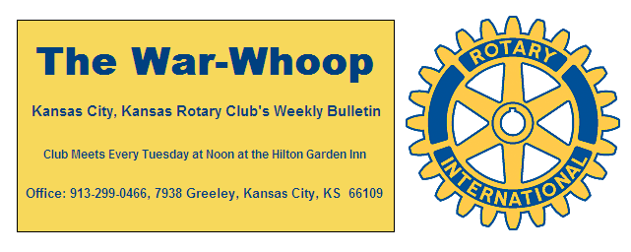

Websites: Club: www.rotarydowntownkck.org, District: www.rotary5710.org, International: www.rotary.org

Volume 81 July 26, 2019 No. 04
LAST WEEK AT ROTARY- Steph Seupham, KC Film Commissioner talked about the impact of film industry on the metropolitan area. Her objective, as a commissioner, is to market the Kansas City area as a destination for the film industry. She added that they had 222 projects last year and on an average they have 200 projects during a year. She talked about the millions of dollars that are spent on a location when filming a commercial or regular film. She told of flipping houses just to film a project. She said that there were some films being produced in the near future that she was not at liberty to talk about at this time. Her presentation was very interesting and had a lot of questions during her talk. Here is a link to the page on our website with the Queer Eye producer’s testimonial video: http://www.kcfilmoffice.com/testimonials/http://www.kcfilmoffice.com/testimonials/
President John opened the meeting and Kathleen VonAchen gave the invocation. Scott Kaufmann led the singing and Todd Jordan introduced the visitors. John Hosler and his wife, Mary, Florida, were visiting for the second time. Joe Gilta from Waterloo, Iowa was a visitor for the first time. Dan Duncan and Jen Wewers had potential members as their guests. John and his wife were guests last year about this time. Their son and his family live in our community.
NEXT WEEK AT ROTARY- Next week is the 5th Tuesday of the month and we will be at the MOCKINGBIRD LOUNGE for our social event. The Lounge is located at 204 Orchard St in Strawberry Hill. The event will be held from 5:30 to 7:30pm.

Jen Wewers and Dan Duncan are the program chairs for the event

++++Secretary Jim will be in the hotel lobby next door for a make up from 12:00 to 12:30pm for members not able to attend the social hour and would like to check in.

ROSTER BOOK PAGES- Roster Book pages for the new year were passed out last Tuesday. Pick up a copy of your pages at the check in table next Rotary luncheon.

PAUL HARRIS DRAWING- Guest Mary Hosler won the right to draw for the joker last Tuesday. Mary did not draw the joker and the amount goes to $116.00 for next week’s drawing.

MEMORIAL SERVICE- The memorial service for Mike Calwell was held at Kaw Point last Saturday evening. Terry Robinson took some pictures of the services and Rotary members can view them on our Rotary’s Face Book page. Members Ken Davis and Rick Behrens took part in the services. Mike made a lasting impression on all his friends that he met during his lifetime.

FEW REASONS WHY DOGS HAVE SO MANY FRIENDS- “The reason a dog has so many friends is that they wag their tails instead of their mouths.” -Anonymous This saying came from the pamphlet that was given out at Mike’s’ memorial service.

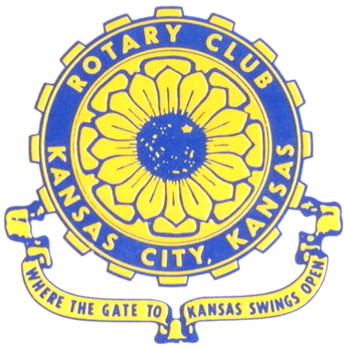
Where the Gate to Kansas Swings Open
The Kansas City, Kansas Rotary Club was organized on November 2, 1915 and received its charter as Club No. 195 in January 1916. Its members take pride in more than 100 years of Rotary service to the community and to international fellowship. From this Club have come five District Governors and two Directors of Rotary International. The Club’s history is as rich as that of the community it represents.
Following the Lewis and Clark expedition which camped at the confluence of the Kansas and Missouri rivers on June 26, 1804, in present day Kansas City, Kansas, this area became an important center for fur trappers. In the following years, many Indian tribes were relocated here from the East. In 1842 the Wyandot Indians acquired land here and founded a town. During this period, and for the next five decades, this area became the main gateway to the inviting majesty of the sprawling Kansas Prairie and the American West. This was where the frontier began. Pioneers found river transportation, outfitters and the beginning of the Santa Fe and Oregon Trails. After the covered wagons came major trunk railroads and barge lines.
In 1886, Kansas City, Kansas received its charter as an incorporated city, combining the towns of Wyandot, Argentine and Armourdale. (Rosedale was added in 1922.) Kansas City, Kansas is the site of the first industrial park in the United States, home of the prestigious University of Kansas Medical Center, and the location of the National Agricultural Hall of Fame and the nationally recognized Kansas Speedway.
Near the geographical and population centers of the contiguous United States, it is in the temperate latitudes at an elevation of 726 feet above sea level. The average rainfall is 35 inches. The average mean temperature ranges from 30°F in January to 80°F in July. The lowest recorded temperature was -23°F on December 23, 1989, and the highest was 113°F on August 14, 1936. Our city’s population of 145,000 and 155 square miles rank it 158th among cities in the United States.
Welcome to Kansas City, Kansas Rotary, and the vibrant community it represents.

Service Above Self
Rotary Websites:
KCK Club: www.rotarydowntownkck.org, District: www.rotary5710.org, International: www.rotary.org

WHERE NEARBY TO MAKE UP ATTENDANCE
MONDAY
Bonner Springs (11:45am) --------------------------------- Twister Bar & Grill, 13100 Kansas Ave.
Overland Park (11:30am) ----------------------------------- Doubletree Hotel, 10100 College Blvd.
TUESDAY
Gladstone (7:00am) -------------------------------------- Fairview Christian Church, 1800 N.E. 65th
WEDNESDAY
Overland Park South (7:15am) ------------------------ Deer Creek Country Club, 7000 W. 133rd
Leavenworth (Noon) --------------------------- Riverfront Community Center, 123 S. Esplanade
KCI, Missouri (Noon) -------------------------------- Granite City Pub, 8461 NW Prairie View Rd.
Shawnee Mission (Noon) -------- Sylvester Powell Community Ctr, 6200 Martway, Mission
Olathe (Noon) ------------------------------------- Hilton Garden Inn, 12080 S. Strang Line Road
Kansas City South, Missouri (Noon) ------------------------------- Margarita’s, 13401 Holmes Rd.
Johnson County-Sunset (5:15pm) ------------------------- Hilton Garden Inn Olathe, 119th & I-35
Waldo-Brookside, Missouri (5:15pm) ----------------------------- Waldo Pizza, 7433 Broadway
THURSDAY
Johnson County (7:15am) ----------------------------------- Holiday Inn, 8787 Reeder St., OPKS
Leawood (7:15am) ---------------------------------- Hallbrook Country Club, 11200 Overbrook Rd
Village West (7:15am) -------------------------- Famous Dave’s, 1320 Village West Pkwy., KCK
Gardner (7:30am) ---------------------------------------------- Gardner Community Ctr., 128 E. Park
Santa Fe Trail (7:30am) --- Mid-Am Nazarene U, 2030 E. College Way, Campus Ctr.,Olathe
Kansas City, Missouri (Noon) -------------------------------- The Gallery, 61 E. 14th Street, KCMO
FRIDAY
Desoto (7:00am) ------------------------ Desoto United Methodist Church, 8760 Kill Creek Road
Shawnee (7:15am) -------------------------------------- Shawnee Town Hall, 11600 Johnson Drive
Plaza, Missouri (7:15am) ------------------------------------- Grand Street Cafe, 4740 Grand Ave.
North Kansas City, Missouri (Noon) ------------------------------ NKC Library, 2251 Howell Street
Parkville, Missouri (Noon) ------------------------ Park University Underground, Woodard Center
Lenexa (Noon) --------------------- Lakeview Village, Southridge Bldg., 14001 W. 92nd, 5th Floor
Meeting make ups can be made 14 days before or after the missed meeting.
Please see the Secretary for the world directory of all Rotary Club’s meeting times, days and places.
2019-2020 Board of Directors
Officers Directors
John Freshnock Ashley Adorante
President Rick Behrens
Scott Martens Karole Bradford
Vice President Phil Gibbs
Greg Shondell Tony Martinez
Treasurer Terry Robinson
Jim Knight Kathleen VonAchen
Secretary Jen Wewers
Rosemary Podrebarac
Sergeant at Arms
Melissa Sieben
Past President

