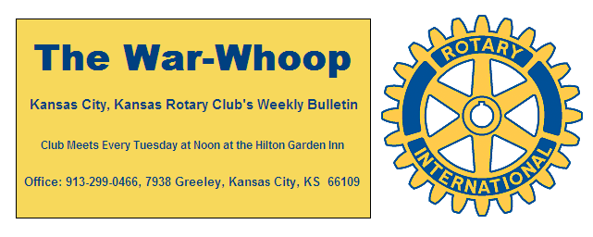
Websites: Club: www.rotarydowntownkck.org, District: www.rotary5710.org, International: www.rotary.org

Volume 81 September 13, 2019 No. 11
LAST WEEK AT ROTARY – Byran Lisbona, co-founder of Kinfolk Creative, along with his cousin talked about how they created their business through their family life in Kansas. They promote local products made on the Kansas side of Kansas City. He showed a power point presentation on their products. They sell all the products on the internet. All their products, tee shirts, show Kansas history in some way. He added that he is going to move his young family back to the country so that relive the life he lived growing up.

President John opened the meeting and Kathleen VonAchen gave the invocation. Scott Kaufmann led the singing and Ashley Adorante introduced the visitors. Bess Bonewits was a guest of Jen Wewers this week.

PAUL HARRIS DRAWING- Bruce Schlosser won the right to draw for the joker last week. Bruce did not draw the joker and the amount goes to $190 for next week’s drawing.

IRISH FEST- Mike Calwell’s wife, Laura, would like to present an Irish Toast to remember him next Tuesday. She is going to bring the jigger glasses and the liquor to honor Mike. An Irish Toast was made to Mike at his funeral in July. Mike will be remembered for all his work on the Kaw Point.

INTRODUCE SOMEONE TO ROTARY
NEXT WEEK AT ROTARY- As we send out the bulletin this week, the program has not been confirmed. If we get an update on a program it will be forwarded on to the members.

Tony Martinez is the program chair scheduled for the day and for the month.

OUR ROAMING ROTARIAN
Lenexa-----------------------------------------Dave Skidgel

MAKEUPS- At the recent Rotary International Convention an ADOPTED ENACTMENT 19-35 of the 2019 Council on Legislation allows Rotary members to make up a miss of a meeting any time during the year. The year is considered July 1st of the present year to the following year June 30th. Make up rules are becoming easier. Reminder that when a member makes up at a Rotary function of another Rotary Club meeting the member will also receive FINANCIAL CREDIT for that meeting. The bonus is that the member can make new business contacts.

ANNUAL ROTARY FOUNDATION CAMPAIGN- A letter and a pledge form will be sent as an attachment this week as a reminder to participate in the annual Rotary Foundation and Polio Plus Campaign. Members that want to pay their pledges on a quarterly basis should send their pledge forms in by September 17th so that it can be included in the October billing.

HISPANIC DEVELOPMENT FUND-Our KCK Rotary Club will be supporting the HDF campaign starting on September 15th thru October 15th. Each dollar raised by our club membership will be matched up to $1,000 by the club’s Foundation and then again by the HDF Donors. All monies raise by our club will go to support Latino students in Wyandotte County.

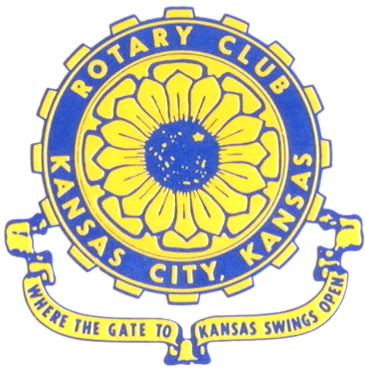
Where the Gate to Kansas Swings Open
The Kansas City, Kansas Rotary Club was organized on November 2, 1915 and received its charter as Club No. 195 in January 1916. Its members take pride in more than 100 years of Rotary service to the community and to international fellowship. From this Club have come five District Governors and two Directors of Rotary International. The Club’s history is as rich as that of the community it represents.
Following the Lewis and Clark expedition which camped at the confluence of the Kansas and Missouri rivers on June 26, 1804, in present day Kansas City, Kansas, this area became an important center for fur trappers. In the following years, many Indian tribes were relocated here from the East. In 1842 the Wyandot Indians acquired land here and founded a town. During this period, and for the next five decades, this area became the main gateway to the inviting majesty of the sprawling Kansas Prairie and the American West. This was where the frontier began. Pioneers found river transportation, outfitters and the beginning of the Santa Fe and Oregon Trails. After the covered wagons came major trunk railroads and barge lines.
In 1886, Kansas City, Kansas received its charter as an incorporated city, combining the towns of Wyandot, Argentine and Armourdale. (Rosedale was added in 1922.) Kansas City, Kansas is the site of the first industrial park in the United States, home of the prestigious University of Kansas Medical Center, and the location of the National Agricultural Hall of Fame and the nationally recognized Kansas Speedway.
Near the geographical and population centers of the contiguous United States, it is in the temperate latitudes at an elevation of 726 feet above sea level. The average rainfall is 35 inches. The average mean temperature ranges from 30°F in January to 80°F in July. The lowest recorded temperature was -23°F on December 23, 1989, and the highest was 113°F on August 14, 1936. Our city’s population of 145,000 and 155 square miles rank it 158th among cities in the United States.
Welcome to Kansas City, Kansas Rotary, and the vibrant community it represents.

Service Above Self
Rotary Websites:
KCK Club: www.rotarydowntownkck.org, District: www.rotary5710.org, International: www.rotary.org
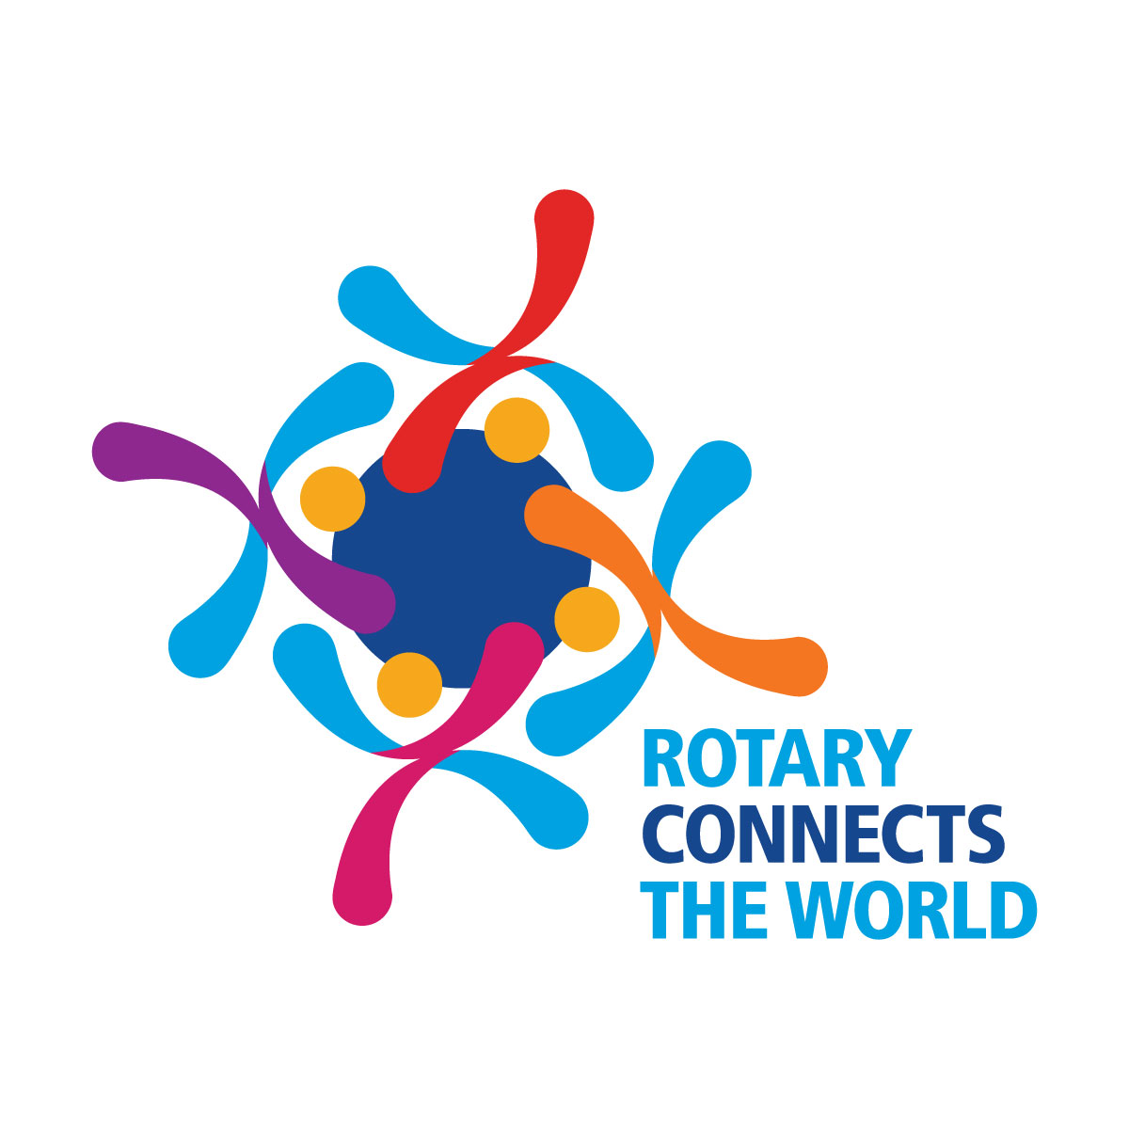
WHERE NEARBY TO MAKE UP ATTENDANCE
MONDAY
Bonner Springs (11:45am) --------------------------------- Twister Bar & Grill, 13100 Kansas Ave.
Overland Park (11:30am) ----------------------------------- Doubletree Hotel, 10100 College Blvd.
TUESDAY
Gladstone (7:00am) -------------------------------------- Fairview Christian Church, 1800 N.E. 65th
WEDNESDAY
Overland Park South (7:15am) ------------------------ Deer Creek Country Club, 7000 W. 133rd
Leavenworth (Noon) --------------------------- Riverfront Community Center, 123 S. Esplanade
KCI, Missouri (Noon) -------------------------------- Granite City Pub, 8461 NW Prairie View Rd.
Shawnee Mission (Noon) -------- Sylvester Powell Community Ctr, 6200 Martway, Mission
Olathe (Noon) ------------------------------------- Hilton Garden Inn, 12080 S. Strang Line Road
Kansas City South, Missouri (Noon) ------------------------------- Margarita’s, 13401 Holmes Rd.
Johnson County-Sunset (5:15pm) ------------------------- Hilton Garden Inn Olathe, 119th & I-35
Waldo-Brookside, Missouri (5:15pm) ----------------------------- Waldo Pizza, 7433 Broadway
THURSDAY
Johnson County (7:15am) ----------------------------------- Holiday Inn, 8787 Reeder St., OPKS
Leawood (7:15am) ---------------------------------- Hallbrook Country Club, 11200 Overbrook Rd
Village West (7:15am) -------------------------- Famous Dave’s, 1320 Village West Pkwy., KCK
Gardner (7:30am) ---------------------------------------------- Gardner Community Ctr., 128 E. Park
Santa Fe Trail (7:30am) --- Mid-Am Nazarene U, 2030 E. College Way, Campus Ctr.,Olathe
Kansas City, Missouri (Noon) -------------------------------- The Gallery, 61 E. 14th Street, KCMO
FRIDAY
Desoto (7:00am) ------------------------ Desoto United Methodist Church, 8760 Kill Creek Road
Shawnee (7:15am) -------------------------------------- Shawnee Town Hall, 11600 Johnson Drive
Plaza, Missouri (7:15am) ------------------------------------- Grand Street Cafe, 4740 Grand Ave.
North Kansas City, Missouri (Noon) ------------------------------ NKC Library, 2251 Howell Street
Parkville, Missouri (Noon) ------------------------ Park University Underground, Woodard Center
Lenexa (Noon) --------------------- Lakeview Village, Southridge Bldg., 14001 W. 92nd, 5th Floor
Meeting make ups can be made 14 days before or after the missed meeting.
Please see the Secretary for the world directory of all Rotary Club’s meeting times, days and places.
2019-2020 Board of Directors
Officers Directors
John Freshnock Ashley Adorante
President Rick Behrens
Scott Martens Karole Bradford
Vice President Phil Gibbs
Greg Shondell Tony Martinez
Treasurer Terry Robinson
Jim Knight Kathleen VonAchen
Secretary Jen Wewers
Rosemary Podrebarac
Sergeant at Arms
Melissa Sieben
Past President

