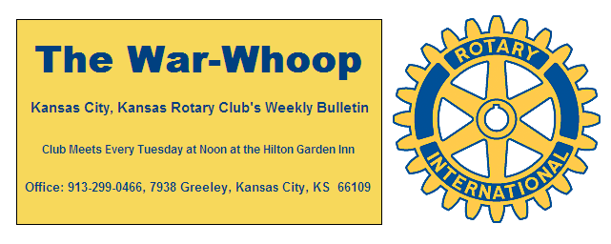
Websites: Club: www.rotarydowntownkck.org, District: www.rotary5710.org, Internationalwww.rotary.org
Volume 81 October 18, 2019 No. 16
LAST WEEK AT ROTARY- Kansas City Kansas Fire Chief Michael Callahan presented this year’s honoree, Mallory Sipes, Training Instructor for the Fire department. She has established a training class for a “peer group” that would be able to assist the department in emergency situations. She has 26 people attending her class. She has spent many hours in up grading the position.
After the award ceremony, Chief Callahan talked about the department in general. He told Rotarians that there many changes being made with the purchasing new apparatuses and the upgrading of the fire houses. A new firehouse is being built in the Piper area.
He proceeded to talk about some statistics on the local department. We have 18 fire stations with 18 pumpers and 387 firefighters. The department also has 46 boats that can be put in the water when needed. Firefighters in attendance were; Fire Deputy Chief Jack Andrade, Asst Chiefs Morris Letcher and James Zeeb.

President John opened the meeting and Dan Duncan gave the invocation. Scott Kaufmann led the singing and Pat Crilly introduced the visitors.

NEW MEMBER- President John introduced Dr. Reed Maxwell for the second time. Reed is a Clinical Psychologist at the new Kansas Medical Center at 901 North 5th Street. His classification in Rotary “Clinical Psychologist”. Please welcome him when you meet him next week.

NEXT WEEK AT ROTARY-The Police Department will present their ”Annual Safety Award” to one of their police officers. .

Melissa Sieben and Rosemary Podrebarac are the program chairs scheduled for the day.

5TH TUESDAY- October is a busy month with several events happening in our Club, so don’t forget to mark October 29th for the 5th Tuesday at Sarah’s on the Hill, 612 North 5th from 5:00-7:00pm. Halloween costumes are encouraged.

SAVE THE DATE- PINTS FOR POLIO for October. 24, 2019, 5pm-8pm at Chicago's (534 Central Ave,) KCK $50.00 includes 2 drinks and food. Slats Barbecue will provide the food for the event. (See attachment this week).

PAUL HARRIS DRAWING- Dave Skidgel won the right to draw for the joker last week. Dave did not draw the joker and the amount goes to $241 for next week’s drawing. There are ten cards left. That’s five to one odds for the nongamblers.

50th YEAR CELEBRATION- Celebrate with Secretary Jim his 50th year as our secretary. The celebration will be held at Greg Shondell’s home at 3905 Delmar Dr. in Prairie Village. His home is located 2 houses west of 65th and Mission. The celebration will be held between 4:00pm to 7:00pm.
**Can you name the other Rotarian that has 50 years of membership in our Club? Answer next week?

INTRODUCE SOMEONE TO ROTARY

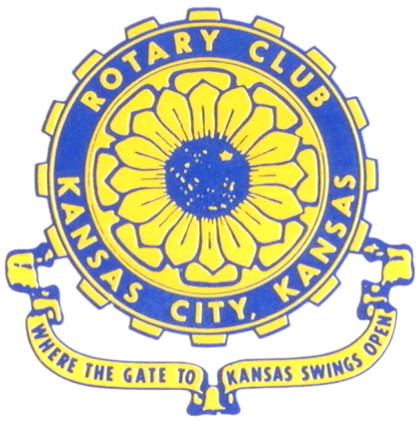
Where the Gate to Kansas Swings Open
The Kansas City, Kansas Rotary Club was organized on November 2, 1915 and received its charter as Club No. 195 in January 1916. Its members take pride in more than 100 years of Rotary service to the community and to international fellowship. From this Club have come five District Governors and two Directors of Rotary International. The Club’s history is as rich as that of the community it represents.
Following the Lewis and Clark expedition which camped at the confluence of the Kansas and Missouri rivers on June 26, 1804, in present day Kansas City, Kansas, this area became an important center for fur trappers. In the following years, many Indian tribes were relocated here from the East. In 1842 the Wyandot Indians acquired land here and founded a town. During this period, and for the next five decades, this area became the main gateway to the inviting majesty of the sprawling Kansas Prairie and the American West. This was where the frontier began. Pioneers found river transportation, outfitters and the beginning of the Santa Fe and Oregon Trails. After the covered wagons came major trunk railroads and barge lines.
In 1886, Kansas City, Kansas received its charter as an incorporated city, combining the towns of Wyandot, Argentine and Armourdale. (Rosedale was added in 1922.) Kansas City, Kansas is the site of the first industrial park in the United States, home of the prestigious University of Kansas Medical Center, and the location of the National Agricultural Hall of Fame and the nationally recognized Kansas Speedway.
Near the geographical and population centers of the contiguous United States, it is in the temperate latitudes at an elevation of 726 feet above sea level. The average rainfall is 35 inches. The average mean temperature ranges from 30°F in January to 80°F in July. The lowest recorded temperature was -23°F on December 23, 1989, and the highest was 113°F on August 14, 1936. Our city’s population of 145,000 and 155 square miles rank it 158th among cities in the United States.
Welcome to Kansas City, Kansas Rotary, and the vibrant community it represents.

Service Above Self
Rotary Websites:
KCK Club: www.rotarydowntownkck.org, District: www.rotary5710.org, International: www.rotary.org

WHERE NEARBY TO MAKE UP ATTENDANCE
MONDAY
Bonner Springs (11:45am) --------------------------------- Twister Bar & Grill, 13100 Kansas Ave.
Overland Park (11:30am) ----------------------------------- Doubletree Hotel, 10100 College Blvd.
TUESDAY
Gladstone (7:00am) -------------------------------------- Fairview Christian Church, 1800 N.E. 65th
WEDNESDAY
Overland Park South (7:15am) ------------------------ Deer Creek Country Club, 7000 W. 133rd
Leavenworth (Noon) --------------------------- Riverfront Community Center, 123 S. Esplanade
KCI, Missouri (Noon) -------------------------------- Granite City Pub, 8461 NW Prairie View Rd.
Shawnee Mission (Noon) -------- Sylvester Powell Community Ctr, 6200 Martway, Mission
Olathe (Noon) ------------------------------------- Hilton Garden Inn, 12080 S. Strang Line Road
Kansas City South, Missouri (Noon) ------------------------------- Margarita’s, 13401 Holmes Rd.
Johnson County-Sunset (5:15pm) ------------------------- Hilton Garden Inn Olathe, 119th & I-35
Waldo-Brookside, Missouri (5:15pm) ----------------------------- Waldo Pizza, 7433 Broadway
THURSDAY
Johnson County (7:15am) ----------------------------------- Holiday Inn, 8787 Reeder St., OPKS
Leawood (7:15am) ---------------------------------- Hallbrook Country Club, 11200 Overbrook Rd
Village West (7:15am) -------------------------- Famous Dave’s, 1320 Village West Pkwy., KCK
Gardner (7:30am) ---------------------------------------------- Gardner Community Ctr., 128 E. Park
Santa Fe Trail (7:30am) --- Mid-Am Nazarene U, 2030 E. College Way, Campus Ctr.,Olathe
Kansas City, Missouri (Noon) -------------------------------- The Gallery, 61 E. 14th Street, KCMO
FRIDAY
Desoto (7:00am) ------------------------ Desoto United Methodist Church, 8760 Kill Creek Road
Shawnee (7:15am) -------------------------------------- Shawnee Town Hall, 11600 Johnson Drive
Plaza, Missouri (7:15am) ------------------------------------- Grand Street Cafe, 4740 Grand Ave.
North Kansas City, Missouri (Noon) ------------------------------ NKC Library, 2251 Howell Street
Parkville, Missouri (Noon) ------------------------ Park University Underground, Woodard Center
Lenexa (Noon) --------------------- Lakeview Village, Southridge Bldg., 14001 W. 92nd, 5th Floor
Meeting make ups can be made 14 days before or after the missed meeting.
Please see the Secretary for the world directory of all Rotary Club’s meeting times, days and places.
2019-2020 Board of Directors
Officers Directors
John Freshnock Ashley Adorante
President Rick Behrens
Scott Martens Karole Bradford
Vice President Phil Gibbs
Greg Shondell Tony Martinez
Treasurer Terry Robinson
Jim Knight Kathleen VonAchen
Secretary Jen Wewers
Rosemary Podrebarac
Sergeant at Arms
Melissa Sieben
Past President

