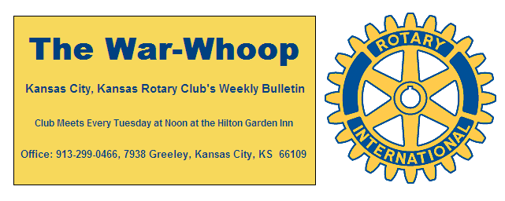
Websites: Club: www.rotarydowntownkck.org, District: www.rotary5710.org, Internationalwww.rotary.org

Volume 81 November 1, 2019 No. 18

LAST WEEK AT ROTARY- Jason Young, executive with the Capital Group talked about what an investor might do to prepare for a recession. The first thing he told members was that the world is “a crazy place right now”. He passed out a booklet then took members through the declines and growth of business cycles. He went on to say that recessions are normal and natural. What should a investor do to prepare for a recession: (1) Stay Calm, (2) Maintain a balanced and broadly diversified portfolio, (3) Balance equity portfolios, (4) Choose funds with a strong history of weathering market declines, (4) Talk with and advisor. He touched on the economic indicators that can warn for a recession. He ended talking about the strength of the United States versus the European markets. He answered questions after his presentation.

President John opened the meeting and Dan Duncan gave the invocation. Scott Kaufmann led the singing and Bud Thurston introduced the visitors.

LOSS GLASSES FOUND- A pair of glasses were found after the meeting two weeks ago. Pick up at the back table.

OUR ROAMING ROTARIANS
Lenexa--------------------------------------------Dave Skidgel
Plaza, KCMo-------------------------------------Hank Chamberlain
NEXT WEEK AT ROTARY-Kendra Wyatt, founder, New Birth Company, will discuss their method of helping mothers give birth in a holistic fashion. Former member Tim Ryan used them in the birth of his son Clark.
Scott Kaufmann will be the program chair for the day and the month.
PAUL HARRIS DRAWING- Dave Skidgel for the third week in a row won the right to draw the joker. Dave drew the joker and won half of the $276.00 pot.
HAPPY BIRTHDAY- Scott led the members in singing “Happy Birthday” to members with birthdays in November. They are John Bukaty, David Bluford, Jay Dunlap, Karen Hostetler and Chris McCord.
DISTRICT 5710 FOUNDATION BANQUET-Five members of our club attended the banquet last Friday evening. They were President John and wife, Rebecca, Melissa Sieben and husband Darren, Greg Shondell and Cecelia Woods, Jim Knight and wife Eva, and Hank Chamberlain. See attachment for pictures or go to Rotary’s face book page and see all our activities over the past year. Thanks to Melissa Sieben. Ashley Adorante and Terry Robinson for taking all the pictures KCKs Rotary’s face book page
WHO IS BACK- It was great to see Dan Duncan and Fred Zimmerman back after their trip from St Louis to California by the route of highway 66. Bill Porter was also in attendance back from his trip to the east coast.
DISTRICT NEWSLETTER-The district newsletter was sent out this week to all Rotarians. Take time to read the monthly letter to find out what is happening in the district.
INTRODUCE SOMEONE TO ROTARY

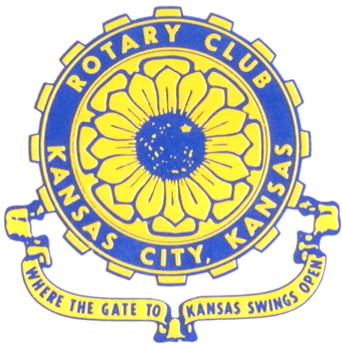
Where the Gate to Kansas Swings Open
The Kansas City, Kansas Rotary Club was organized on November 2, 1915 and received its charter as Club No. 195 in January 1916. Its members take pride in more than 100 years of Rotary service to the community and to international fellowship. From this Club have come five District Governors and two Directors of Rotary International. The Club’s history is as rich as that of the community it represents.
Following the Lewis and Clark expedition which camped at the confluence of the Kansas and Missouri rivers on June 26, 1804, in present day Kansas City, Kansas, this area became an important center for fur trappers. In the following years, many Indian tribes were relocated here from the East. In 1842 the Wyandot Indians acquired land here and founded a town. During this period, and for the next five decades, this area became the main gateway to the inviting majesty of the sprawling Kansas Prairie and the American West. This was where the frontier began. Pioneers found river transportation, outfitters and the beginning of the Santa Fe and Oregon Trails. After the covered wagons came major trunk railroads and barge lines.
In 1886, Kansas City, Kansas received its charter as an incorporated city, combining the towns of Wyandot, Argentine and Armourdale. (Rosedale was added in 1922.) Kansas City, Kansas is the site of the first industrial park in the United States, home of the prestigious University of Kansas Medical Center, and the location of the National Agricultural Hall of Fame and the nationally recognized Kansas Speedway.
Near the geographical and population centers of the contiguous United States, it is in the temperate latitudes at an elevation of 726 feet above sea level. The average rainfall is 35 inches. The average mean temperature ranges from 30°F in January to 80°F in July. The lowest recorded temperature was -23°F on December 23, 1989, and the highest was 113°F on August 14, 1936. Our city’s population of 145,000 and 155 square miles rank it 158th among cities in the United States.
Welcome to Kansas City, Kansas Rotary, and the vibrant community it represents.

Service Above Self
Rotary Websites:
KCK Club: www.rotarydowntownkck.org, District: www.rotary5710.org, International: www.rotary.org

WHERE NEARBY TO MAKE UP ATTENDANCE
MONDAY
Bonner Springs (11:45am) --------------------------------- Twister Bar & Grill, 13100 Kansas Ave.
Overland Park (11:30am) ----------------------------------- Doubletree Hotel, 10100 College Blvd.
TUESDAY
Gladstone (7:00am) -------------------------------------- Fairview Christian Church, 1800 N.E. 65th
WEDNESDAY
Overland Park South (7:15am) ------------------------ Deer Creek Country Club, 7000 W. 133rd
Leavenworth (Noon) --------------------------- Riverfront Community Center, 123 S. Esplanade
KCI, Missouri (Noon) -------------------------------- Granite City Pub, 8461 NW Prairie View Rd.
Shawnee Mission (Noon) -------- Sylvester Powell Community Ctr, 6200 Martway, Mission
Olathe (Noon) ------------------------------------- Hilton Garden Inn, 12080 S. Strang Line Road
Kansas City South, Missouri (Noon) ------------------------------- Margarita’s, 13401 Holmes Rd.
Johnson County-Sunset (5:15pm) ------------------------- Hilton Garden Inn Olathe, 119th & I-35
Waldo-Brookside, Missouri (5:15pm) ----------------------------- Waldo Pizza, 7433 Broadway
THURSDAY
Johnson County (7:15am) ----------------------------------- Holiday Inn, 8787 Reeder St., OPKS
Leawood (7:15am) ---------------------------------- Hallbrook Country Club, 11200 Overbrook Rd
Village West (7:15am) -------------------------- Famous Dave’s, 1320 Village West Pkwy., KCK
Gardner (7:30am) ---------------------------------------------- Gardner Community Ctr., 128 E. Park
Santa Fe Trail (7:30am) --- Mid-Am Nazarene U, 2030 E. College Way, Campus Ctr.,Olathe
Kansas City, Missouri (Noon) -------------------------------- The Gallery, 61 E. 14th Street, KCMO
FRIDAY
Desoto (7:00am) ------------------------ Desoto United Methodist Church, 8760 Kill Creek Road
Shawnee (7:15am) -------------------------------------- Shawnee Town Hall, 11600 Johnson Drive
Plaza, Missouri (7:15am) ------------------------------------- Grand Street Cafe, 4740 Grand Ave.
North Kansas City, Missouri (Noon) ------------------------------ NKC Library, 2251 Howell Street
Parkville, Missouri (Noon) ------------------------ Park University Underground, Woodard Center
Lenexa (Noon) --------------------- Lakeview Village, Southridge Bldg., 14001 W. 92nd, 5th Floor
Meeting make ups can be made 14 days before or after the missed meeting.
Please see the Secretary for the world directory of all Rotary Club’s meeting times, days and places.
2019-2020 Board of Directors
Officers Directors
John Freshnock Ashley Adorante
President Rick Behrens
Scott Martens Karole Bradford
Vice President Phil Gibbs
Greg Shondell Tony Martinez
Treasurer Terry Robinson
Jim Knight Kathleen VonAchen
Secretary Jen Wewers
Rosemary Podrebarac
Sergeant at Arms
Melissa Sieben
Past President

