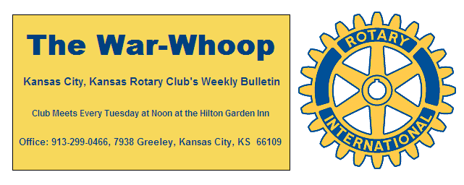
Websites: Club: www.rotarydowntownkck.org, District: www.rotary5710.org, Internationalwww.rotary.org

Volume 81 November 29, 2019 No. 22

LAST WEEK AT ROTARY- Jeff Miner, Founder of Performance Institute, talked about his life and how he got into this type of business. Jeff was a wrestler at Iowa State and blew his knee out. He talked about he felt so much pressure and anxiety before each match that the pressure wore him down before a match actually occurred. He talked about pressure when a person is expected to win. He was a professional counselor to Olympic athletes and the Utah Jazz professional basketball team. There are 5 professional counselors on his staff, four locally and one in Florida. When asked which sports provide the most pressure, he replied “individual sports like golf and tennis.” He answered many questions about his profession, before he finished.

President John opened the meeting and Merle Parks gave the invocation. Scott Kaufmann led the singing and Scott Martens introduced the visitors. Hank Chamberlain had two young ladies with him from Mexico City. One of the ladies was active in Rotaract in Mexico.

VILLAGE WEST CLUB. The Village West Club is now meeting at the NEW BLIND BOX BARBEQUE located of the west side of Nebraska Furniture Mart.

HAPPY THANKSGIVING TO YOU AND YOUR
FAMILY
PROGRAM NEXT WEEK-New member Dr Reed Maxwell will be our speaker next week. Not only will it be Reed’s classification talk, he will be talking about the new facility that opened September 1st.
Dan Duncan is the program chairman for the day and for the month.

BELL RINGING-YOUR HELP is needed on Saturday, December 7th for ONLY ONE HOUR DURING THE DAY. We need one Rotarian at 3-4 and 4-5. PLEASE sign up this week by emailing Secretary Jim at jknight26@kc.rr.com. Rotary has been ringing bells for the Salvation Army for many years. Sign up this week. just one hour of your time.

TIPS- There will be a TIP JAR at the back table for the next two weeks for our server, TIM, for Rotarians to show their appreciation for his great service during this past year.

PAUL HARRIS DRAWING- President John won the right to draw for the joker last week. John did not draw the joker and the balance for next week’s drawing is $11.00.

BOARD OF DIRECTORS ELECTION- The election for the new year beginning on July 1, 2020 will be held on December 10th. The Nomination Committee consists of Chairperson Melissa Sieben, Fred Zimmerman and Ashley Adorante. Members should recommend potential board members to the Nominating Committee.

SUMNER CHOIR- The Sumner Choir will perform for our club on Tuesday, December 10th. If you plan on bringing a guest, please let the secretary know. We need reservations for this program.

ROTARIAN ON THE MOVE- See where Dave Skidgel and his wife, Carol, are this week. See attachment.

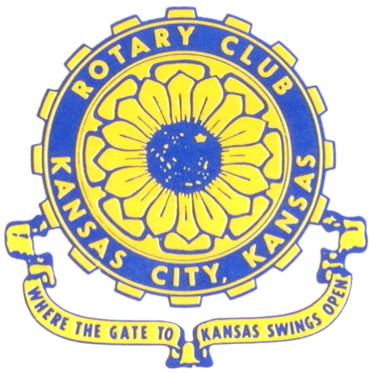
Where the Gate to Kansas Swings Open
The Kansas City, Kansas Rotary Club was organized on November 2, 1915 and received its charter as Club No. 195 in January 1916. Its members take pride in more than 100 years of Rotary service to the community and to international fellowship. From this Club have come five District Governors and two Directors of Rotary International. The Club’s history is as rich as that of the community it represents.
Following the Lewis and Clark expedition which camped at the confluence of the Kansas and Missouri rivers on June 26, 1804, in present day Kansas City, Kansas, this area became an important center for fur trappers. In the following years, many Indian tribes were relocated here from the East. In 1842 the Wyandot Indians acquired land here and founded a town. During this period, and for the next five decades, this area became the main gateway to the inviting majesty of the sprawling Kansas Prairie and the American West. This was where the frontier began. Pioneers found river transportation, outfitters and the beginning of the Santa Fe and Oregon Trails. After the covered wagons came major trunk railroads and barge lines.
In 1886, Kansas City, Kansas received its charter as an incorporated city, combining the towns of Wyandot, Argentine and Armourdale. (Rosedale was added in 1922.) Kansas City, Kansas is the site of the first industrial park in the United States, home of the prestigious University of Kansas Medical Center, and the location of the National Agricultural Hall of Fame and the nationally recognized Kansas Speedway.
Near the geographical and population centers of the contiguous United States, it is in the temperate latitudes at an elevation of 726 feet above sea level. The average rainfall is 35 inches. The average mean temperature ranges from 30°F in January to 80°F in July. The lowest recorded temperature was -23°F on December 23, 1989, and the highest was 113°F on August 14, 1936. Our city’s population of 145,000 and 155 square miles rank it 158th among cities in the United States.
Welcome to Kansas City, Kansas Rotary, and the vibrant community it represents.

Service Above Self
Rotary Websites:
KCK Club: www.rotarydowntownkck.org, District: www.rotary5710.org, International: www.rotary.org

WHERE NEARBY TO MAKE UP ATTENDANCE
MONDAY
Bonner Springs (11:45am) --------------------------------- Twister Bar & Grill, 13100 Kansas Ave.
Overland Park (11:30am) ----------------------------------- Doubletree Hotel, 10100 College Blvd.
TUESDAY
Gladstone (7:00am) -------------------------------------- Fairview Christian Church, 1800 N.E. 65th
WEDNESDAY
Overland Park South (7:15am) ------------------------ Deer Creek Country Club, 7000 W. 133rd
Leavenworth (Noon) --------------------------- Riverfront Community Center, 123 S. Esplanade
KCI, Missouri (Noon) -------------------------------- Granite City Pub, 8461 NW Prairie View Rd.
Shawnee Mission (Noon) -------- Sylvester Powell Community Ctr, 6200 Martway, Mission
Olathe (Noon) ------------------------------------- Hilton Garden Inn, 12080 S. Strang Line Road
Kansas City South, Missouri (Noon) ------------------------------- Margarita’s, 13401 Holmes Rd.
Johnson County-Sunset (5:15pm) ------------------------- Hilton Garden Inn Olathe, 119th & I-35
Waldo-Brookside, Missouri (5:15pm) ----------------------------- Waldo Pizza, 7433 Broadway
THURSDAY
Johnson County (7:15am) ----------------------------------- Holiday Inn, 8787 Reeder St., OPKS
Leawood (7:15am) ---------------------------------- Hallbrook Country Club, 11200 Overbrook Rd
Village West (7:15am) -------------------------- Famous Dave’s, 1320 Village West Pkwy., KCK
Gardner (7:30am) ---------------------------------------------- Gardner Community Ctr., 128 E. Park
Santa Fe Trail (7:30am) --- Mid-Am Nazarene U, 2030 E. College Way, Campus Ctr.,Olathe
Kansas City, Missouri (Noon) -------------------------------- The Gallery, 61 E. 14th Street, KCMO
FRIDAY
Desoto (7:00am) ------------------------ Desoto United Methodist Church, 8760 Kill Creek Road
Shawnee (7:15am) -------------------------------------- Shawnee Town Hall, 11600 Johnson Drive
Plaza, Missouri (7:15am) ------------------------------------- Grand Street Cafe, 4740 Grand Ave.
North Kansas City, Missouri (Noon) ------------------------------ NKC Library, 2251 Howell Street
Parkville, Missouri (Noon) ------------------------ Park University Underground, Woodard Center
Lenexa (Noon) --------------------- Lakeview Village, Southridge Bldg., 14001 W. 92nd, 5th Floor
Meeting make ups can be made 14 days before or after the missed meeting.
Please see the Secretary for the world directory of all Rotary Club’s meeting times, days and places.
2019-2020 Board of Directors
Officers Directors
John Freshnock Ashley Adorante
President Rick Behrens
Scott Martens Karole Bradford
Vice President Phil Gibbs
Greg Shondell Tony Martinez
Treasurer Terry Robinson
Jim Knight Kathleen VonAchen
Secretary Jen Wewers
Rosemary Podrebarac
Sergeant at Arms
Melissa Sieben
Past President

