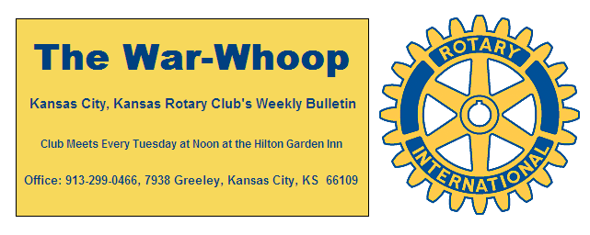
Websites: Club: www.rotarydowntownkck.org, District: www.rotary5710.org, Internationalwww.rotary.org

Volume 81 January 3, 2020 No. 27
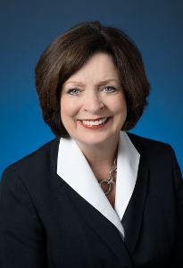

NEXT WEEK AT ROTARY= Kathy Wolfe Moore will be our speaker to start off the new year. It will be interesting to hear her prospective on what will happen in the Kansas House in the new year.

HAPPY NEW YEAR

ATTENDANCE- Attendance for the present quarter was 64%. The top attenders for the quarter were:

100%
John Freshnock Greg Shondell
Scott Kaufmann Dave Skidgel
Terry Robinson Bill Strumillo

92% (One Miss)
John Bukaty Pat Crilly
Bud Thurston
83% (Two Misses)
Karen Hostetler Melissa Sieben
Todd Jordan Dave Tyler
Rosemary Podrebarac Fred Zimmerman

75% (Three misses)
Hank Chamberlain Jay Dunlap
Dan Duncan Chris McCord
If YOU have any questions about your attendance, please check with the secretary.

The new attendance rule is that a member may make up their attendance for a meeting within the same year to receive credit for the miss of a meeting. Attendance at the board meeting or committee meeting counts as a make up for regular luncheon. Attendance at a district meeting would also count as a make up for a luncheon. Rotary year is from July 1st to June 30th. Secretary needs to be notified of the make ups.

ATTENTION- Board Members The January board meeting will be held on Wednesday, January 8th at the United Way Board Room. Please mark this change on your calendars.


Where the Gate to Kansas Swings Open
The Kansas City, Kansas Rotary Club was organized on November 2, 1915 and received its charter as Club No. 195 in January 1916. Its members take pride in more than 100 years of Rotary service to the community and to international fellowship. From this Club have come five District Governors and two Directors of Rotary International. The Club’s history is as rich as that of the community it represents.
Following the Lewis and Clark expedition which camped at the confluence of the Kansas and Missouri rivers on June 26, 1804, in present day Kansas City, Kansas, this area became an important center for fur trappers. In the following years, many Indian tribes were relocated here from the East. In 1842 the Wyandot Indians acquired land here and founded a town. During this period, and for the next five decades, this area became the main gateway to the inviting majesty of the sprawling Kansas Prairie and the American West. This was where the frontier began. Pioneers found river transportation, outfitters and the beginning of the Santa Fe and Oregon Trails. After the covered wagons came major trunk railroads and barge lines.
In 1886, Kansas City, Kansas received its charter as an incorporated city, combining the towns of Wyandot, Argentine and Armourdale. (Rosedale was added in 1922.) Kansas City, Kansas is the site of the first industrial park in the United States, home of the prestigious University of Kansas Medical Center, and the location of the National Agricultural Hall of Fame and the nationally recognized Kansas Speedway.
Near the geographical and population centers of the contiguous United States, it is in the temperate latitudes at an elevation of 726 feet above sea level. The average rainfall is 35 inches. The average mean temperature ranges from 30°F in January to 80°F in July. The lowest recorded temperature was -23°F on December 23, 1989, and the highest was 113°F on August 14, 1936. Our city’s population of 145,000 and 155 square miles rank it 158th among cities in the United States.
Welcome to Kansas City, Kansas Rotary, and the vibrant community it represents.

Service Above Self
Rotary Websites:
KCK Club: www.rotarydowntownkck.org, District: www.rotary5710.org, International: www.rotary.org

WHERE NEARBY TO MAKE UP ATTENDANCE
MONDAY
Bonner Springs (11:45am) --------------------------------- Twister Bar & Grill, 13100 Kansas Ave.
Overland Park (11:30am) ----------------------------------- Doubletree Hotel, 10100 College Blvd.
TUESDAY
Gladstone (7:00am) -------------------------------------- Fairview Christian Church, 1800 N.E. 65th
WEDNESDAY
Overland Park South (7:15am) ------------------------ Deer Creek Country Club, 7000 W. 133rd
Leavenworth (Noon) --------------------------- Riverfront Community Center, 123 S. Esplanade
KCI, Missouri (Noon) -------------------------------- Granite City Pub, 8461 NW Prairie View Rd.
Shawnee Mission (Noon) -------- Sylvester Powell Community Ctr, 6200 Martway, Mission
Olathe (Noon) ------------------------------------- Hilton Garden Inn, 12080 S. Strang Line Road
Kansas City South, Missouri (Noon) ------------------------------- Margarita’s, 13401 Holmes Rd.
Johnson County-Sunset (5:15pm) ------------------------- Hilton Garden Inn Olathe, 119th & I-35
Waldo-Brookside, Missouri (5:15pm) ----------------------------- Waldo Pizza, 7433 Broadway
THURSDAY
Johnson County (7:15am) ----------------------------------- Holiday Inn, 8787 Reeder St., OPKS
Leawood (7:15am) ---------------------------------- Hallbrook Country Club, 11200 Overbrook Rd
Village West (7:15am) -------------------------- Famous Dave’s, 1320 Village West Pkwy., KCK
Gardner (7:30am) ---------------------------------------------- Gardner Community Ctr., 128 E. Park
Santa Fe Trail (7:30am) --- Mid-Am Nazarene U, 2030 E. College Way, Campus Ctr.,Olathe
Kansas City, Missouri (Noon) -------------------------------- The Gallery, 61 E. 14th Street, KCMO
FRIDAY
Desoto (7:00am) ------------------------ Desoto United Methodist Church, 8760 Kill Creek Road
Shawnee (7:15am) -------------------------------------- Shawnee Town Hall, 11600 Johnson Drive
Plaza, Missouri (7:15am) ------------------------------------- Grand Street Cafe, 4740 Grand Ave.
North Kansas City, Missouri (Noon) ------------------------------ NKC Library, 2251 Howell Street
Parkville, Missouri (Noon) ------------------------ Park University Underground, Woodard Center
Lenexa (Noon) --------------------- Lakeview Village, Southridge Bldg., 14001 W. 92nd, 5th Floor
Meeting make ups can be made 14 days before or after the missed meeting.
Please see the Secretary for the world directory of all Rotary Club’s meeting times, days and places.
2019-2020 Board of Directors
Officers Directors
John Freshnock Ashley Adorante
President Rick Behrens
Scott Martens Karole Bradford
Vice President Phil Gibbs
Greg Shondell Tony Martinez
Treasurer Terry Robinson
Jim Knight Kathleen VonAchen
Secretary Jen Wewers
Rosemary Podrebarac
Sergeant at Arms
Melissa Sieben
Past President

