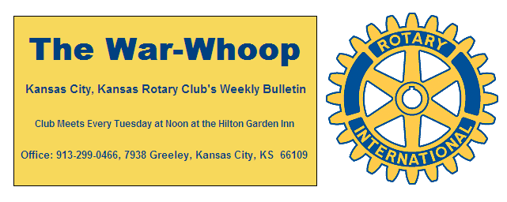
Websites: Club: www.rotarydowntownkck.org, District: www.rotary5710.org, Internationalwww.rotary.org

Volume 81 January10, 2020 No. 28

LAST WEEK AT ROTARY- Kathy Wolfe Moore, State representative from Wyandotte County, talked about what we can expect in the legislature this year. She touched on tax credits and health care for Kansans. She expressed optimism that there would be a compromise on the issue of Medicare this year. She asked members what our lives would be without health insurance. Wyandotte County really needs this benefit fo its citizens. She went on to say that 20% of Wyandotte county citizens do not have health insurance. She is part of a committee that is working on Natural discourse. She added that there probably would not be a lot done on firearms legislation.
Ms. Moore told Rotarians that the lobbyists have a big influence on the legislators. She added that the mental health issue needs to be addressed in Kansas. Legislators traveled through Kansas this past year and there is a need for expansion and the workforce areas. There is a lack of beds in this area. She answered many questions after her presentation.

Jen Wewers, Program Chair filled in for President John and opened the meeting. Jay Dunlap gave the invocation and Bill Porter led the singing. Dave Tyler introduced the visiting Rotarians.

NEXT WEEK AT ROTARY- Joab Ortiz, new President of the Board of Directors of the Kansas City, Kansas Chamber of Commerce, will be our speaker next week.

Ken Davis is the program chairman for the day and for the month.

HAPPY BIRTHDAY- Bill led members in singing “Happy Birthday” to Bill Porter and Frank Simonich.

OUR ROAMING ROTARIAN
Shawnee----------------------------------------------Dave Tyler
Shawnee Mission-----------------------------------Dave Tyler
These two makeups make Dave 100% in attendance again. Dave and David Skidgel have been 100% in attendance since the 80s.

PAUL HARRIS DRAWING- Secretary Jim won the right to draw for the joker. Jim did not draw the joker and the amount goes to $35.00 for next week. The drawing is growing slowly with only eight or nine members are participating.

DUES STATEMENTS- Dues statements were passed out at our luncheon on Tuesday. Members not in attendance should receive their statements in the mail. If YOU have any questions regarding your statement or attendance, please check with the secretary.

TRAVEL KANSAS- Co-authors Marci Penner and WenDee Rowe will take you on a photo journey of about 40 interesting and lesser-known places to visit in Kansas on Tuesday, January 28th from 6-7:30pm at the West Branch. They traveled to everyone of the 626 incorporated cities in Kansas to research for Kansas Guidebook 2 For Explorers. The program is sponsored by our Shepherd’s Center and member Karen Hostetler. To register call 913-295-8250 ext 5108.
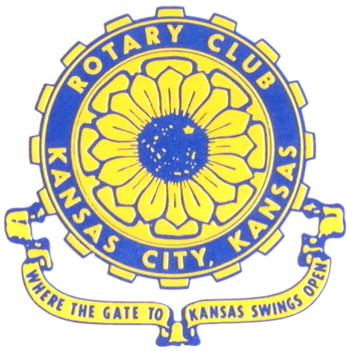
Where the Gate to Kansas Swings Open
The Kansas City, Kansas Rotary Club was organized on November 2, 1915 and received its charter as Club No. 195 in January 1916. Its members take pride in more than 100 years of Rotary service to the community and to international fellowship. From this Club have come five District Governors and two Directors of Rotary International. The Club’s history is as rich as that of the community it represents.
Following the Lewis and Clark expedition which camped at the confluence of the Kansas and Missouri rivers on June 26, 1804, in present day Kansas City, Kansas, this area became an important center for fur trappers. In the following years, many Indian tribes were relocated here from the East. In 1842 the Wyandot Indians acquired land here and founded a town. During this period, and for the next five decades, this area became the main gateway to the inviting majesty of the sprawling Kansas Prairie and the American West. This was where the frontier began. Pioneers found river transportation, outfitters and the beginning of the Santa Fe and Oregon Trails. After the covered wagons came major trunk railroads and barge lines.
In 1886, Kansas City, Kansas received its charter as an incorporated city, combining the towns of Wyandot, Argentine and Armourdale. (Rosedale was added in 1922.) Kansas City, Kansas is the site of the first industrial park in the United States, home of the prestigious University of Kansas Medical Center, and the location of the National Agricultural Hall of Fame and the nationally recognized Kansas Speedway.
Near the geographical and population centers of the contiguous United States, it is in the temperate latitudes at an elevation of 726 feet above sea level. The average rainfall is 35 inches. The average mean temperature ranges from 30°F in January to 80°F in July. The lowest recorded temperature was -23°F on December 23, 1989, and the highest was 113°F on August 14, 1936. Our city’s population of 145,000 and 155 square miles rank it 158th among cities in the United States.
Welcome to Kansas City, Kansas Rotary, and the vibrant community it represents.

Service Above Self
Rotary Websites:
KCK Club: www.rotarydowntownkck.org, District: www.rotary5710.org, International: www.rotary.org

WHERE NEARBY TO MAKE UP ATTENDANCE
MONDAY
Bonner Springs (11:45am) --------------------------------- Twister Bar & Grill, 13100 Kansas Ave.
Overland Park (11:30am) ----------------------------------- Doubletree Hotel, 10100 College Blvd.
TUESDAY
Gladstone (7:00am) -------------------------------------- Fairview Christian Church, 1800 N.E. 65th
WEDNESDAY
Overland Park South (7:15am) ------------------------ Deer Creek Country Club, 7000 W. 133rd
Leavenworth (Noon) --------------------------- Riverfront Community Center, 123 S. Esplanade
KCI, Missouri (Noon) -------------------------------- Granite City Pub, 8461 NW Prairie View Rd.
Shawnee Mission (Noon) -------- Sylvester Powell Community Ctr, 6200 Martway, Mission
Olathe (Noon) ------------------------------------- Hilton Garden Inn, 12080 S. Strang Line Road
Kansas City South, Missouri (Noon) ------------------------------- Margarita’s, 13401 Holmes Rd.
Johnson County-Sunset (5:15pm) ------------------------- Hilton Garden Inn Olathe, 119th & I-35
Waldo-Brookside, Missouri (5:15pm) ----------------------------- Waldo Pizza, 7433 Broadway
THURSDAY
Johnson County (7:15am) ----------------------------------- Holiday Inn, 8787 Reeder St., OPKS
Leawood (7:15am) ---------------------------------- Hallbrook Country Club, 11200 Overbrook Rd
Village West (7:15am) -------------------------- Famous Dave’s, 1320 Village West Pkwy., KCK
Gardner (7:30am) ---------------------------------------------- Gardner Community Ctr., 128 E. Park
Santa Fe Trail (7:30am) --- Mid-Am Nazarene U, 2030 E. College Way, Campus Ctr.,Olathe
Kansas City, Missouri (Noon) -------------------------------- The Gallery, 61 E. 14th Street, KCMO
FRIDAY
Desoto (7:00am) ------------------------ Desoto United Methodist Church, 8760 Kill Creek Road
Shawnee (7:15am) -------------------------------------- Shawnee Town Hall, 11600 Johnson Drive
Plaza, Missouri (7:15am) ------------------------------------- Grand Street Cafe, 4740 Grand Ave.
North Kansas City, Missouri (Noon) ------------------------------ NKC Library, 2251 Howell Street
Parkville, Missouri (Noon) ------------------------ Park University Underground, Woodard Center
Lenexa (Noon) --------------------- Lakeview Village, Southridge Bldg., 14001 W. 92nd, 5th Floor
Meeting make ups can be made 14 days before or after the missed meeting.
Please see the Secretary for the world directory of all Rotary Club’s meeting times, days and places.
2019-2020 Board of Directors
Officers Directors
John Freshnock Ashley Adorante
President Rick Behrens
Scott Martens Karole Bradford
Vice President Phil Gibbs
Greg Shondell Tony Martinez
Treasurer Terry Robinson
Jim Knight Kathleen VonAchen
Secretary Jen Wewers
Rosemary Podrebarac
Sergeant at Arms
Melissa Sieben
Past President

