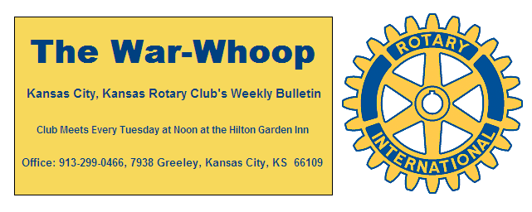
Websites: Club: www.rotarydowntownkck.org, District: www.rotary5710.org, Internationalwww.rotary.org

Volume 81 February 14, 2020 No. 33

LAST WEEK AT ROTARY- Three representatives from the organization “The Village Initiative” talked about their work with men that have been released from prison. The organization was founded in 2007. They told Rotarians that it usually takes two to three years for these men to become adjusted to society after many years in prison. Many of these men get out of jail lost and do not know how to handle this new found freedom. The organization partner with other organizations in the community when needed. According to the speakers as many as 82% of these men return back to prison.

President John and opened the meeting. Gorge Turner gave the invocation. and Frank and Donna Simonich led members in singing “Let Me Call You Sweetheart.” Great Job. Dave Tyler introduced the visiting Rotarians. Karole Bradford had her nephew with her again this week

PAUL HARRIS DRAWING- Jay Dunlap won the right to draw for the joker. Jay did not draw the joker and the amount goes to $85.00 for next week. Ten members participated in the drawing last Tuesday.

WEEK AT ROTARY- Keith Cluster, Founder and CEO of the organization “Ripple” will be our speaker next week,
Todd Jordan in the program chair for the day and for the month.

ROAMING ROTARIAN
North Kansas City-----------------------------------Dave Tyler

Dave reported that the NKC Club has moved to the North Parks and recreation Building located at 1201 Clark Ferguson Drive for their Luncheon.
*** The Bonner Springs Rotary Club is now meeting on the first and third Mondays of the month. They are still meeting at the Twister Bar and Grill.

VILLAGE WEST CLUB- Will be holding their SEAFOOD FEST on March 6th. Mark this date down in your calendars. The Club is now meeting at Providence Medical Center in the cafeteria on Thursday mornings. Mark this change on your schedules.

HUMAN TRAFFICING-The Leawood and Lenexa Rotary Clubs invite us to attend the Human Trafficking Awareness & Action Conference on Friday, March 6, 2020 from 7:45 AM to 11:30 AM at Church of the Resurrection,13720 Roe Ave., Leawood, KS 66224. These two clubs are asking Rotarians to join them to learn more about how Rotary can help stop Human Trafficking in our communities.

BOARD MINUTES- An item on the board meeting agenda this month was about how a Peacebuilder Club can be set. Your board needs some guidance which means our club needs someone to step up and become involved.
The board is very interested in setting up some projects for our club. Please talk to a board member about your concerns.

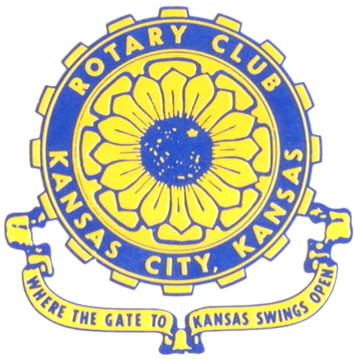
Where the Gate to Kansas Swings Open
The Kansas City, Kansas Rotary Club was organized on November 2, 1915 and received its charter as Club No. 195 in January 1916. Its members take pride in more than 100 years of Rotary service to the community and to international fellowship. From this Club have come five District Governors and two Directors of Rotary International. The Club’s history is as rich as that of the community it represents.
Following the Lewis and Clark expedition which camped at the confluence of the Kansas and Missouri rivers on June 26, 1804, in present day Kansas City, Kansas, this area became an important center for fur trappers. In the following years, many Indian tribes were relocated here from the East. In 1842 the Wyandot Indians acquired land here and founded a town. During this period, and for the next five decades, this area became the main gateway to the inviting majesty of the sprawling Kansas Prairie and the American West. This was where the frontier began. Pioneers found river transportation, outfitters and the beginning of the Santa Fe and Oregon Trails. After the covered wagons came major trunk railroads and barge lines.
In 1886, Kansas City, Kansas received its charter as an incorporated city, combining the towns of Wyandot, Argentine and Armourdale. (Rosedale was added in 1922.) Kansas City, Kansas is the site of the first industrial park in the United States, home of the prestigious University of Kansas Medical Center, and the location of the National Agricultural Hall of Fame and the nationally recognized Kansas Speedway.
Near the geographical and population centers of the contiguous United States, it is in the temperate latitudes at an elevation of 726 feet above sea level. The average rainfall is 35 inches. The average mean temperature ranges from 30°F in January to 80°F in July. The lowest recorded temperature was -23°F on December 23, 1989, and the highest was 113°F on August 14, 1936. Our city’s population of 145,000 and 155 square miles rank it 158th among cities in the United States.
Welcome to Kansas City, Kansas Rotary, and the vibrant community it represents.

Service Above Self
Rotary Websites:
KCK Club: www.rotarydowntownkck.org, District: www.rotary5710.org, International: www.rotary.org

WHERE NEARBY TO MAKE UP ATTENDANCE
MONDAY
Bonner Springs (11:45am) --------------------------------- Twister Bar & Grill, 13100 Kansas Ave.
Overland Park (11:30am) ----------------------------------- Doubletree Hotel, 10100 College Blvd.
TUESDAY
Gladstone (7:00am) -------------------------------------- Fairview Christian Church, 1800 N.E. 65th
WEDNESDAY
Overland Park South (7:15am) ------------------------ Deer Creek Country Club, 7000 W. 133rd
Leavenworth (Noon) --------------------------- Riverfront Community Center, 123 S. Esplanade
KCI, Missouri (Noon) -------------------------------- Granite City Pub, 8461 NW Prairie View Rd.
Shawnee Mission (Noon) -------- Sylvester Powell Community Ctr, 6200 Martway, Mission
Olathe (Noon) ------------------------------------- Hilton Garden Inn, 12080 S. Strang Line Road
Kansas City South, Missouri (Noon) ------------------------------- Margarita’s, 13401 Holmes Rd.
Johnson County-Sunset (5:15pm) ------------------------- Hilton Garden Inn Olathe, 119th & I-35
Waldo-Brookside, Missouri (5:15pm) ----------------------------- Waldo Pizza, 7433 Broadway
THURSDAY
Johnson County (7:15am) ----------------------------------- Holiday Inn, 8787 Reeder St., OPKS
Leawood (7:15am) ---------------------------------- Hallbrook Country Club, 11200 Overbrook Rd
Village West (7:15am) -------------------------- Famous Dave’s, 1320 Village West Pkwy., KCK
Gardner (7:30am) ---------------------------------------------- Gardner Community Ctr., 128 E. Park
Santa Fe Trail (7:30am) --- Mid-Am Nazarene U, 2030 E. College Way, Campus Ctr.,Olathe
Kansas City, Missouri (Noon) -------------------------------- The Gallery, 61 E. 14th Street, KCMO
FRIDAY
Desoto (7:00am) ------------------------ Desoto United Methodist Church, 8760 Kill Creek Road
Shawnee (7:15am) -------------------------------------- Shawnee Town Hall, 11600 Johnson Drive
Plaza, Missouri (7:15am) ------------------------------------- Grand Street Cafe, 4740 Grand Ave.
North Kansas City, Missouri (Noon) ------------------------------ NKC Library, 2251 Howell Street
Parkville, Missouri (Noon) ------------------------ Park University Underground, Woodard Center
Lenexa (Noon) --------------------- Lakeview Village, Southridge Bldg., 14001 W. 92nd, 5th Floor
Meeting make ups can be made 14 days before or after the missed meeting.
Please see the Secretary for the world directory of all Rotary Club’s meeting times, days and places.
2019-2020 Board of Directors
Officers Directors
John Freshnock Ashley Adorante
President Rick Behrens
Scott Martens Karole Bradford
Vice President Phil Gibbs
Greg Shondell Tony Martinez
Treasurer Terry Robinson
Jim Knight Kathleen VonAchen
Secretary Jen Wewers
Rosemary Podrebarac
Sergeant at Arms
Melissa Sieben
Past President

