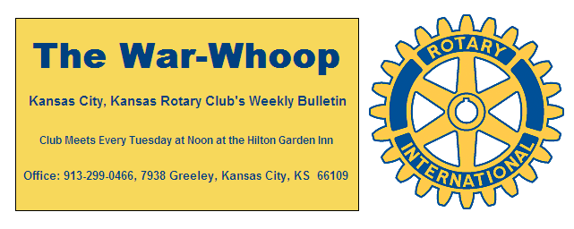
Websites: Club: www.rotarydowntownkck.org, District: www.rotary5710.org, Internationalwww.rotary.org

Volume 81 March 6, 2020 No. 36

LAST WEEK AT ROTARY- Stan Weber, Sports analysist for the Kansas State Wildcats, told a few stories and talked about the sports season for the Big 12. Stan has been the sports analysist for the Cats Network for thirty-three years. He told Rotarians that Kansas City is the best city to host the Big 12 Tournament. He touched on some the different ideas that are being floated around regarding financial payments to student athletes. He answered many questions after his presentation. Thanks John for scheduling Stan again this year.

President John opened the meeting. Dan Duncan gave the invocation. Scott Kaufmann, led members in singing. Frank Simonich introduced the guests. Guests this week were Clayton Hunter, Rotarian from Village West Club, Sally and Andy Bukaty, guests of John Bukaty. Andy raised $2,500 for Rotary’s Polio Plus program last year through his March Madness.

PAUL HARRIS DRAWING- George Turner won the right to draw the joker last week. George did not draw the joker and the amount goes to $113.00 for next week’s drawing.

NEXT WEEK AT ROTARY-Erin Strykee Executive Director of Rosedale Development Association, will be talking about building on the strengths of Rosedale.

Karole Bradford is the program chair for the day and for the month

HAPPY BIRTHDAY-Scott led members in singing “Happy Birthday” to Dan Duncan and Terry Robinson.

VILLAGE WEST CLUB- Just another reminder that the Village West Club will be holding their SEAFOOD FEST on March 6th (this Friday) at the Savior of the World Center Pastoral Center. It is located at 126th and Parallel Parkway. The evening starts at 6:00pm.

KANSAS CITY DAY- Dan Duncan attended the organiza-tional meeting for Kansas City Day last week and reported that the program will remain the same as last year. Mark your calendars for Thursday, April 2nd and plan on getting up early.

INVOCATIONS- Karen Hostetler passed out the signup sheet for invocations. If you did not have an opportunity to sign up yesterday, please check with Karen and pick a date.

MEMBERSHIP- Bring a guest to Rotary next Tuesday. Your guest will be our guest if they are potential members. Business contacts that are made every day are great way to introduce someone to Rotary. YOU are the best salesperson for Rotary. If YOU don’t talk about Rotary to someone WHO will.

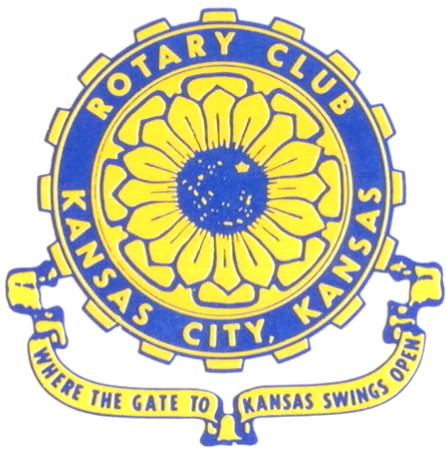
Where the Gate to Kansas Swings Open
The Kansas City, Kansas Rotary Club was organized on November 2, 1915 and received its charter as Club No. 195 in January 1916. Its members take pride in more than 100 years of Rotary service to the community and to international fellowship. From this Club have come five District Governors and two Directors of Rotary International. The Club’s history is as rich as that of the community it represents.
Following the Lewis and Clark expedition which camped at the confluence of the Kansas and Missouri rivers on June 26, 1804, in present day Kansas City, Kansas, this area became an important center for fur trappers. In the following years, many Indian tribes were relocated here from the East. In 1842 the Wyandot Indians acquired land here and founded a town. During this period, and for the next five decades, this area became the main gateway to the inviting majesty of the sprawling Kansas Prairie and the American West. This was where the frontier began. Pioneers found river transportation, outfitters and the beginning of the Santa Fe and Oregon Trails. After the covered wagons came major trunk railroads and barge lines.
In 1886, Kansas City, Kansas received its charter as an incorporated city, combining the towns of Wyandot, Argentine and Armourdale. (Rosedale was added in 1922.) Kansas City, Kansas is the site of the first industrial park in the United States, home of the prestigious University of Kansas Medical Center, and the location of the National Agricultural Hall of Fame and the nationally recognized Kansas Speedway.
Near the geographical and population centers of the contiguous United States, it is in the temperate latitudes at an elevation of 726 feet above sea level. The average rainfall is 35 inches. The average mean temperature ranges from 30°F in January to 80°F in July. The lowest recorded temperature was -23°F on December 23, 1989, and the highest was 113°F on August 14, 1936. Our city’s population of 145,000 and 155 square miles rank it 158th among cities in the United States.
Welcome to Kansas City, Kansas Rotary, and the vibrant community it represents.

Service Above Self
Rotary Websites:
KCK Club: www.rotarydowntownkck.org, District: www.rotary5710.org, International: www.rotary.org

WHERE NEARBY TO MAKE UP ATTENDANCE
MONDAY
Bonner Springs (11:45am) --------------------------------- Twister Bar & Grill, 13100 Kansas Ave.
Overland Park (11:30am) ----------------------------------- Doubletree Hotel, 10100 College Blvd.
TUESDAY
Gladstone (7:00am) -------------------------------------- Fairview Christian Church, 1800 N.E. 65th
WEDNESDAY
Overland Park South (7:15am) ------------------------ Deer Creek Country Club, 7000 W. 133rd
Leavenworth (Noon) --------------------------- Riverfront Community Center, 123 S. Esplanade
KCI, Missouri (Noon) -------------------------------- Granite City Pub, 8461 NW Prairie View Rd.
Shawnee Mission (Noon) -------- Sylvester Powell Community Ctr, 6200 Martway, Mission
Olathe (Noon) ------------------------------------- Hilton Garden Inn, 12080 S. Strang Line Road
Kansas City South, Missouri (Noon) ------------------------------- Margarita’s, 13401 Holmes Rd.
Johnson County-Sunset (5:15pm) ------------------------- Hilton Garden Inn Olathe, 119th & I-35
Waldo-Brookside, Missouri (5:15pm) ----------------------------- Waldo Pizza, 7433 Broadway
THURSDAY
Johnson County (7:15am) ----------------------------------- Holiday Inn, 8787 Reeder St., OPKS
Leawood (7:15am) ---------------------------------- Hallbrook Country Club, 11200 Overbrook Rd
Village West (7:15am) -------------------------- Famous Dave’s, 1320 Village West Pkwy., KCK
Gardner (7:30am) ---------------------------------------------- Gardner Community Ctr., 128 E. Park
Santa Fe Trail (7:30am) --- Mid-Am Nazarene U, 2030 E. College Way, Campus Ctr.,Olathe
Kansas City, Missouri (Noon) -------------------------------- The Gallery, 61 E. 14th Street, KCMO
FRIDAY
Desoto (7:00am) ------------------------ Desoto United Methodist Church, 8760 Kill Creek Road
Shawnee (7:15am) -------------------------------------- Shawnee Town Hall, 11600 Johnson Drive
Plaza, Missouri (7:15am) ------------------------------------- Grand Street Cafe, 4740 Grand Ave.
North Kansas City, Missouri (Noon) ------------------------------ NKC Library, 2251 Howell Street
Parkville, Missouri (Noon) ------------------------ Park University Underground, Woodard Center
Lenexa (Noon) --------------------- Lakeview Village, Southridge Bldg., 14001 W. 92nd, 5th Floor
Meeting make ups can be made 14 days before or after the missed meeting.
Please see the Secretary for the world directory of all Rotary Club’s meeting times, days and places.
2019-2020 Board of Directors
Officers Directors
John Freshnock Ashley Adorante
President Rick Behrens
Scott Martens Karole Bradford
Vice President Phil Gibbs
Greg Shondell Tony Martinez
Treasurer Terry Robinson
Jim Knight Kathleen VonAchen
Secretary Jen Wewers
Rosemary Podrebarac
Sergeant at Arms
Melissa Sieben
Past President

