P.O. BOX 4376, OLATHE, KS 66063 July 2016 CHARTERED AUGUST 17, 1937





OLATHE ROTARY CLUB

**District 5710 Club** **1625**

Thank You Outgoing President Jason Armstrong For a Great Year of Rotary!

2016-2017

Olathe Rotary Club

Officers and Board

**7/1/2016 to 6/30/2017**

Larry Rinne, President

lrinne@comcast.net

**Jason Armstrong, Past President**

**Vanessa Vaughn West**

**President Elect**

**Ernie Hicks, Treasurer,13th yr**

913 764-5197

ernieofolathe@yahoo.com

**Doug Brownlee, Secretary, 2nd yr**

**Pat O’Donnell, Director**

1st of 2 year term

**Jasen Mangrum, Director**

2nd of 2 year term

**Aimee Hruska, Director**

2nd of 2 year term

**Karin Brownlee, Director**

1st of 2 year term

**Geoff Neufeld, Director**

1st of 2 year term

Olathe Rotarians Enjoy Our

Year End Banquet Celebration

Olathe Rotary

Speakers/Events

July 01 Beginning of new Rotary

Year

July 06 No Meeting

July 13 Pat O’Donnell, Rotary

International Conference

Recap, and Club

Engagement Activity

July 20 Gordon Docking, KidsTLC

Update

July 27 Deanna Snider, Olathe

Boys and Girls Clubs

Speaker Chair

**Vanessa Vaughn West**

VLVaughnWest@OLATHEKS.ORG

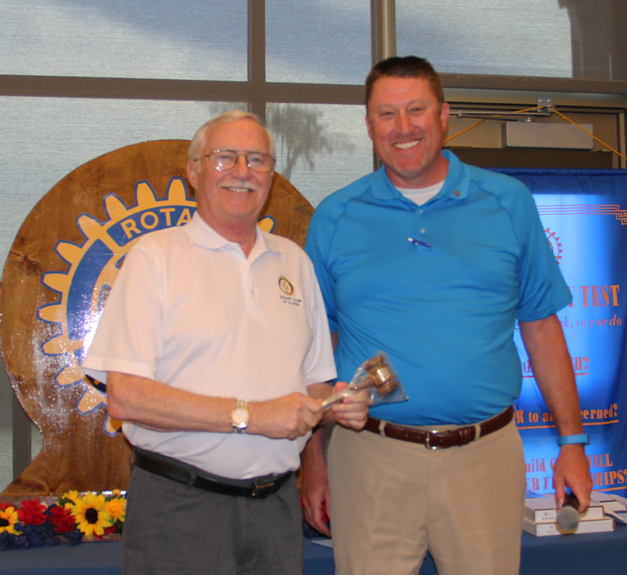

Outgoing President Jason Armstrong, right, passes the gavel to incoming Olathe Rotary President, Larry Rinne, who, days before, had surgery but came with a smile and his lovely wife Carol. He even left his cane at home! We welcome our incoming President as he begins to lead us through another fun, exciting, busy and fruitful year beginning July 1, 2016.

Outgoing President Jason, received a plaque for a job very well done, and a Paul Harris Fellow. He lead the 2016 Days of Wine and Rotary team to a successful fundraiser and helped guide and encourage us through a number of other great fundraising projects, board meetings, and weekly club meetings throughout the year. Thank you Jason!

Congratulations

Olathe Rotarian

of the Year 2016,

Aimee Hruska

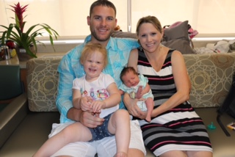

Quiet Rotarian of the Year, Pat O’Donnell

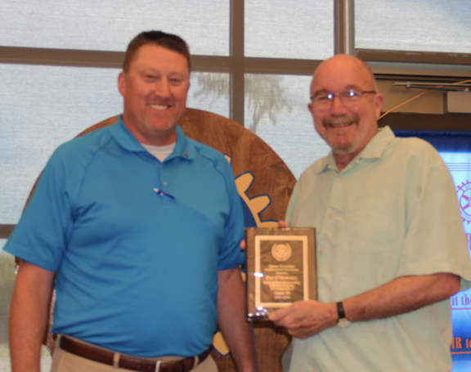

Quiet Rotarian of the Year.

Vanessa Vaughn West

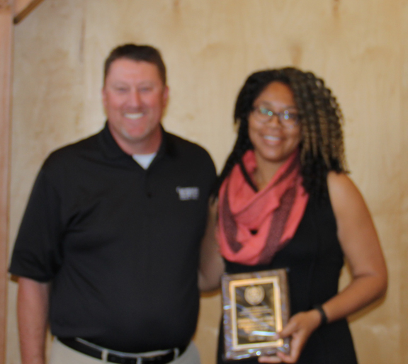

Vanessa joined Olathe Rotary April 2015. She immediately jumped on board to help with Days of Wine and Rotary. She became a board

President Jason awarded Aimee Hruska “Olathe Rotarian of the Year”. Aimee was instrumental in the success of our annual Days of Wine and Rotary fundraiser, helping to plan and organize, the event, paying close attention to detail, even through pregnancy! She also redirected and organized the new www.olatherotary.org to be able to link to district and Rotary International data for reporting, and is active on the Olathe Rotary board.

After 8 years in East Wichita Rotary, Pat joined Olathe Rotary November 2015. He dove right in helping with a number of projects, including Days of Wine and Rotary. He became the club’s website master, and joined the Olathe Rotary board. He attended the 2016 RI Conference in Korea with his daughter, Trish Reedy, 2016-2017 Overland Park Rotary Club President.

member for the 2015-2016 Rotary year and is currently President Elect and our Speaker Chair. Vanessa will be Olathe Rotary President in the 2017-2018 Rotary year. She helps behind the scenes anywhere she can, which is much appreciated. She is Community Relations Manager for the City of Olathe.

Olathe American Cancer Society

Relay for Life

The eighteenth and final Olathe Relay For Life occurred on a hot night in early June. Thanks to all the “Rotary Ramblers” who braved the heat and came out to walk. I especially commend Ernie Hicks for helping set up our tent; David, Dianne and Danny White who stayed the entire 12 hours; Geoff Neufeld who kept pace with Branden until 4:30 AM; and Michael Ashcraft who heard his alarm and joined us @ 3:00 AM!

The $6510 we have raised so far puts us in second place out of 34 teams. We will need to reach at least $12,000 by the end of August to successfully defend our #1 ranking. The “Rotary Ramblers” are now legendary for our strong fundraising finishes. Checks can be made out to the American Cancer Society and given to me or Ernie. Online donations are easy, too. Go to [www.relayforlife.org/olathe](http://www.relayforlife.org/olathe) and find our “Rotary Ramblers” team and follow the prompts. Please help us “Finish the Fight” against cancer.

*Olathe Rotary Ramblers Team Captain, Gerald Gentry*

A Gift of Friendship from Japan

Olathe Rotary Welcomes New Member, John Staton

John joined Olathe Rotary August, 2015, and his sponsor is Frank Devocelle. He is Senior Vice President of Operations at Olathe Medical Center. John has been with OMC since 2000, has a Bachelor of Science Degree in Medical Technology from Pittsburg State University, and a Master of Health Services Administration from the University of Kansas. John is board certified in healthcare management as a Fellow (FACHE) of the American College of Healthcare Executives.

John and his wife Amy live in Olathe and have been married for 18 years. Amy is a special education teacher and is currently back in school pursuing a degree in American Sign Language. They have two boys. Brady is a junior at Olathe Northwest and Chance is a 6th grader at Prairie Trail Middle School.

John is an avid sports fan, cheering on the ONW Ravens, Chiefs, Royals, and of course, the

During his trip to the Rotary Intl. Convention in Korea, Pat O’Donnell visited the Maebashie West Rotary Club in Japan. He was given a gift of friendship from the officers of the

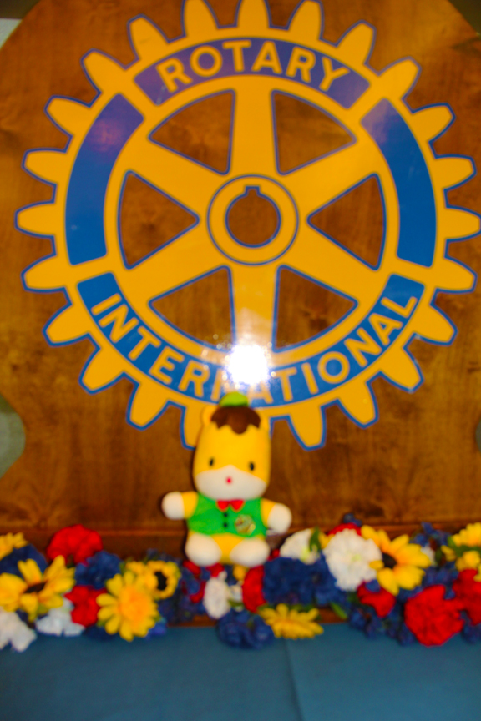

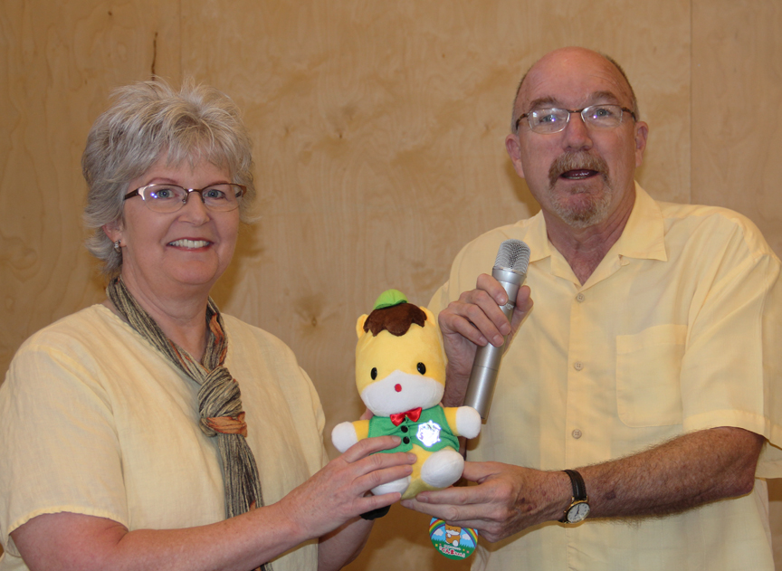

Rotary club to bring back to Olathe Rotary.

He made the presenta-

tion to Olathe Rotary Japanese Exchange Chair, Dianne Daughtery. The little stuffed animal is called Gumma (Goo ma) chan. He is the prefecture’s mascot. He is a horse which is the symbol of Gunma Prefecture.

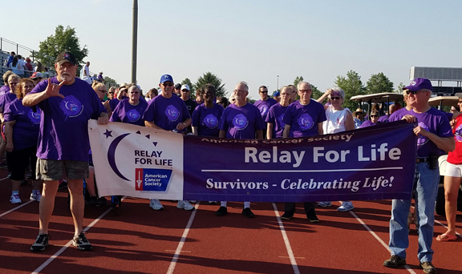Photo By Kim Graming

Olathe Rotarians Planning A

Visit to Japan This Fall

Dianne Daughtery also just returned from Maebashi, Japan. She had a nice dinner at a traditional Japanese restaurant with about 15 Rotarians on Thursday night and attended the Maebashi Club meeting on Friday. Maebashi Rotarians are hoping we can gather a small group from our club that can visit this fall. They already have suggested some wonderful excursions.

If you would like to be a part of the

Olathe Rotary **visit to Japan this fall**, contact:

Olathe Rotarian**, Dianne Daughtery**

[**ddkototaiko@gmail.com**](mailto:ddkototaiko@gmail.com)

Olathe Rotary Welcomes New Member, Nick Rodriguez

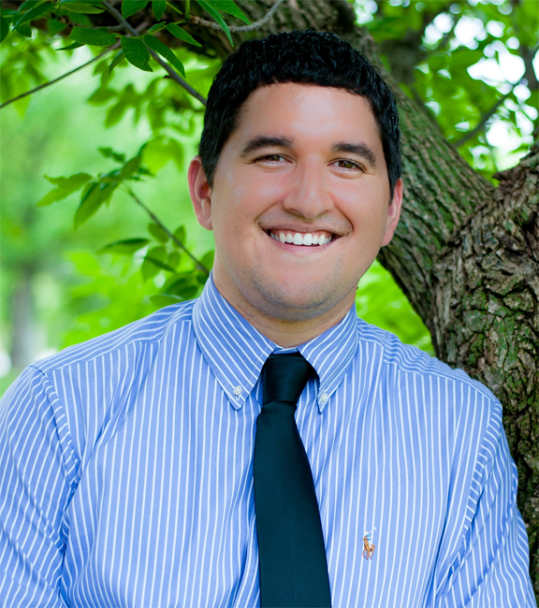

Dr. Nick Rodriguez is originally from Olathe, KS and attended Olathe East High School graduating in 2009. He then attended Cleveland Chiropractic College and in April 2016 graduated with his Doctorate in Chiropractic and Bachelors of Science in Human Biology. Upon graduation he accepted a position in Olathe at Miller Chiropractic Health Center working with his long time mentor Dr. Dennis Miller. They specialize in effective pain relief through gentle chiropractic adjustments and nutritional counseling**.**

Dr. Nick married his beautiful wife Jennifer in May of 2015. She is a cardiac Registered Nurse at Shawnee Mission Medical Center since 2014. They both enjoy time at the lake with family and friends in their free time.

Dr. Nick is a current member of the Kansas Chiropractors Association, Cleveland Chiropractic Alumni Association, NBCE board certified, and holds a active license with the Kansas State Board of Healing Arts. He is also active in his Church: Redeemer Fellowship - Johnson County. "

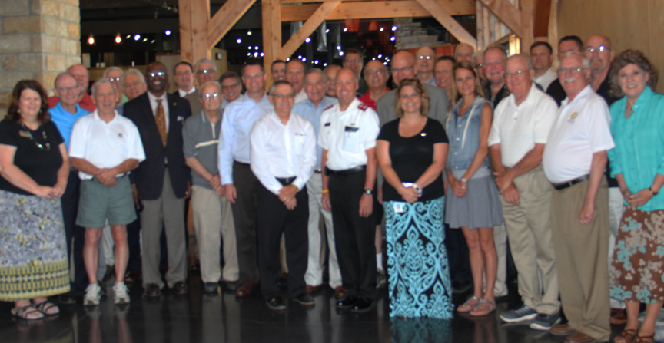

With Heavy Hearts Olathe Rotarians Say Goodbye to Major Mark Martsolf

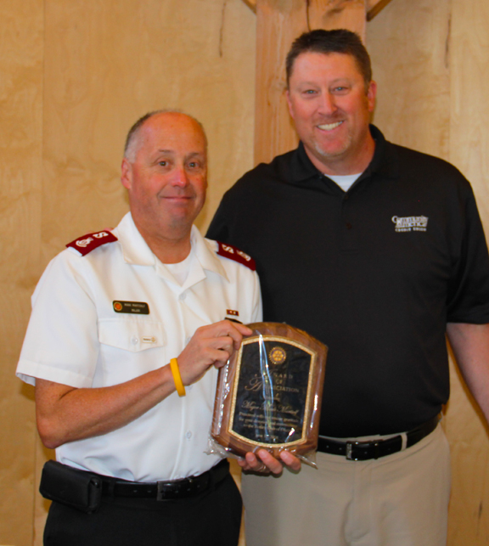

Right, President Jasen presents Major Mark with a plaque of appreciation for his outstanding service to our club. Also before moving to Rockford, he was awarded the Paul Harris Fellow, that was earned by Major Mark.

Olathe Rotarians gathered to wish Major Mark Martsolf well as he and his wife Major Teri Martsolf move to their newly assigned Salvation Army post in Rockford, Illinois June 27th. Major Mark has definitely left his mark on the hearts and minds of many Olatheans. Many have been personally touched by his kindness, including the editor of this newsletter.