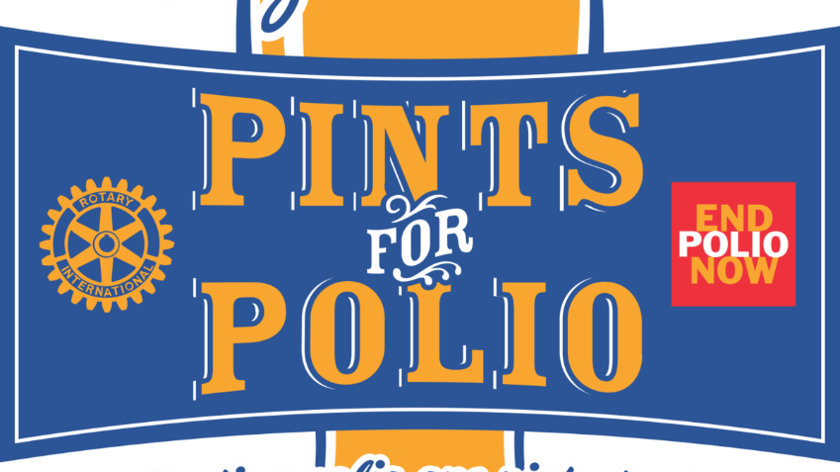
DRINK A BEER AND SAVE A LIFE!
We’re sharing a pint and stamping out polio. $50 gets you wonderful Blind Tiger beer, a Pints For Polio collectible glass to put it in AND a $50 tax deductible contribution to the Rotary International Foundation Polio Plus campaign Please bring your 2020 or 2021 glass if you have one. Also on tap: snacks, an interesting Polio program and the chance to buy a one of a kind, up-close and personal Giraffe Experience at the Topeka Zoo!
Thursday, October 20
5:30-8pm
Constitution Hall and Rotary Pocket Park
429 S. Kansas Ave.
