This year’s “Duck Pluck” will take place on April 23, 2022. The winning ducks will be plucked out at our District Conference in Coralville!
Here’s how it works:
- Each club (including individuals from that club) will be represented by a single duck in the race.
- The first three ducks to be plucked will be the winners. Once the winning three clubs have been determined a computer pick at random will occur to choose one winner of a Paul Harris Fellow designation for each of the three winning clubs.
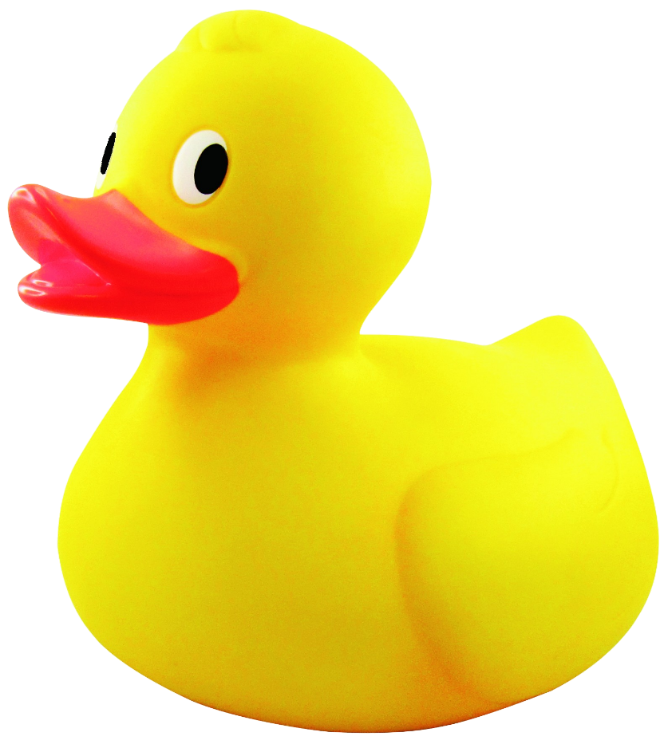
- Each club participating in the race will receive Foundation Paul Harris Fellow points for the full amount of dollars contributed by the club through the purchase of ducks.
Ducks are $5 each.
Checks can be made payable to: The Rotary Foundation
and mailed to (must be mailed to arrive by April 12, 2022):
Theresa Mickelson
1929 Ridgeway Drive SE
Cedar Rapids, IA 52403
Phone: 319-981-0792
Email: mickelson.theresa@gmail.com
They can be purchased online at district5970.org If you choose to purchase ducks online we kindly request you pay for the credit card fees therefore ducks are $5.42 each.

Rotary District 5970 - Duck Race 2022
Supporting The Rotary Foundation
Name:____________________________ Club:_________________________
Number of Ducks Purchased:________ Total = $_________ Date:___________
Thank you!

