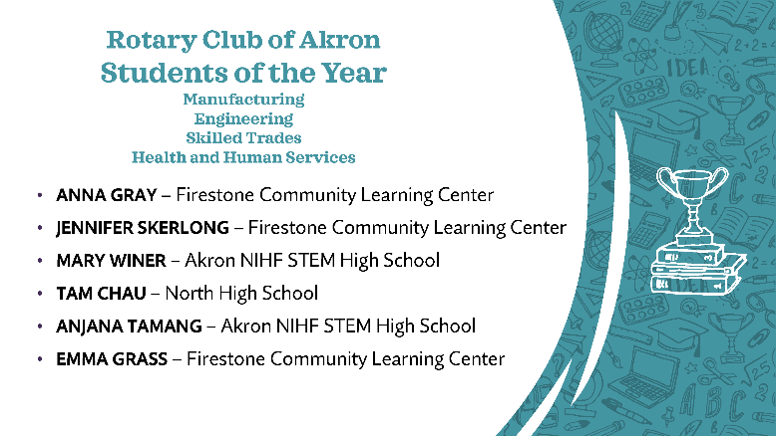

Anna Gray

Anna is a Senior at Firestone Community Learning Center. She is enrolled in the Project Lead the Way Engineering Program and the International Baccalaureate (IB) program.

In addition to her rigorous academic schedule, Anna has been very engaged in other school activities. She has participated in the school’s Women’s tennis program for the past 4 years including being a varsity member for all four years and Co-captain her senior year. She has also been engaged in the Eco Club, the Debate Club, and the Robotics Club. She has been a member of the National Honor Society her Junior and Senior years.

When not studying or participating in other school activities, Anna has contributed many service hours in the community. A few of those service activities include the website manager and other duties for the Akron Touchdown Club Foundation, volunteer for the One-Way Café at the Gateway Worship Center, and numerous other service hours in a variety of settings. In addition, Anna assists her mother in cleaning various offices and homes.

When asked how her participation in the engineering career pathway has prepared her to be successful in the future, Anna stated. “Participating in Project Lead the Way has been one of the best decisions I have made for my future. This program provided me with a confident foundation in engineering that will allow me to begin pursuing a degree in Aerospace Engineering at the University of Akron. Additionally, it has given me the opportunity to experience real life applications to engineering problems through trouble shooting solutions and experiencing the advantages of communication in teamwork.” She goes on to say “From middle school to my sophomore year, I was a dancer, singer and actress. The enthusiasm Mr. Spak taught with finally won me over and now I am a vex robotics programmer. It has taught me to accept new challenges with a smile, how to be calm and professional in interviews and presentations, and how to work with a team to overcome challenges."

Jennifer Beaven, IB English/Literature instructor for Anna has this to say: “It is a pleasure to recommend Anna for the Akron Rotary Scholarship. Anna’s work efforts and ownership of her learning are excellent indicators of what she can and will accomplish. She is inquisitive and a critical thinker. While she excels academically, Anna also excels in her community through various activities. She pursues what fuels her passions and touches her heart.”

Mr. Andrew Wallen, Aerospace instructor had this to say “Anna reaches out and pulls up the people that she is around and pushes them to hold themselves to a higher standard.”

Anna maintains a 4.1 cumulative GPA. Anna plans on attending the University of Akron pursuing a major in Aerospace Engineering and a minor in marketing or business.

Jennifer Skerlong

Jennifer is a senior at Firestone Community Learning Center and is enrolled in the Aerospace Engineering program. Jennifer has a 3.8 GPA and has managed to make honor roll recognition all four years.

Jennifer has been involved in the Firestone Women’s Varsity Soccer program for all 4 years. In addition, she currently serves as the Treasurer for the Robotics team. She has been a member of the National Honor Society for the past two years.

Her commitment to community service is outstanding. She has been involved with the Faith Lutheran Church Mission trips for the past 6 years. She travels to southern Ohio and spends a week doing yard work, painting, and building wheelchair ramps. Jennifer estimates she has performed over 210 hours of community service in this project alone.In addition to the mission experiences, Jennifer also babysits 30 preschool aged children one Friday night a month for 4 hours at a time for a Pajama Party. For two years she has participated in Goodyear STEM day where she presents to Middle school students about Robotics as well as showing them the different careers that are available in pursuing STEM. For the past three years she has been educating middle schools about robotics and the opportunities available through Akron Public Schools, as well as helping the students with a design challenge.

For the past several years, Jennifer has worked at the Fairlawn Swim and Tennis Club during the summer months lifeguarding the pool and other miscellaneous tasks she was assigned.

When Jennifer was asked how the career technical program has prepared her future, Jennifer responded: “In my career technical education program, I realized that engineering is something that I would like to pursue. I was always interested in math and science but, until I got into the Aerospace Academy at Firestone, did I realize that Engineering was something I wanted to make my career. Through the academy, I have been able to participate in the robotics club where I have been very successful. With my teams qualifying for State all three years as well as the world competitions. This has allowed me to work with several different people to establish the importance of teamwork.

According to Andrew Wallen, Aerospace instructor, “Jennifer holds herself to a high standard striving to turn in work that goes above what is required. She sets a great example for her classmates and helps those who are struggling. In robotics she brings new ideas as they build, program, and compete. She is able to keep her team running smoothly.”

Another instructor, Scott Westphal had this to say: “I have had the pleasure of having Jenny in class for two years. The first year was our Pre-IB class Integrated Honors Chemistry-Physics, which includes the best and brightest Sophomores in the greater Akron area and the second year was our AP Chemistry class. Jenny performed at the highest level in each class showing the determination and passion to succeed in her goal of studying mechanical engineering. Jenny has a positive, respectful attitude in class and is willing to assist others. Jenny has strong organizational, leadership, and time management skills.”

Jennifer will be attending The Ohio State studying mechanical engineering. Ten years from now, Jennifer would like to be working for “Engineers Without Borders.”

Mary Winer

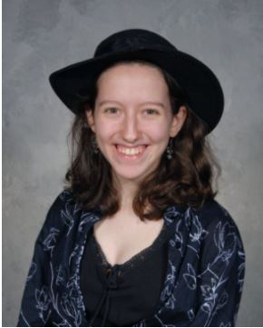
Mary is a senior at the Akron NIHF STEM High School and is enrolled in the Environmental Engineering program. Mary has a cumulative 3.7 GPA.
Besides being involved in the rigorous STEM coursework, Mary has been involved in several school activities. She has been involved in the Patchwork: Diversity Club for the past 4 years where she has held leadership positions of Marketing and President. She has also been involved with the Art Club, Robotics Club, and the National Honor Society.

Mary has been involved in several community service causes. For the past 6 years, she has been involved with Herps Alive Reptile Rescue. She has assisted with cleaning and caring for animals, helping customers, and working at events. She calculates she has volunteered over 200 hours over these six years.

Mary has worked an average of 12 hours per week for the past 18 months at the Akron Public Library.

When Mary was asked about an individual or group project that she was proud of and what was the biggest challenge, Mary explained to us about a project involving the completion of a book on frogs. Mary explained there are 26 frog species, and she created an A-Z book describing each of the 26 species. Mary hopes to get the book published.
According to Zach Griffith, an Engineering Instructor at STEM, Mary is super creative and a pleasure to be around. She is civically engaged in social issues and cares about her community.

Tanner Hughes, a Math teacher who has known Mary for 3 years states that “Mary has displayed a great work ethic in my math classes. This combined with her strong character and the drive to continue to improve will set her up for success. Mary has been nothing but respectful during the years that I have known her and interacts well with other students and teachers. It has been rewarding to see her develop her math skills through problem solving and critical thinking.”

Mary will be attending Ohio University, pursuing a degree in Graphic Design.

Tam Chau

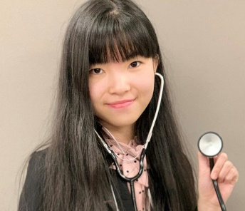
Tam Chau is a senior at North High School and is enrolled in the Biomedical Science Academy. Tam has a 4.125 GPA.

A few of the activities Tam has participated in during her high school career include Chess Club, Varsity golf, student council, Biomedical Science Club, HPAC Club (Valor Home Project), and the North High School Rotary Interact Club where she has served as President

Community Service has also been high on Tam’s list of activities. She has been a Hospital Guide for Summa Health, accumulating over 100 hours of service. She has also volunteered at the Akron/Canton Foodbank, Haven of Rest and Valor Home.

Alma Kryah-Deblasio, Tam’s English teacher and Interact Advisor had this to say about Tam: “I have been very fortunate to have worked with Tam for the past two years. She has been an amazingly disciplined go getter. Tam schedules all the Interact events, plans out all the fundraisers, and keeps things rolling with meetings during the pandemic. She is very organized and can think through all the steps of running a school club, both practically and socially. Even as an English Language Learner, she is amazingly successful at all her classes including Biomedical Science.” Tam immigrated from Viet Nam less than 5 years ago.

Kelly Dine who teaches Tam the Biomedical Science classes has this to say: “I’ve not known anyone more determined to succeed than Tam. She is a role model of volunteerism, professionalism, and leadership. Besides leading the Rotary Interact for the past 2 years, Tam has also completed multiple other community service projects, especially in caring for veterans at the Harry Donovan Valor Home. Tam is a Viking Scholar and is at the top of her class academically. Tam is the first to say, ‘I’ll help’ whenever someone needs assistance.”

Tam has been accepted at The Ohio State where she intends to study pre-Med. She wishes to attend medical school specializing in Ear, Nose and Throat.

Anjana Tamang

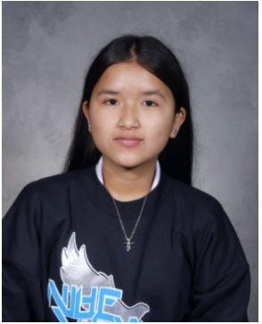
Anjana is a Senior at the Akron NIHF STEM high school. She is enrolled in the Biomedical Sciences program. Anjana spent the first ten years of her life in Nepal as a Bhutanese refugee. Anjana has a cumulative GPA of 3.73.

During her high school years, Anjana has played soccer, has been a student council representative for 2 years and has been a school ambassador for the past 2 years.

Anjana has provided community service to the Tamang and Gurung Communities by helping with programs, festivals, serving food and cleaned up after the events were completed.

Anjana works an average of 14-20 hours per week at the Kent Walmart.

According to Coach Graber, Anjana’s Mathematics instructor, Anjana is one of the hardest working learners in our school. She is dedicated to her success and has an excellent work ethic. She has strong academic skills and caught on to mathematical concepts very quickly. Even more important, she is respectful and kind to everyone that she interacts with, both her teachers and her peers.

When one looks at Anjana’s commitment, one only needs to look at the commitment she made to playing soccer. While she attended the NIHF STEM high school in downtown Akron, she played Soccer at North High School. She had to take the bus daily to get from STEM to North.

Anjana has been accepted at the University of Akron and Stark State College. She will be majoring in Accounting. Anjana hopes to one day work as a bank accountant.

Emma Grass

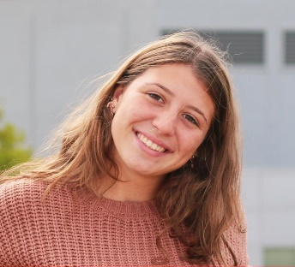
Emma is a senior at Firestone Community Learning Center and is enrolled in the Nursing Career Technical Pathway. Emma has a 3.8 GPA.

Prior to attending Firestone CLC for her high school years, Emma attended the Miller South School for the Visual and Performing Arts for several years.

Emma has been involved in several school activities. She has been a member of the National Honor Society for the past year, a member of Student Council for 2 years, a member of ASA (dance) for 4 years and a member of the National Honor Society of Dance Arts for 2 years.

Emma has been a member of the Mayor’s Youth Leadership Council.

Emma currently works 20 hours per week at the West Side Bakery. During the Summer she lifeguards at the Fairlawn Country Club.

Kelly Berick, a Dance instructor for Emma has this to say about Emma: “Academically, Miss Grass is an eager and engaged student. She willingly accepts challenging material and returns timely written and/or movement responses that are thoughtful and honest. She can work independently or collaboratively. She is also one of the most responsible students I have ever had she never procrastinates, knows how to prioritize, and asks questions that indicate depth of thought and understanding and a desire for clarity and goal achievement. She has developed work ethic and leadership skills that cause classmates to elevate their participation to match hers. As a four-year soccer team athlete, it is no wonder she has served two years as captain.”

Tammie Purcell, Emma’s instructor for AP History, sociology and psychology had this to say: “Emma works hard at whatever she sets her mind to learn. Her interest in the world around her and her concern for others last year led her to join me and a few other students to attend a conference at the Ohio State House on human trafficking. In response to that conference, she teamed up with a few of the other students and created a presentation targeted at teaching middle school students of the very real dangers in social media and in communicating with others through the internet.”

Emma intends to begin her college career at Ohio University to pursue a degree in Nursing. Long term, Emma plans to become a Nurse Anesthetist.

