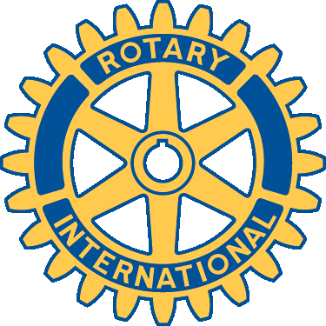

Rotary Club of Fort Collins Breakfast

Community Service Committee Grant Application

Date of Application:

To request a grant from the Community Service Committee of the Rotary Club of Fort Collins Breakfast please complete the information below and answer the following questions in no more than two pages. This request form is only for the Community Service Committee.

Rotary’s motto is “Service Above Self” and we seek to fund projects that will make an impact on our community. Specifically we target projects that impact youth. Funding will typically not be provided for capital projects.
There is no grant deadline. Applications will be reviewed within eight weeks of receipt and our decision will be communicated to you at that time.

Grant applications should be returned to a Rotary Contact Person:

Name of Organization:

Name of Program or Project (if applicable):

Amount of request:
Details of amount requested:

Organization’s Contact Person:

Address:

Phone:

- Mission of Organization:
- Describe the program or project including purpose and goals:
- Date or timeline of program/project (if applicable):
- Description of beneficiaries of the program/project including the number of individuals who will be served:
- Overall program/project budget including the specific purpose of the requested funds:
- What are your other sources of funding?: Have you ever received funding from the Rotary Club of Fort Collins Breakfast and if so how were the funds used?:

*** Please submit your most recent financial statement and this application to:
Jim Dawdy, Community Service Committee
jim_dawdy@msn.com

