Annual Lee’s
Summit Rotary “Investing in Our Youth”
Invitational
Golf Tournament

Thursday May 4th, 2017

Sponsorship Opportunities

Hole Sponsor - $700
One foursome, sponsor sign on course tee box & green, announced at
Luncheon & Awards Ceremony

Lunch Sponsor - $700
One foursome, 1 sponsor signs on each the course tee box & green, announced at
Luncheon & Awards Ceremony

Awards Ceremony Sponsor - $700
One foursome, sponsor signs on each the course tee box & green, announced at
Luncheon & Awards Ceremony

Putting Green/Beverage Cart - $400
(1 Putting green; 2 Beverage Carts available)
Two Players, sponsorship signage on tee, green or beverage cart, announced at Luncheon & Awards Ceremony

Silver Sponsor - $200
Signage Only, No Golfers

Individual Golfers - $150*
18 holes of golf, cart, range balls, giveaways, snacks/beverages, Luncheon & Awards Ceremony

Registration
Return this form no later than April 28, 2017 with your check payable to Rotary:
Rotary Club of Lee’s Summit Endowment Fund Golf Tournament
c/o Robert Sauve 816-935-3293
P.O. Box 785, Lee’s Summit, MO 64081

Name: ________________________ E mail: _____________________________
Company:__________________________________________________________
Address: ___________________________________________________________
City, State, ZIP: _____________________________________________________

____ Putting Green Sponsor ($400) ____ Hole Sponsorships ($700)
____ Beverage Cart Sponsor ($400) ____ Lunch Sponsorship ($700)
____ Awards Ceremony Sponsor ($700) ____ Silver Sponsorship ($200) ____ Individual Player ($150)*

( ) Please place me on a team -or- ( ) Here is my team

Please provide name & phone number or email address for each golfer.
Name: ______________________ Phone/e-mail: ______________________
Name: ______________________ Phone/e-mail: ______________________
Name: ______________________ Phone/e-mail: ______________________
Name: ______________________ Phone/e-mail: ______________________

Company Name & Address for signage, if sponsor
_________________________________________________________________
_________________________________________________________________

# of individuals golfer ($150/each)*_____ x $150 = $ ________
Sponsor [Name: ____________________ amount $ ________
Total Amount: $ ________
* Competitive Package includes: entry in the Hole-in-One Contest, 2 mulligans
and hole contests (e.g., closest to pin, longest putt, longest drive/men’s &
women’s)

Mail: The Rotary Club of Lee’s Summit Endowment Fund,
P.O. Box 785, Lee’s Summit, MO 64081
Missouri Tax ID Number: 15671658

**$95 of each Registration is Tax Deductible**

Annual Rotary Club of Lee’s Summit “Investing in Our Youth”
Invitational Golf Tournament
THURSDAY May 4,
2017

Presented by

Rotary Club of Lee’s Summit

Proceeds of this golf tournament are dedicated to the Rotary Club of LS Endowment Fund whereby, the Rotary Club of Lee’s Summit is proud to support seven students annually (3 boys and 3 girls) from the three Lee’s Summit High Schools and one student from Lee’s Summit Christian School each with a $1,000 scholarship to attend the college of their choice within the MCC network.

Co-Chairs:
Kent Shelman and Larry Hillier
For tournament information, contact
Rob Sauve
816-525-6159
Sauve812@aol.com
816-935-3293
or go to:
http://www.lsrotary.com

Annual Rotary Club of Lee’s Summit “Investing in Our Youth”
Invitational Golf Tournament
THURSDAY May 4,
2017
11:00 a.m. - Registration
11:30 a.m. 1:00 p.m. - Lunch/Registration
12:00-1:00 p.m. Putting Contest/ Range Open
1:00 p.m. Shotgun Start
5:30 p.m. Awards Ceremony

Awesome Raffle Prizes !!!!
Hole-in-One Contest
Multiple Flight Payouts
Competition Package
Great Food & Beverages
Lots of Goodies

Rotary Club of Lee’s Summit Endowment is a 501c(3) organization
Missouri Tax ID Number: 15671658

** $95 of your Registration Fee is tax deductible **

Tournament Location:

651 NE Saint Andrews Circle
Lee’s Summit, Missouri 64064
816-373-6886
www.logc.org

Tucked away in the rolling hills of Lee's Summit, Missouri, Lakewood Oaks Golf Club is a haven for golf enthusiasts. The scenic views will remind you that this is golf at its finest. Featuring a blend of lush zoysia fairways, demanding rough and the best greens in the area, Lakewood Oaks offers a magnificent challenge to players of all handicaps.
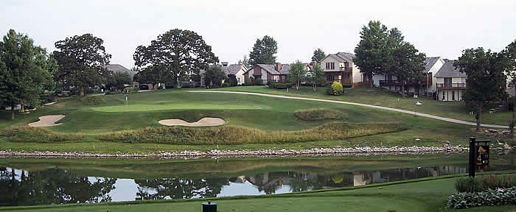

Event includes: Putting Contest, Longest Drive Contests (men’s/ women’s), Hole-in-one contest, closest to the pin, and much, much more.

