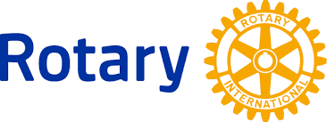
The Rotary Club of Lee’s Summit Community Grants 2019

The Rotary Club of Lee's Summit is actively supporting those who are doing great things in our community! Each year our club selects local non-profit organizations to receive a grant, funded by our Annual Rotary Gala. The application is due by April 15th. We will notify the grant recipients by July 1st and we will be presenting grants to the selected organizations at our Rotary meeting on August 1st. Please help us spread the word to 501c3s who are making an impact in our community!

Click here to see the online grant application.

