Annual Lee’s
Summit Rotary “Investing in Our Youth”
Invitational
Golf Tournament

Thursday May 9, 2019

Sponsorship Opportunities

Hole Sponsor - $700
One foursome, sponsor sign on a tee box & announced at
Awards Ceremony

Lunch Sponsor - $750
One foursome, 1 sponsor sign on a tee box & green, sponsor sign at Luncheon and announced at
Awards Ceremony

Awards Ceremony Sponsor - $750
One foursome, 1 sponsor sign on a tee box & green, at Awards Ceremony and announced at
Awards Ceremony

Putting & Chipping /Beverage Cart - $400
(1 Putting Green; 1 Chipping Contest, 2 Beverage Carts available)
Two Players, sponsorship signage at Contest Sites or the Beverage Cart, and announced at Awards Ceremony

Silver Sponsor - $250
Signage Only, No Golfers

Individual Golfers - $150*
18 holes of golf, cart, range balls, giveaways, snacks/beverages, Luncheon & Awards Ceremony

Registration
Return this form no later than May 2nd, 2019 with your check payable to:
Rotary Club of Lee’s Summit Endowment Fund
c/o Rob Sauve, Treasurer
P.O. Box 785, Lee’s Summit, MO 64081

Name: ________________________ E mail: _____________________________
Company:__________________________________________________________
Address: ___________________________________________________________
City, State, ZIP: _____________________________________________________

____Putting Contest Sponsor ($400) ____ Hole Sponsorships ($700)
___ Chipping Contest Sponsor ($400) ____ Awards Ceremony Sponsor ($750)
____Beverage Cart Sponsor ($400) ____ Lunch Sponsorship ($750)
____ Silver Sponsorship ($250) ____ Individual Player ($150)*

Please provide name & phone number or email address for each golfer.
( ) Please place me on a team -or- ( ) Here is my team
Name: ______________________ Phone/e-mail: ______________________
Name: ______________________ Phone/e-mail: ______________________
Name: ______________________ Phone/e-mail: ______________________
Name: ______________________ Phone/e-mail: ______________________

Company Name and Logo for signage, if sponsor
_________________________________________________________________
_________________________________________________________________

# of individual golfers ($150/each)*_____ x $150 = $ ________
Sponsor [Name: ____________________ amount $ ________
Total Amount: $ ________
* Competitive Package includes: entry in the Hole-in-One Contest, 2 mulligans
and hole contests (e.g., closest to pin, longest putt, longest drive/men’s &
women’s)

Mail: The Rotary Club of Lee’s Summit Endowment Fund,
P.O. Box 785, Lee’s Summit, MO 64081
Missouri Tax ID Number: 15671658

Annual Rotary Club of Lee’s Summit “Investing in Our Youth”
Invitational Golf Tournament
THURSDAY May 9,
2019

Presented by

Rotary Club of Lee’s Summit
Proceeds of this golf tournament are dedicated to the Rotary Club of LS Endowment Fund whereby, the Rotary Club of Lee’s Summit is proud to support eight students annually (3 boys and 3 girls) from the three Lee’s Summit High Schools, one student from Lee’s Summit Christian School and one student from St. Michael the Archangel each with a $2,000 ($1000/year) scholarship to attend the college of their choice within the MCC network.
Co-Chairs:
Kent Shelman and Larry Hillier
For tournament information, contact
Rob Sauve
816-935-3293
Sauve812@aol.com
816-935-3293
or go to:
http://www.lsrotary.com
Annual Rotary Club of Lee’s Summit “Investing in Our Youth”
Invitational Golf Tournament
THURSDAY May 9,
2019
11:00 a.m. - Registration
11:30 a.m. 1:00 p.m. - Lunch/Registration
12:00-1:00 p.m. Putting Contest,
Chipping Contest
Range Open
1:00 p.m. Shotgun Start
5:30 p.m. Awards Ceremony,
Raffle Drawing and
Cocktail Party

Awesome Raffle Prizes!!!!
5 Hole-in-One Contests
Multiple Flight Payouts
Competition Package
Great Food & Beverages
Lots of Goodies

Rotary Club of Lee’s Summit Endowment is a 501c (3) organization
Missouri Tax ID Number: 15671658

$95 of your Registration Fee is tax
deductible

Tournament Location:
651 NE Saint Andrews Circle
Lee’s Summit, Missouri 64064
816-373-6886
www.logc.org
Tucked away in the rolling hills of Lee's Summit, Missouri, Lakewood Oaks Golf Club is a haven for golf enthusiasts. The scenic views will remind you that this is golf at its finest. Featuring a blend of lush zoysia fairways, demanding rough and the best greens in the area, Lakewood Oaks offers a magnificent challenge to players of all handicaps.
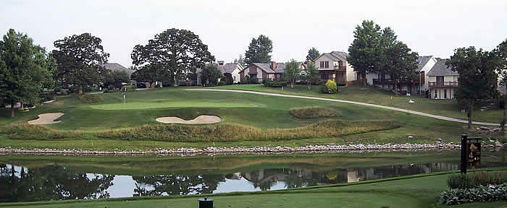

Event includes: Putting and Chipping Contests, Longest Drive Contests (men’s/ women’s), Hole-in-one contests, closest to the pin contest, and much, much more.

