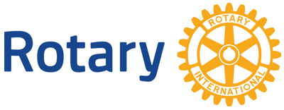

Dear Community Leader:

The Rotary Club of Methuen is seeking sponsors for our various events throughout the year. We will publicize your donation in our program book, you can have signage at our events, advertising on our website and social media accounts and other promotional materials. The newest sponsorship event in the community is our annual “LIGHT UP METHUEN'' event. Last year the response was overwhelming and we look forward to it growing bigger this year. See our website for details, www.methuenrotary.org. I hope that you can join us in making this a successful year. Some of the wonderful things that you will be a part of in the community include but are not limited to the great events and projects listed below:

* Senior Center Valentine’s Day Dance
* Methuen Special Olympics
* June Jubilee Annual Giveaway that supports local non profits
* Eugene Voiland Adopt A Flag Program
* Methuen Little Free Library Project
* Neighbor’s In Need Food Pantry
* MSPCA Nevins Farm
* Methuen Girls Softball
* American Legion
* Nevins Home
* Methuen Cares Center
* On The Move
* Methuen Rail Trail

Our motto is “Service Above Self” and we pride ourselves on providing opportunities for our members and those interested in making a difference… to get involved! We are part of a global community that is 1.2 million members strong and believe that great things happen when people come together. Just look at what we’ve done to eradicate polio…there are less than 50 cases of it left in the world. As we strive to meet the ever increasing demand for help protecting communities from preventable disease, keeping women & children healthy, improving education, and just overall helping others….**won’t you please help us?** Thank you for considering our request. If you are interested in joining us to learn more please visit us on Facebook, Instagram, Twitter, or at www.methuenrotary.org

Sincerely,

Methuen Rotarian

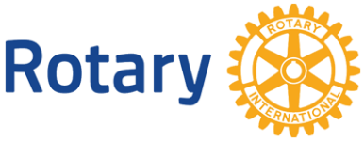 Annual Sponsorship Opportunities

Reach thousands of local customers and gain great exposure. All proceeds benefit the Community of Methuen.

**Peace Maker: $2,500.00**

2 Tickets to Celebration of Achievement Dinner & 2 Tickets to Tournament Full page ad in Keepsake Program Book Logo/Name on our website, Facebook, and Instagram pages Logo/Name included in event publicity , Verbal acknowledgement during programs Banner displayed at events , Logo/Name on table cards

Tree and lighted wreath with signs for *Light Up Methuen*

**Polio Plus: $1,000**

2 Tickets to Celebration of Achievement Dinner Full page ad in Keepsake Program Book, Logo/Name on our website, Facebook, and Instagram pages Logo/Name on table cards

Tree and lighted wreath with signs for *Light Up Methuen* 

**Clean Water: $500**

Half page ad in Keepsake Program Book, Logo/Name on table cards Logo/ Name on Logo/Name our website, Facebook, Twitter, and Instagram pages

Tree & lighted wreath with signs for *Light Up Methuen*

**Literacy Leader: $250**

Quarter page ad in Keepsake Program Book Logo/Name our website, Facebook, Twitter and Instagram pages

Tree with signs for *Light Up Methuen*

**Community Developer: $100**

Logo/Name our website, Facebook, and Twitter and Instagram pages

22 inch lighted wreath with signs for *Light Up Methuen*