Centerville Rotary participates in three International Service Projects.
The Centerville Rotary Club has, in the last two years, participated in 3 service projects in Indonesia, all supported by matching grants from RI and by District Designated Funds. Recently members of the Centerville Rotary went to Indonesia to finalize the projects.
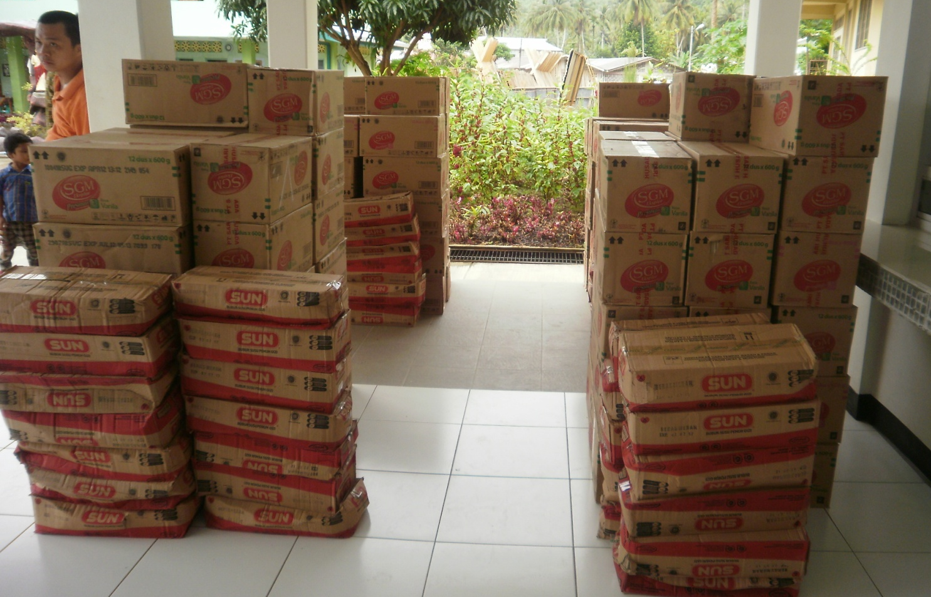
The first project involved providing baby food, cereal and milk to orphans on the Island of Nias. The island was devastated by the tsunami 4 years ago followed by a strong earthquake three months later. Many people perished, leaving many children orphaned. Rotary clubs from all parts of the world have invested nearly $ 500,000 in the rebuilding of Nias. Through the matching grant we were able to help provide food for babies for a period of 6 months. The seven orphanages on the island are run by a Catholic charity.
The second project involved the re-building of a school just outside the city of Padang on the island of Sumatra. On September 30 2009 a very strong earthquake –followed by a second quake the next day - devastated the city causing hundreds of deaths and a ruined infrastructure. About an hour outside the city is a small village, called Patamuan. They had an elementary school attended by some 100 children. That is….until the earthquake caused a landslide which covered the school, and many homes. At least 30 children and 50 adults were buried alive. In collaboration with a Rotary club in Jakarta, a new school is being build and the Centerville club helped providing the funds for the new furniture and the schoolbooks.
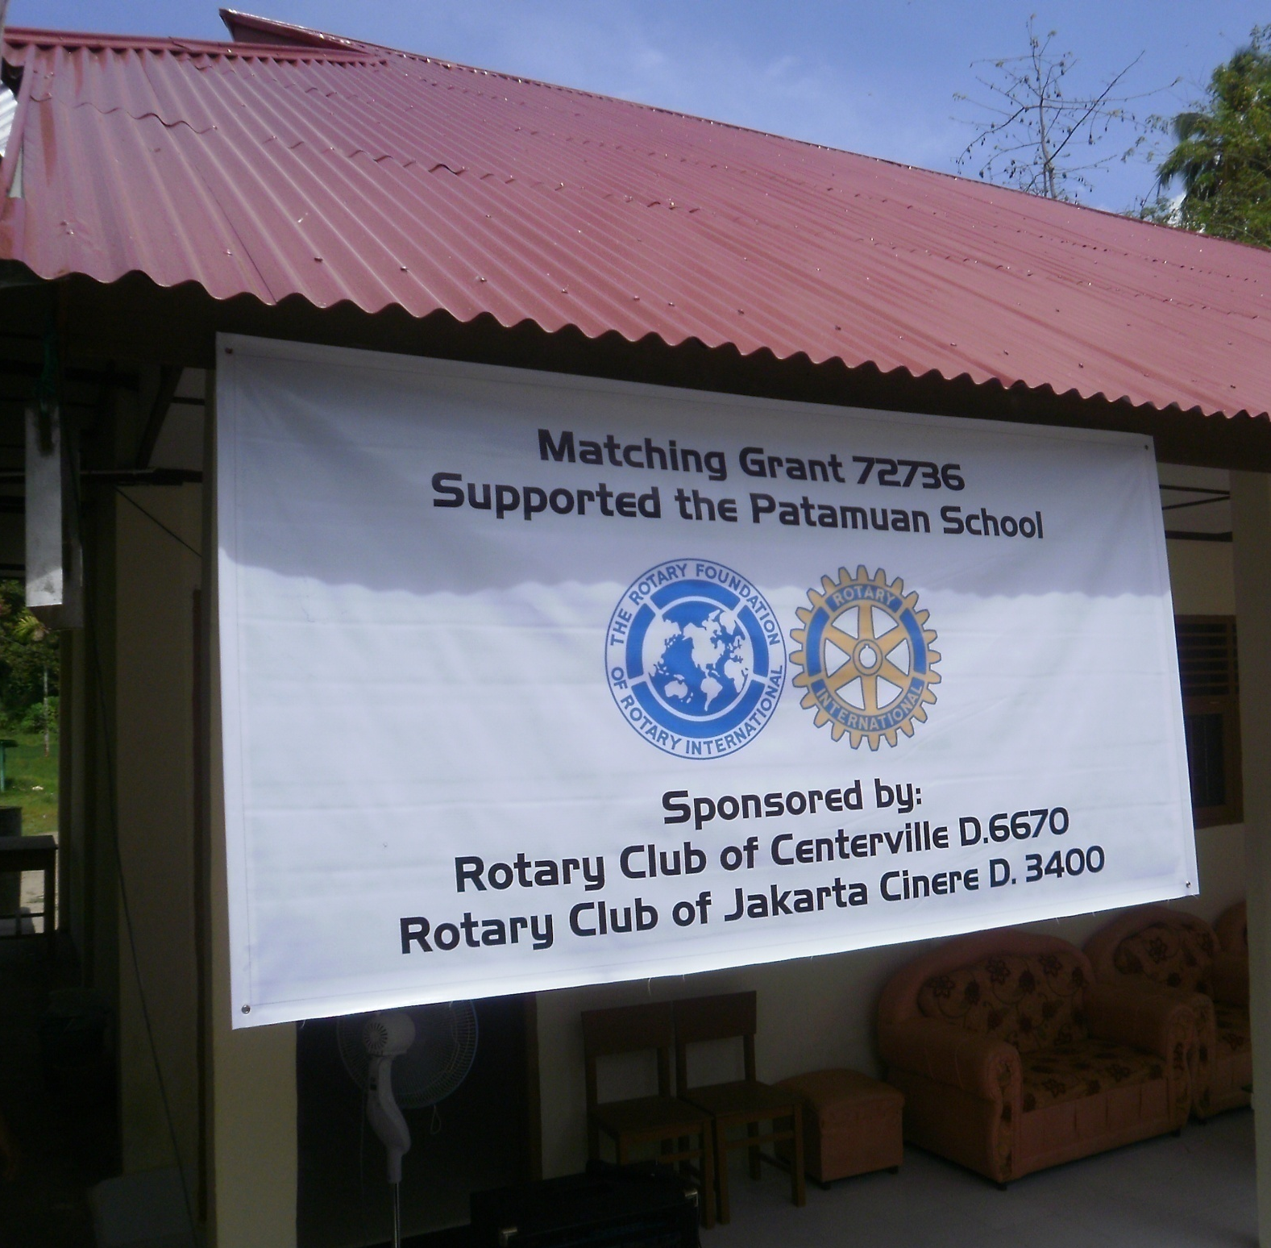
The last project was called “Library-in-the-box” and was implemented in collaboration with the Rotary club In Bandung. Around this city in West Java are many small villages which can only be reached by foot or on a motorcycle. These villages have no library, and often times barely schoolbooks. The intent of the project was to fill 50 thirty gallon plastic boxes with children books, deliver them to the villages – tied on the back of a motorcycle- and then replace them with a new box with new books after 2 – 3 months. When we visited Bandung the last box (# 50) was being delivered to a village about an hour outside Bandung.
At the end of the day, with all three projects finalized, we realized that this is what Rotary is all about: SERVICE ABOVE SELF.

