Two Rotary Friendship Exchanges Planned for 2019: India & Australia

1) An exchange between our Rotary District 6250 and District 2981 in India.

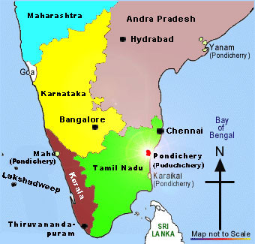
Our Rotary District 6250 Friendship Exchange Committee has arranged an exchange with Rotary District 2981 in India. This district is on the southeast coast of India and includes the city of Pondicherry. We will travel to their District 2981 from Jan. 5 – 20, 2019. We expect to travel with no more than 10 people. Our Rotary District 6250 will host an inbound group from this district in May of 2019 for approximately 14 days.

Anticipated expenses per person for participants:
- Round trip airfare to India
- In-country air, rail or bus travel
- Meals when not at host homes
- Travel insurance
- Personal costs, such as gifts and souvenirs
- Admission charges to museums or events

Hosts on each end of the exchange program support the visitors with room, board and some entertainment/activites and local transportation while in host city.
Detailed in country itineraries will be determined closer to the travel dates

Contact the one of our chairpersons, either Dave Clemens at drdave@dellsdental.net, or Mark Moody at moodymb@charter.net, if you are interested in hosting or traveling.
Rotary Friendship Exchange for 2019 – Australia
With Our Rotary District 6250 and District 9640 in Australia

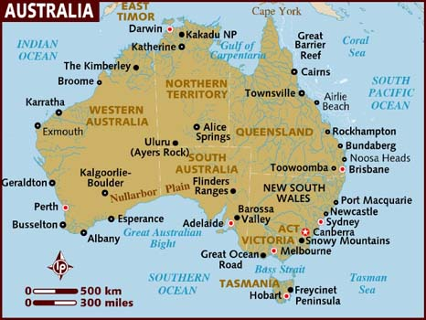
Our Rotary district has arranged Rotary Friendship Exchange for 2019 with District 9640 in Australia which is in the State of Queensland, south of Brisbane. A group from our district will travel to Australia from Feb. 15 to March 4, 2019. This exchange will be no larger than 10 people per group. A group from Australia will visit our district from July 12 to 26, 2019.

Anticipated Expenses for travelers:
- Round trip airfare to Australia
- In-country air, rail or bus travel
- Meals when not at host homes
- Travel insurance
- Personal costs, such as gifts and souvenirs
- Admission charges to museums or events

Hosts on each end of the exchange program support the visitors with room, board and some entertainment/activites and local transportation while in host city.

Detailed in country itineraries will be determined closer to the travel dates

Contact the one of our chairpersons, either Dave Clemens at drdave@dellsdental.net, or Mark Moody at moodymb@charter.net, if you are interested in hosting or traveling.

